# **1.Getting Started With JavaScript**

Because of its wide range of applications, you can run JavaScript in several ways:

* Using console tab of web browsers
* Using Node.js
* By creating web pages

## **1. Using Console Tab of Web Browsers**

All the popular web browsers have built-in JavaScript engines. Hence, you can run JavaScript on a browser. To run JavaScript on a browser,

1. Open your favorite browser (here we will use Google Chrome).
2. Open the developer tools by right clicking on an empty area and select Inspect. Shortcut: F12.

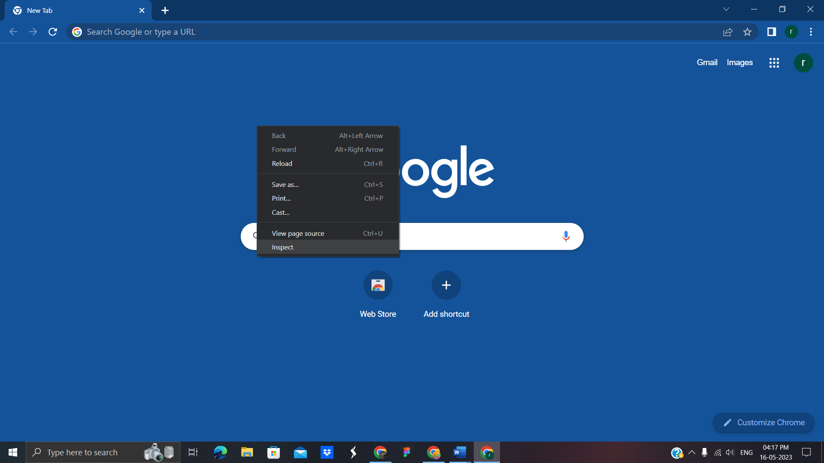

3. On the developer tools, go to the console tab. Then, write JavaScript code and press enter to run the code.

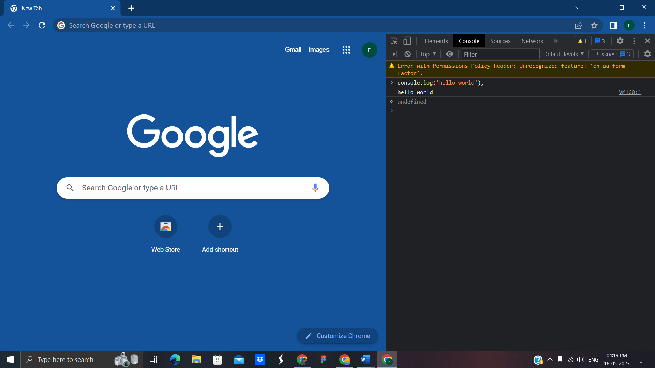

## **2. Using Node.js**

Node is a back-end run-time environment for executing JavaScript code. To run JS using Node.js, follow these steps:

1. Install the latest version of Node.js .
2. Install an IDE/Text Editor like Visual studio code. In VS code, create a file > write JS code > save it with .js extension.

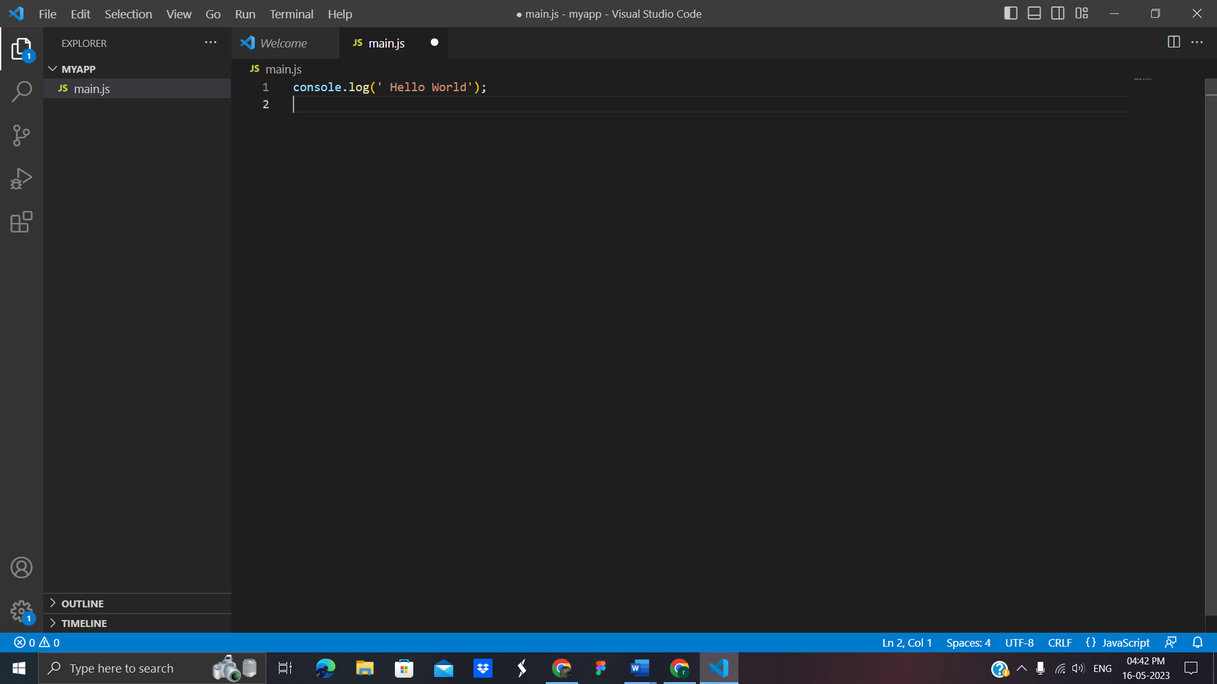

3. Run the code after debugging.

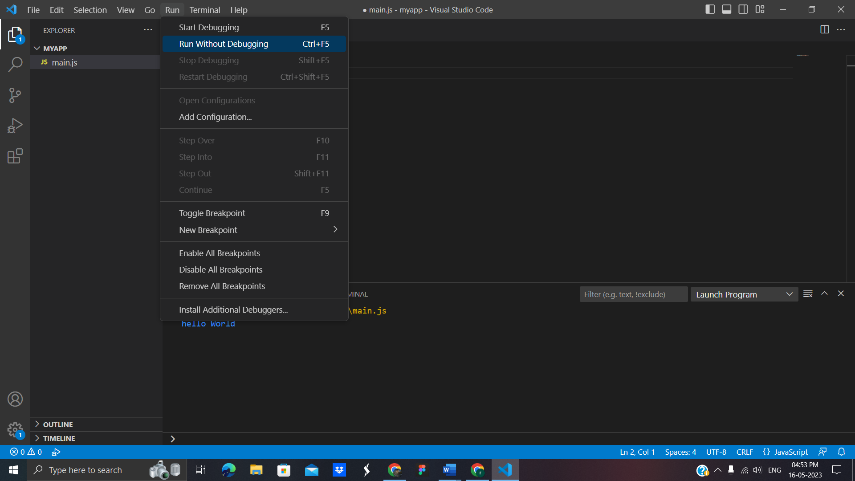

4. You will get output on the terminal.

## **3. By Creating Web Pages**

JavaScript was initially created to make web pages interactive, that's why JavaScript and HTML go hand in hand. To run JS from a webpage, follow these steps:

1. Open VS Code > Go to File > New File > Save it with .html extension. For example, main.html.
2. Add this HTML code and save it in the file.

<!doctype html>

<html lang="en">

<head>

<meta charset="utf-8">

<title>Javascript bootcamp </title>

</head>

<body>

<script src=""></script>

</body>

</html>

3. Similarly create a JS file, write the following JS code and save it with .js extension like main.js

console.log('hello world');

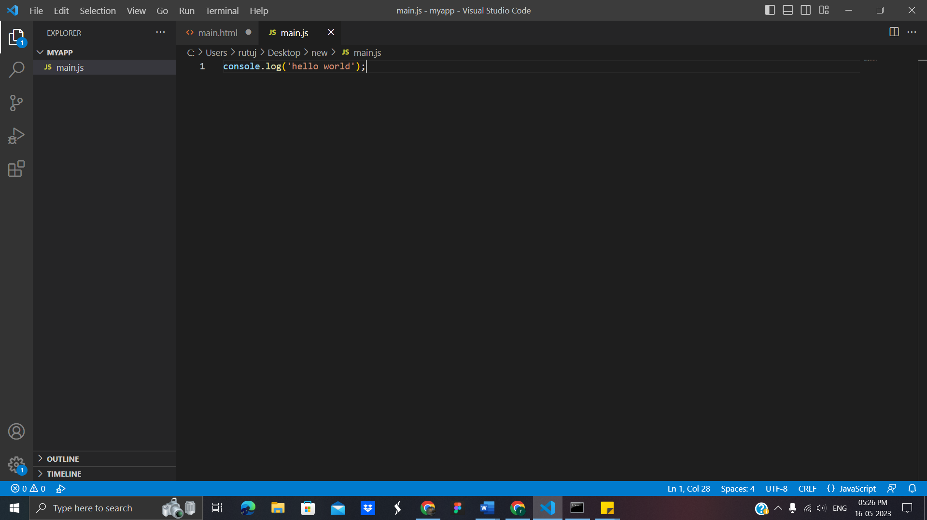

4.From inside the HTML file, we need to link the main.js file to use it. You can achieve that by adding the following code in main.html.

<script scr="main.js"></script>

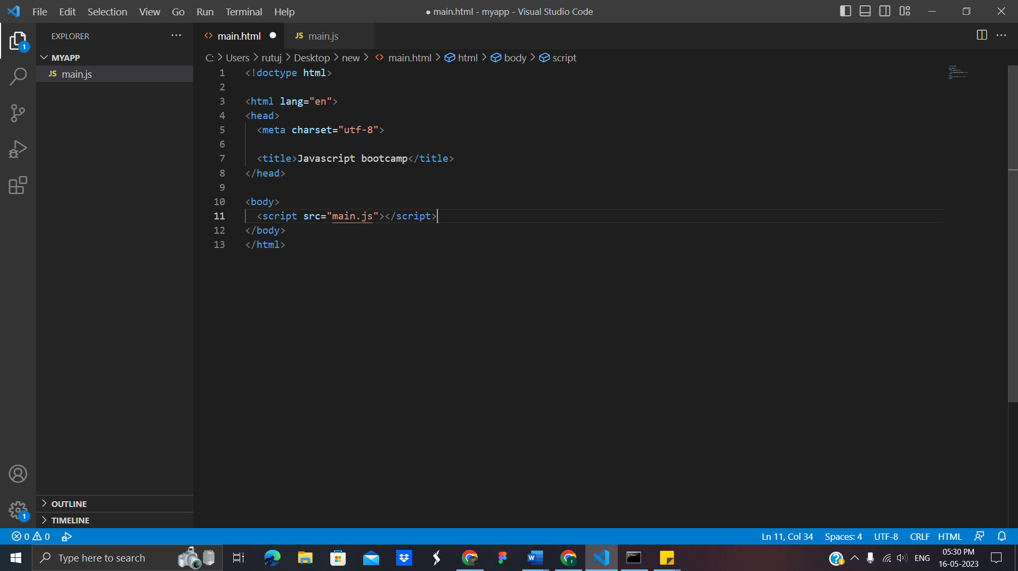

5. Open the main.html file using a browser.

6. To check if our JS code ran or not, Right click on the web page > Inspect > Choose console tab.

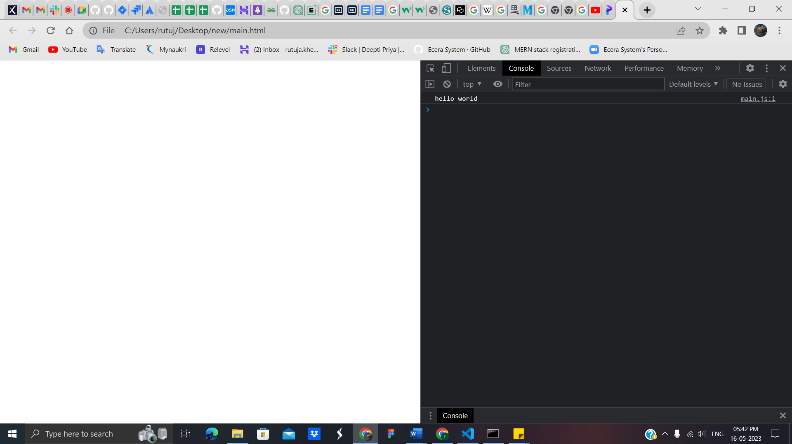

Now we got to know how to run JavaScript, in different ways now let's start learning the basic fundamentals of JavaScript from the next chapter.

# **2. JavaScript basic Example:** now let’s try the basic example

**code :**

<html>

<body>

<script type="text/javascript">

document.write("welcome to javascript");

<script>

</body>

</html>

**Output :**

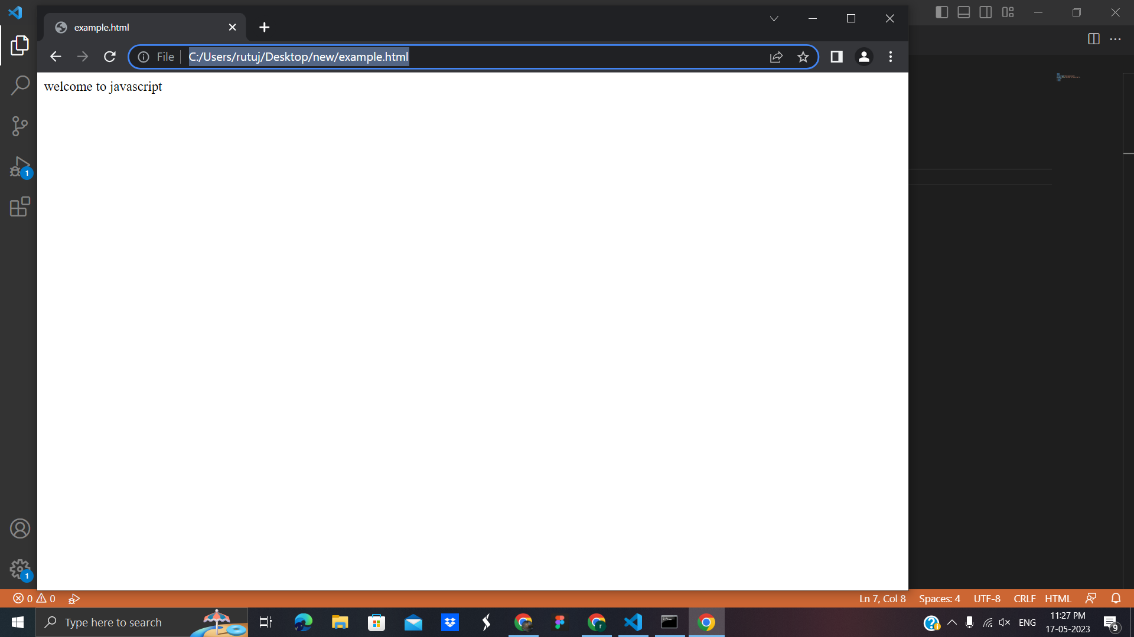:

**3 ways to put JavaScript code**

1. Between the body tag of html
2. Between the head tag of html
3. In .js file (external javaScript)

**1.Between the body tag of html**

**Code:**

<html>

<body>

<script type="text/javascript">

alert("Hello, welcome to javascript tutorial");

</script>

</body>

</html>

**Output:**

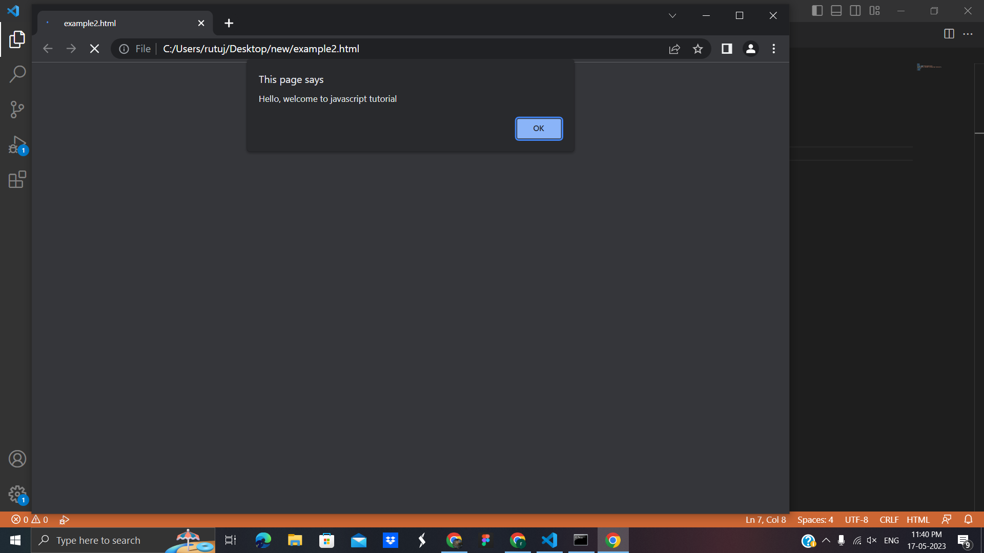

**2.Between the head tag of html**

**Code:**

<html>

<head>

<script type="text/javascript">

function msg(){

alert("Hello Learner...");

}

</script>

</head>

<body>

<p>Welcome to JavaScript</p>

<form>

<input type="button" value="click" onclick="msg()"/>

</form>

</body>

</html>

**Output:**

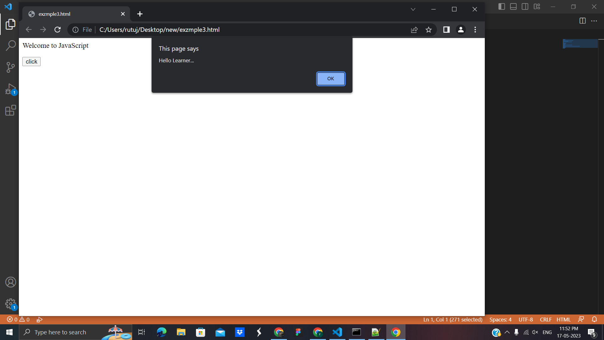

**3. In .js file (external javaScript)**

We can create external JavaScript file and embed it in many html page.Let's create an external [JavaScript](https://www.javatpoint.com/javascript-tutorial) file that prints Hello Javatpoint in a alert dialog box.

**message.js**

function msg(){

alert("Hello learner.");

}

Let's include the JavaScript file into the html page. It calls the javascript function on button click.

**Index.html**

<html>

<head>

<script type="text/javascript" src="message.js"></script>

</head>

<body>

<p>Welcome to JavaScript</p>

<form>

<input type="button" value="click" onclick="msg()"/>

</form>

</body>

</html>

**Output:**

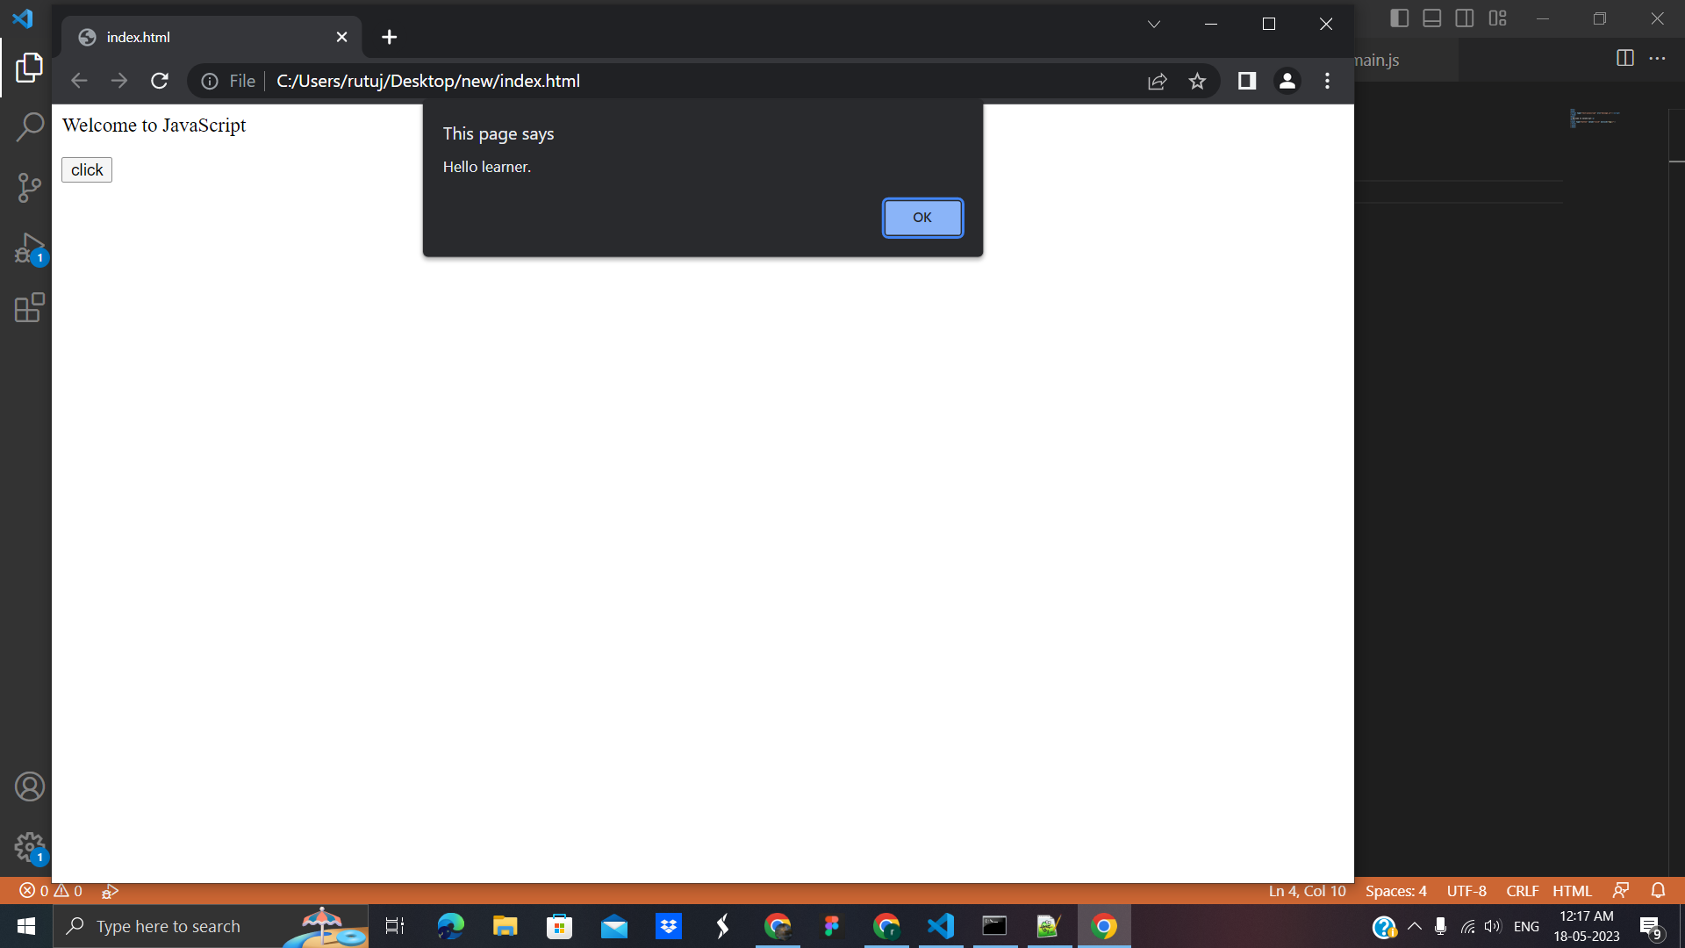

**3. Javascript Basics**

**Javascript comment:** There are two types of comments in JavaScript.

1. Single-line Comment
2. Multi-line Comment

**1.Single-line Comment**

**Code:**

**<html>**

**<body>**

**<script>**

**// It is single line comment**

**document.write("hello Learners");**

**</script>**

**</body>**

**</html>**

**Output:**

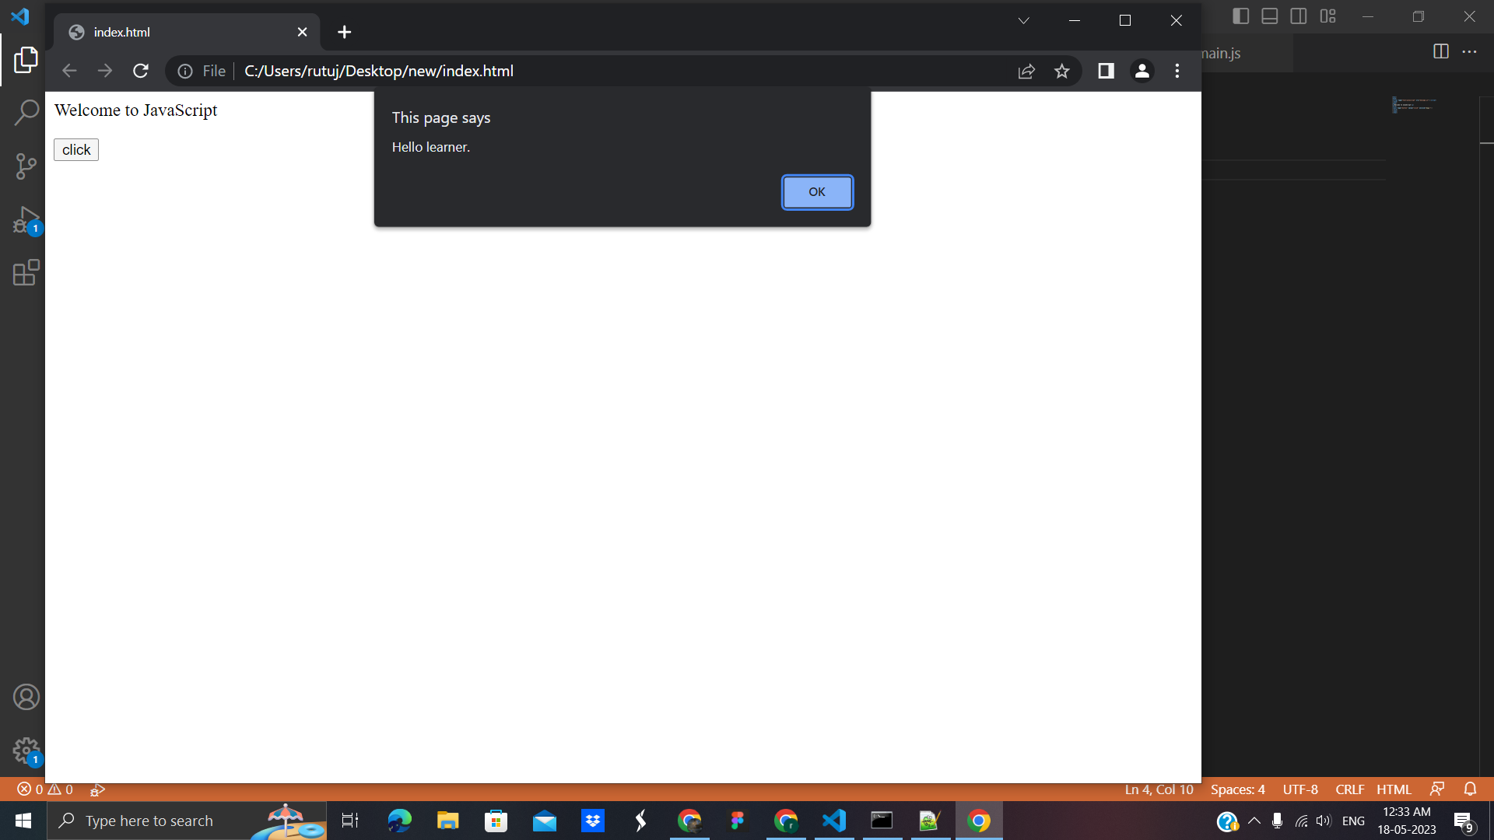

**2.Multi-line Comment**

**Code:**

<html>

<body>

<script>

/* It is a multi-line comment.

It will not be displayed */

document.write("This is the example of javascript multiline comment");

</script>

</body>

</html>

**Output**:

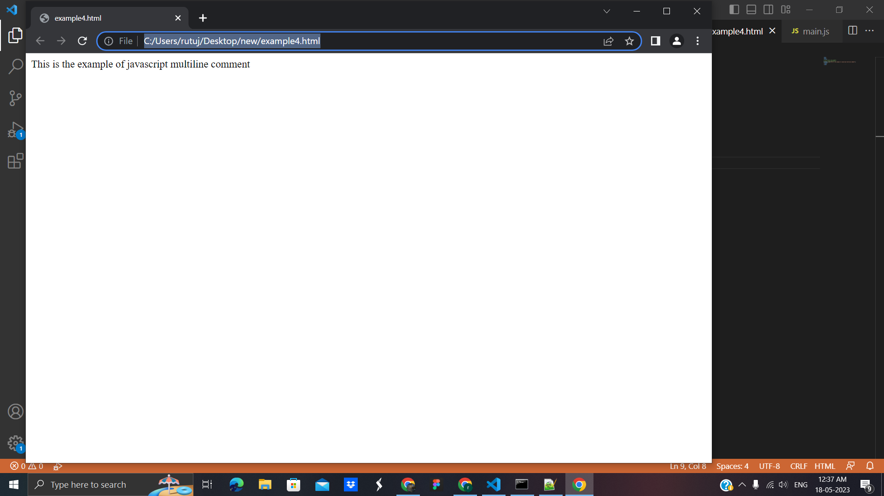

**JavaScript Variable:** is simply a name of storage location. Lets see example of JavaScript variable

**Code:**

<html>

<body>

<script>

var x = 10;

var y = 20;

var z=x+y;

document.write(z);

</script>

</body>

</html>

**Output:**

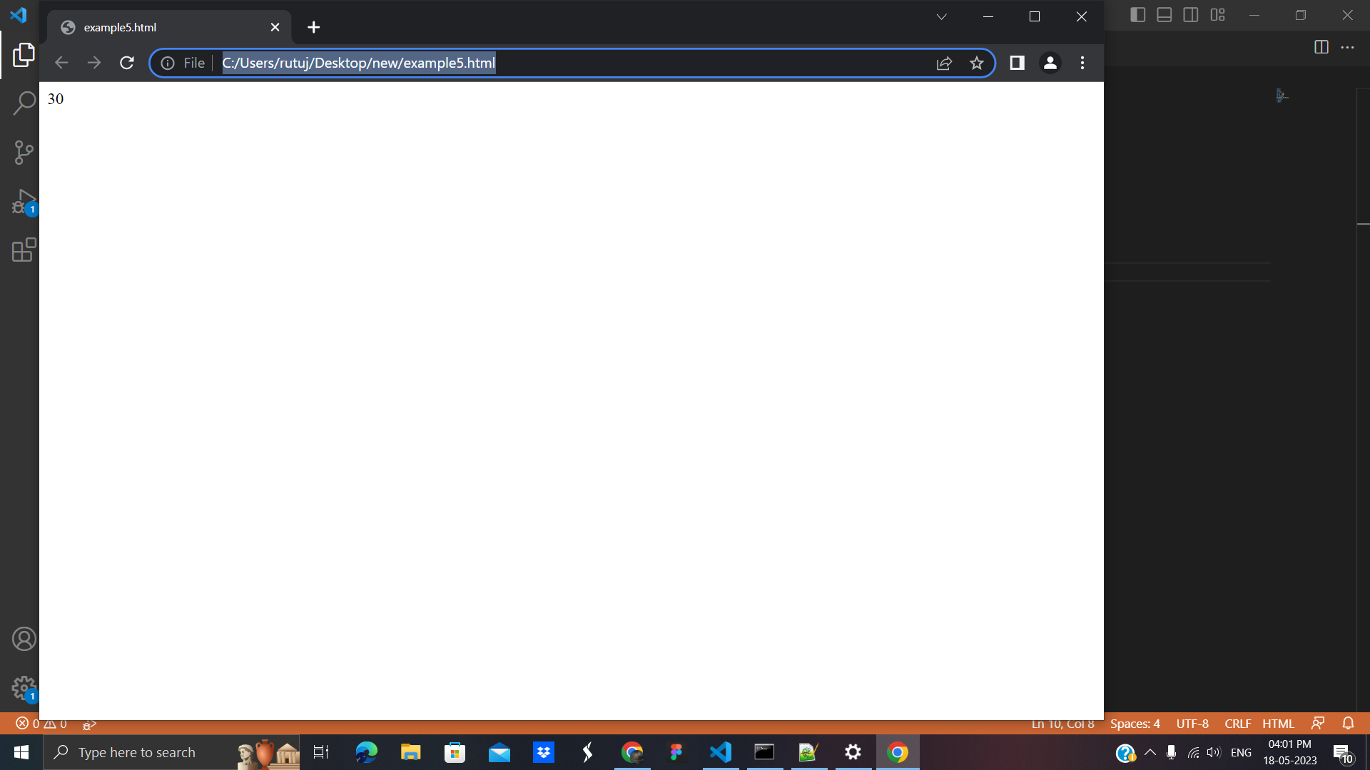

There are two types of variables in JavaScript : local variable and global variable**.**

**Local variable:** A JavaScript local variable is declared inside a block or function. It is accessible within the function or block only.

For example**:**

<script>

function abc(){

var x=10;//local variable

}

</script>

**Global variable**: A **JavaScript global variable** is accessible from any function. A variable i.e. declared outside the function or declared with a window object is known as a global variable.

For example:

**Code** :

<html>

<body>

<script>

var data=200;//gloabal variable

function a(){

document.writeln(data);

}

function b(){

document.writeln(data);

}

a();//calling JavaScript function

b();

</script>

</body>

</html>

**Output:**

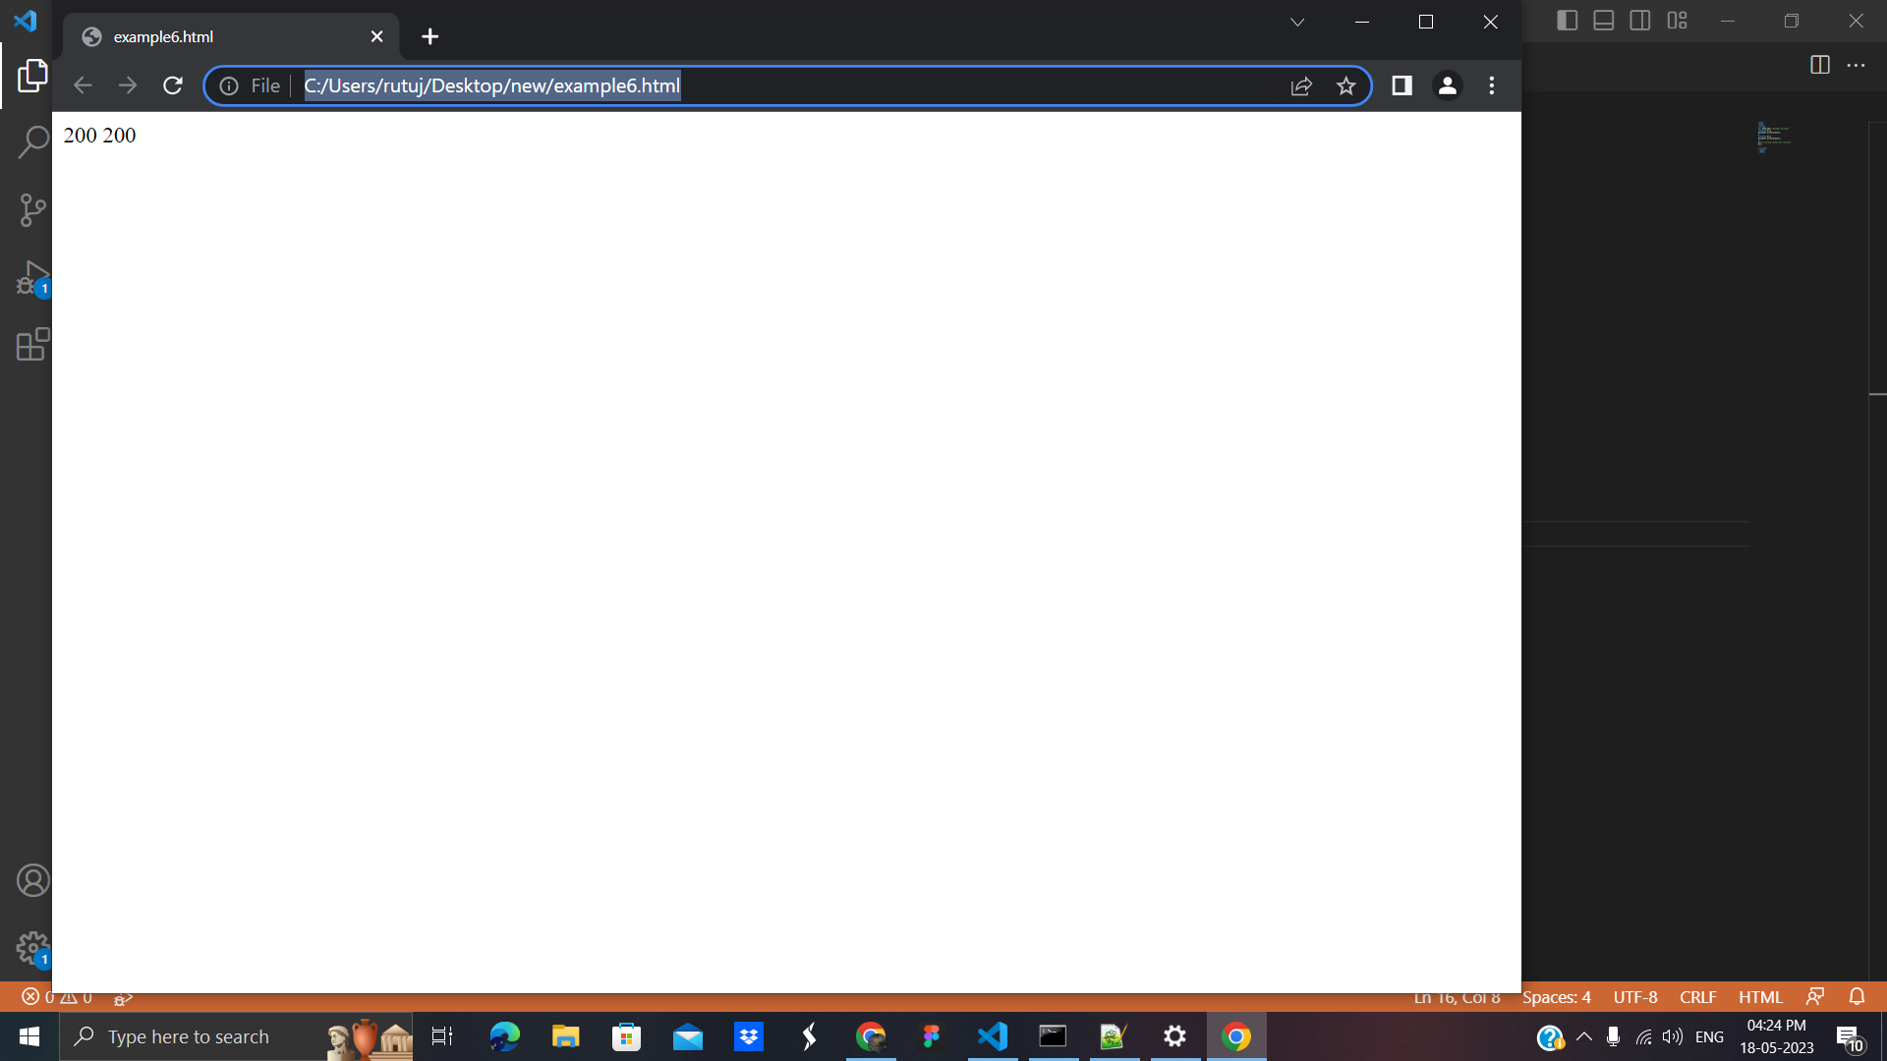

# **4. Javascript Data Types:**

# JavaScript provides different data types to hold different types of values. There are two types of data types in JavaScript.

# Primitive data type

# Non-primitive (reference) data type

**1. Primitive data type :** There are five types of primitive data types in JavaScript. They are as follows:

**1. Number:** Number data type in javascript can be used to hold decimal values as well as values without decimals.

**code** :

<html>

<body>

<script>

let x = 250;

let y = 40.5;

console.log("Value of x=" + x);

console.log("Value of y=" + y);

</script>

</body>

</html>

**Output:**

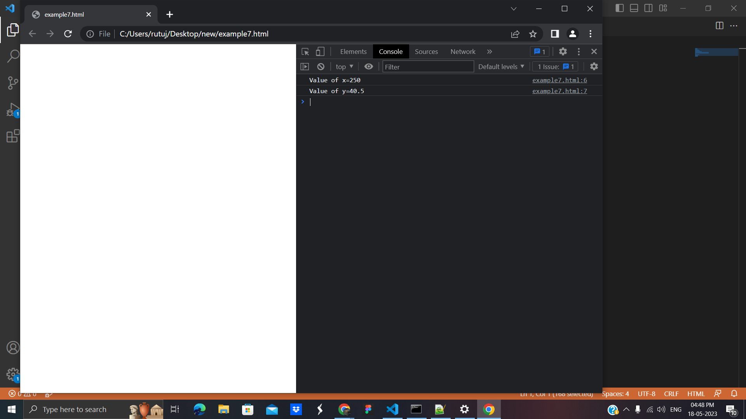

2. **String:** The string data type in javascript represents a sequence of characters that are surrounded by single or double quotes

**Code:**

<html>

<body>

<script>

let str = 'Hello All';

let str1 = "Welcome to my new house";

console.log("Value of str=" + str);

console.log("Value of str1=" + str1);

</script>

</body>

</html>

**Output:**

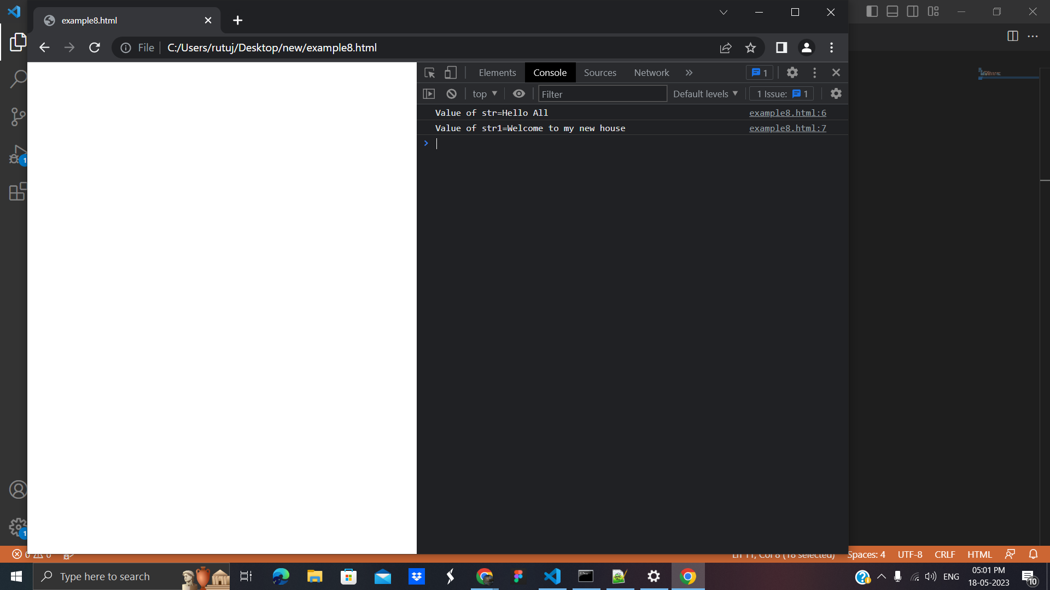

3.[**U**](https://www.geeksforgeeks.org/javascript-undefined-property/)**ndefined:**The meaning of undefined is ‘value is not assigned’.

**Code** :

html>

<body>

<script>

console.log("Value of x=" + x);

</script>

</body>

</html>

**Output**:

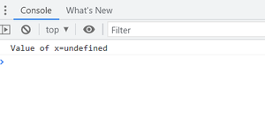

**4. Boolean:** The boolean data type can accept only two values i.e. true and false.

**Code:**

<html>

<body>

<script>

console.log("value of bool=" + bool);

</script>

</body>

</html>

**Output:**

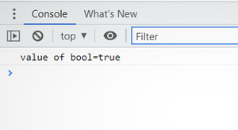

5. **Null**: This data type can hold only one possible value that is null.

**Code:**

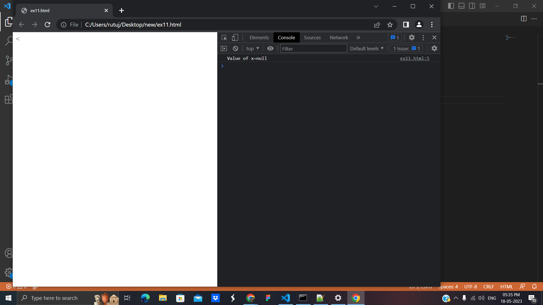

**2.Non-primitive (reference) data type:** The non-primitive data types are as follows:

**1. Object:** An object in Javascript is an entity having properties and methods. Everything is an object in javascript.

Code:

<html>

<body>

<script>

// Creating object with the name person

let person = {

firstName: "Rutuja",

lastName: "Khedkar",

};

// Print the value of object on console

console.log(person.firstName

+ " " + person.lastName);

</script>

</body>

</html>

**Output:**

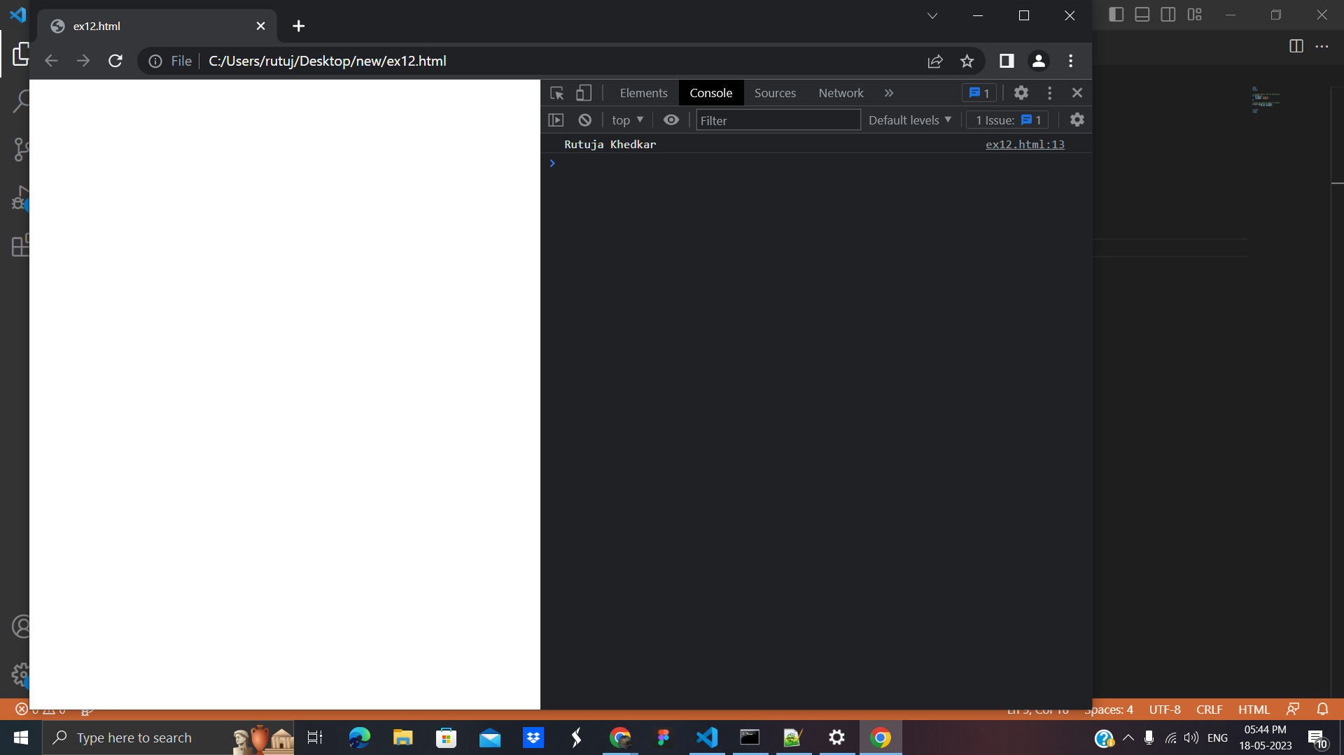

**2. Array:** With the help of an array, we can store more than one element under a single name.

**Code** :

<html>

<body>

<script>

var a = new Array();

var b = new Array(10);

var d = new Array(1, 2, 3, "Hello");

console.log("value of a=" + a);

console.log("value of b" + b);

console.log("value of d=" + d);

</script>

</body>

</html>

**Output :**

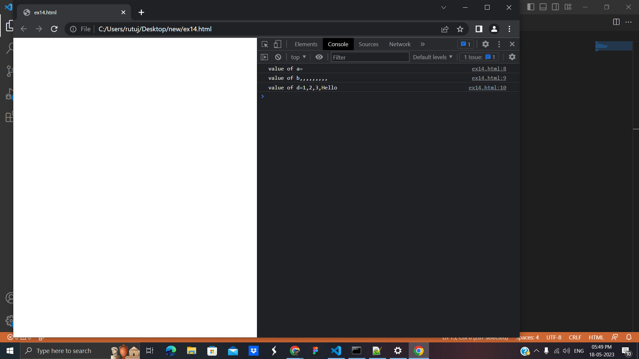

# **5. JavaScript Operators:** JavaScript operators operate the operands,there are various operators supported by JavaScript.

1. JS Arithmetic Operators
2. JS Assignment Operators
3. JS Comparison Operators
4. JS Logical Operators
5. JS Ternary Operators
6. JS Bitwise Operator
7. JS typeof Operator
8. **JS Arithmetic Operators :** in the following example we will use all the operators.

**Code:**

<html>

<body>

<script>

// Addition Operator

let a = 1 + 2

console.log(a);

// Subtraction Operator

let b = 10 - 7

console.log(b);

// Multiplication Operator

let c = 3 * 3

console.log(c);

// Division Operator

let d = 1.0 / 2.0

console.log(d);

// Modulas Operator

let e = 9 % 5

console.log(e)

// Exponentian Operator

let f = 2 ** 5

console.log(f)

// Increment Operator

var g = 2;

g1 = g++;

console.log(g)

// Decrement Operator

var h = 2;

h1 = h--;

console.log(h)

// Unary plus Operator

var i = 3;

i1 = +i;

console.log(i1)

// Negation Operator

var j = 3;

j1 = -j;

console.log(j1)

</script>

</body>

</html>

**Output :**

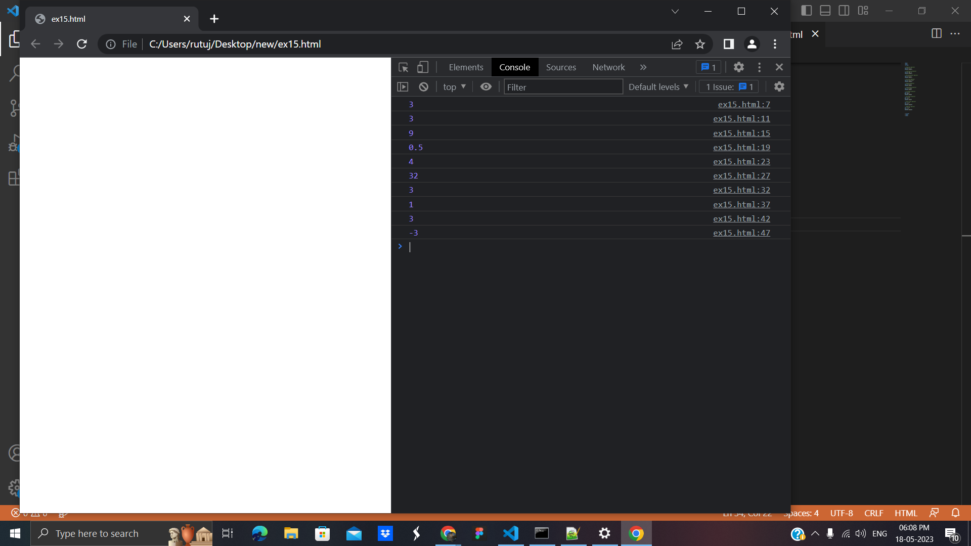

1. **JS Assignment Operators:** The assignment operation evaluates the assigned value. Chaining the assignment operator is possible in order to assign a single value to multiple variables.

**Example:**

<html>

<body>

<script>

// Assignment Operator

let a = 2;

console.log(a);

// Addition Assignment Operator

const b= 3;

console.log(a = b + 1);

// Subtraction Assignment Operator

let yoo=4;

console.log(foo=yoo-1);

// Multiplication Assignment

console.log(yoo=yoo*2);

// Division Assignment Op**e**rator

const moo=2;

console.log(yoo=yoo/moo);

// Modulas Assignment Operator

console.log(yoo%=2);

// Exponentian Assignment Operator

console.log(yoo**moo);

// Left Shift Assignment

console.log(yoo<<=2);

// Right Shift Assignment

console.log(yoo>>=2);

// Bitwise AND Assignment

console.log(yoo&=2);

// Bitwise OR Assignment

console.log(yoo|=2);

// Bitwise XOR Assignment

console.log(yoo^=2)

</script>

</body>

</html>

**Output:**

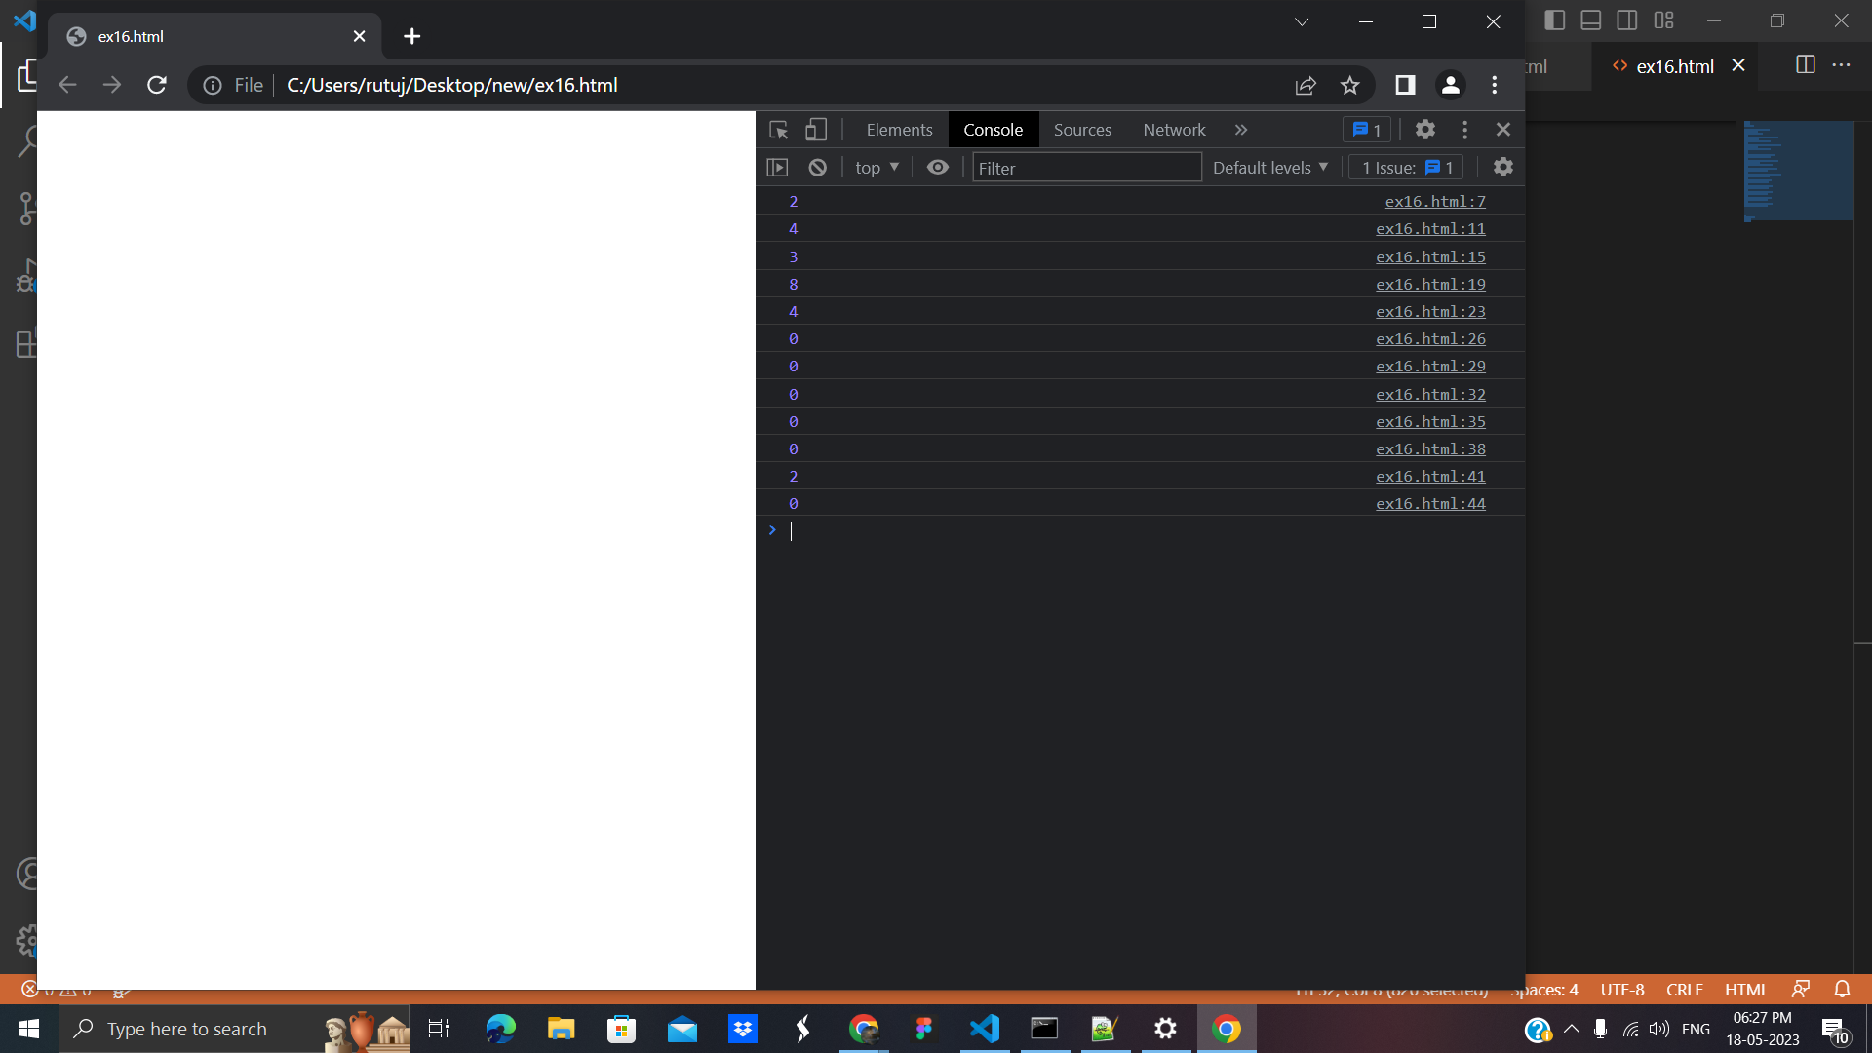

**3.Javascript** **Comparison operators** :Comparison operators are mainly used to perform the logical operations that determine the equality or difference between the values.

**Example:**

<html>

<body>

<script>

// Assigning values

let val1 = 5;

let val2 = 5;

// Equality Operator

console.log(val1 == val2);

// Strict equality Operator

console.log(val1 === val2);

// Inequality Operator

console.log(val1 != val2);

// Strict Inequality Operator

console.log(val1 !== val2);

// Greater than Operator

console.log(val1 > val2);

// Greater than or equal Operator

console.log(val1 >= val2);

// Less than Operator

console.log(val1 < val2);

// Less than or equal Operator

console.log(val1 <= val2);

</script>

</body>

</html>

**Output:**

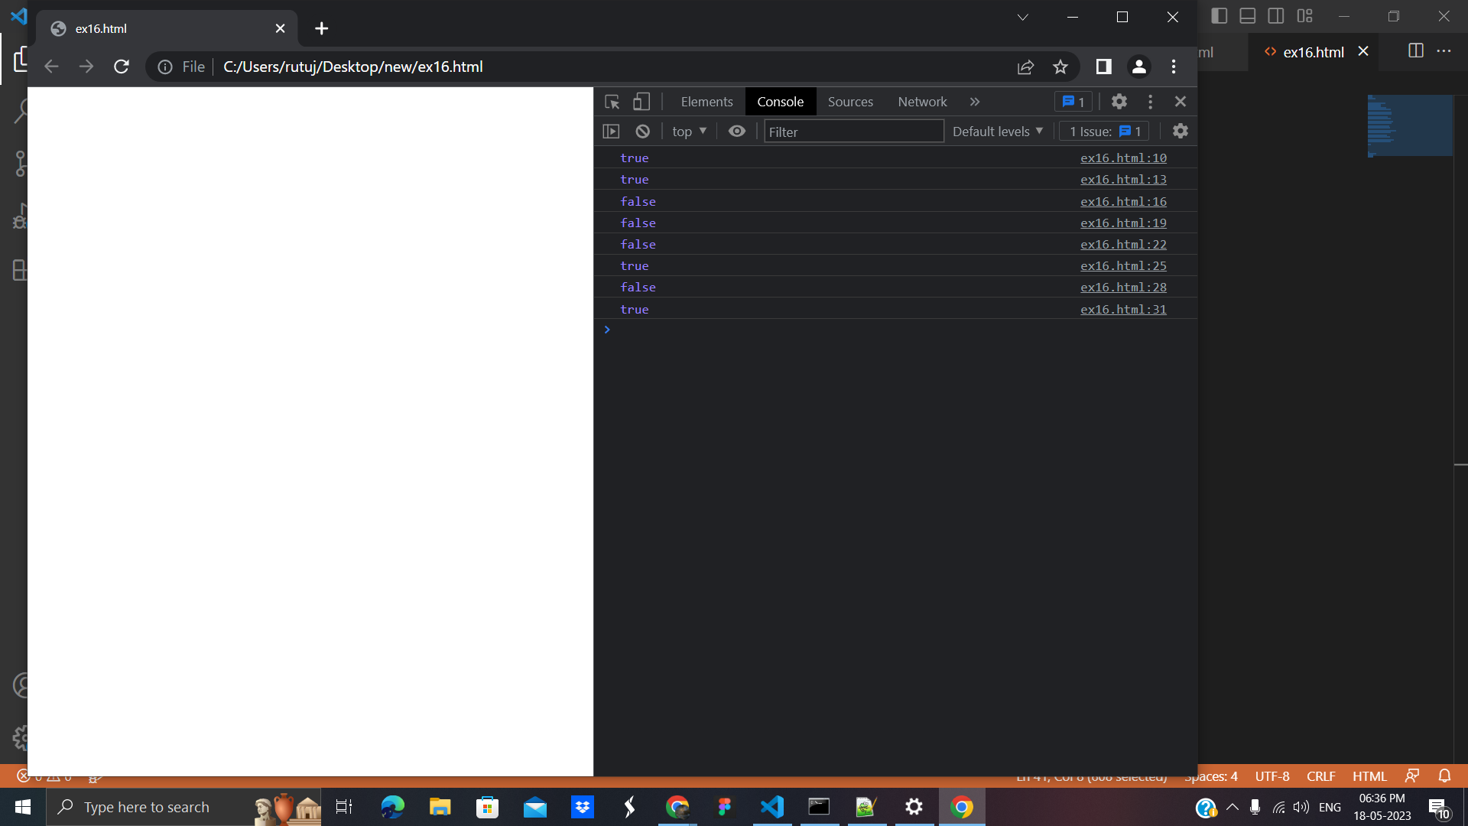

**4. JS Logical Operators:** These operators are used to determine the logic between variables or values.

**Code:**

<html>

<body>

<script>

// Assigning values

let val1 = 5;

let val2 = 5;

// Logical !(NOT) Operator

console.log(!val2);

// Logical &&(AND) Operator

console.log( val1 && val2 );

// Lgical ||(OR) Operator

console.log( val1 || val2 );

</script>

</body>

</html>

**Output:**

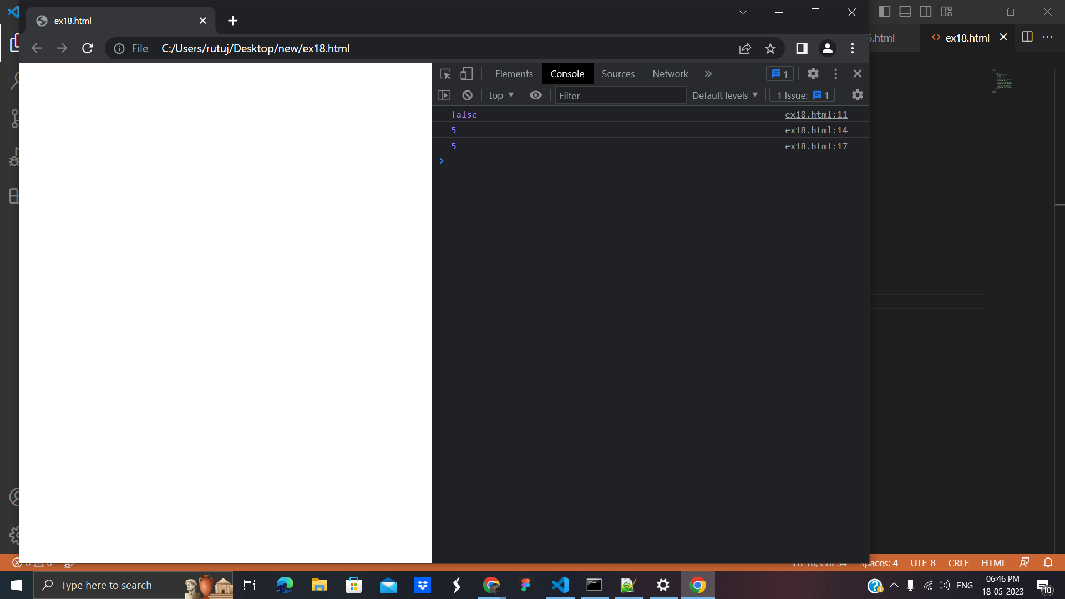

**5.JS Ternary Operators:** The ternary operator has three operands. It is the simplified operator of if/else.

**Example:**

<html>

<body>

<script>

// Assigning values

let PMarks = 40

// Ternary Operator

let result = (PMarks > 39)?

"Pass":"Fail";

console.log(result);

</script>

</body>

</html>

**Output :**

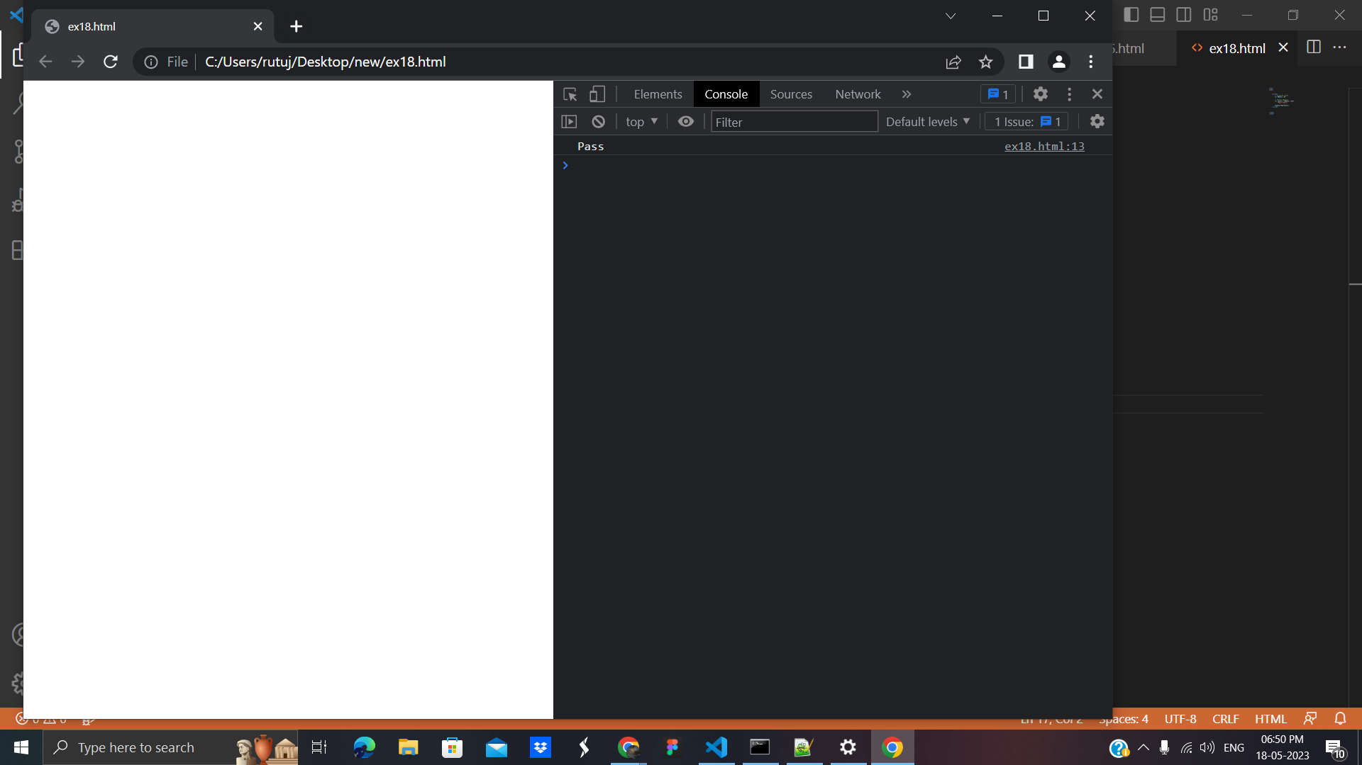

**6**. **Bitwise operator:**

The bitwise operator in JavaScript is used to convert the number to a 32-bit binary number and perform the bitwise operation. The number is converted back to the 64-bit number after the result.

**1.Bitwise AND(&**): The operator returns true only if both the operands are true

A = 6, B=1

A&B = 0

**2.Bitwise OR(|):** The operator returns true even if one of the operands is true

A = 6, B=1

A|B = 7

**3.Bitwise XOR(^):** The operator returns true if both operators are distinct

A = 6, B=1

A^B = 7

**4.Bitwise NOT(~**): This operator is used to invert the boolean value of the operand

A = 6

~A = -7

**5.Bitwise Left Shift(<<)**: In this two operators are used where the first operand is the number and the second operand is the number of bits to shift to the left.

A = 6, B=1

A<<B = 12

**6.Bitwise Right Shift(>>)**: In this two operators are used where the first operand is the number and the second operand is the number of bits to shift to the right.

A = 6, B=1

A>>B = 3

**7.Zero Fill Right Shift(>>>)**: It is the same as a bitwise right shift the only difference is that overflowing bits are discarded.

A = 6, B=1

A>>>B = 3

**7. JS typeof Operator :** It returns the data type of its operand in the form of a string. The operand can be any object, function, or variable.

**Example:**

<html>

<body>

<script type="text/javascript">

var a = 17;

var b = "Rutuja khedkar";

var c = "";

var d = null;

console.log("Type of a = " + (typeof a));

console.log("Type of b = " + (typeof b));

console.log("Type of c = " + (typeof c));

console.log("Type of d = " + (typeof d));

console.log("Type of e = " + (typeof e));

</script>

</body>

</html>

**Output:**

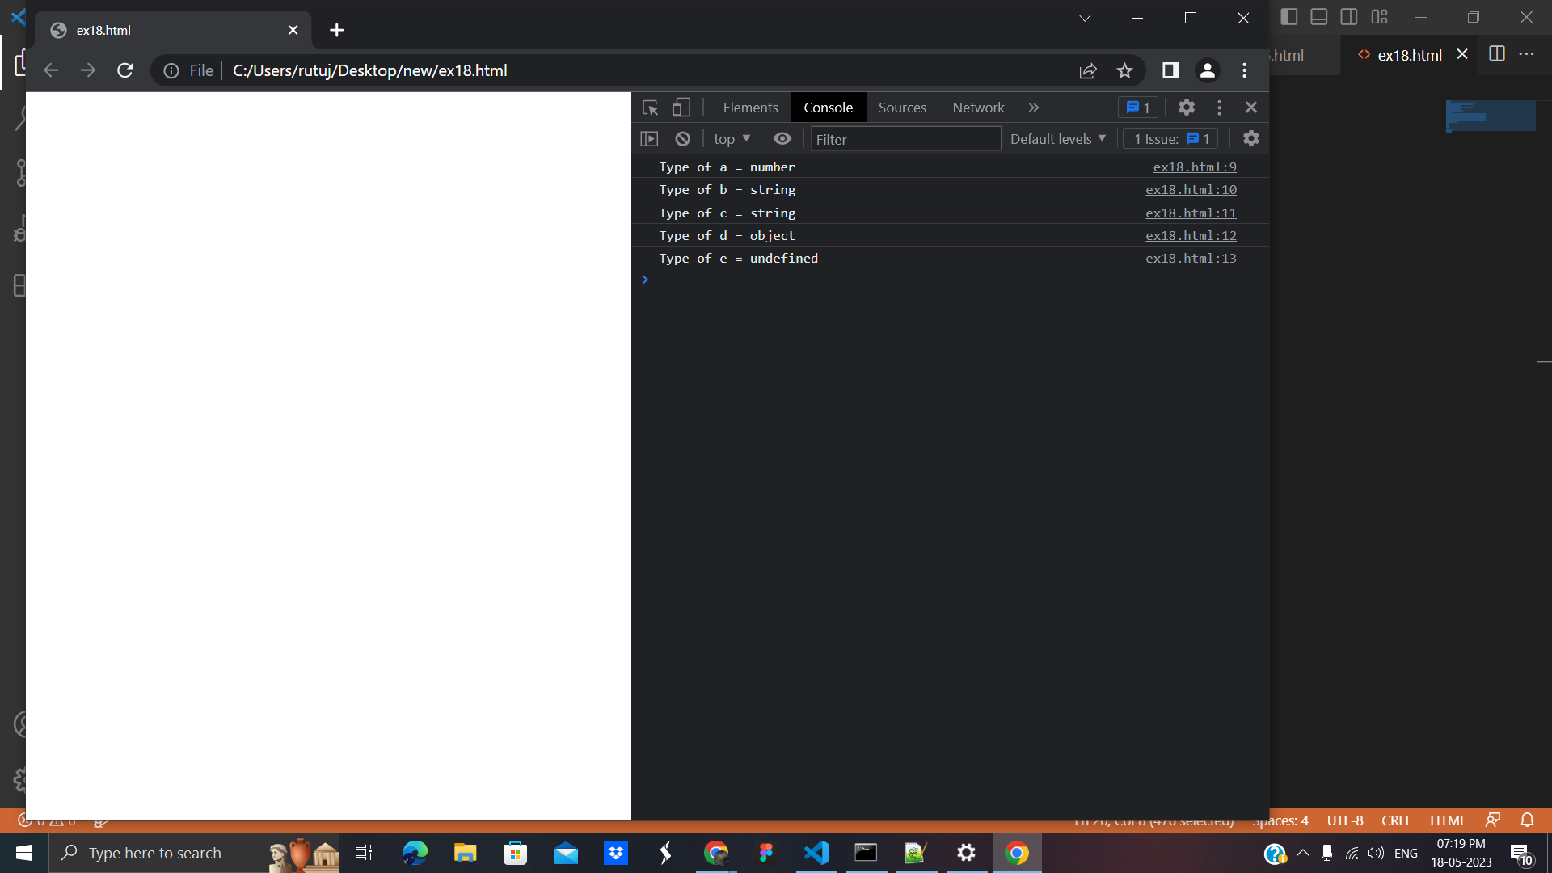

# **6. JavaScript If-else:** used *to execute the code whether condition is true or false*. There are three forms of if statement in JavaScript**.**

# If Statement

# If else statement

# if else if statement

# **1.If Statement:** It evaluates the content only if expression is true

# **Code:**

<html>

<body>

<script>

var a=20;

if(a>10){

document.write("value of a is greater than 10");

}

</script>

</body>

</html>

**Output:**

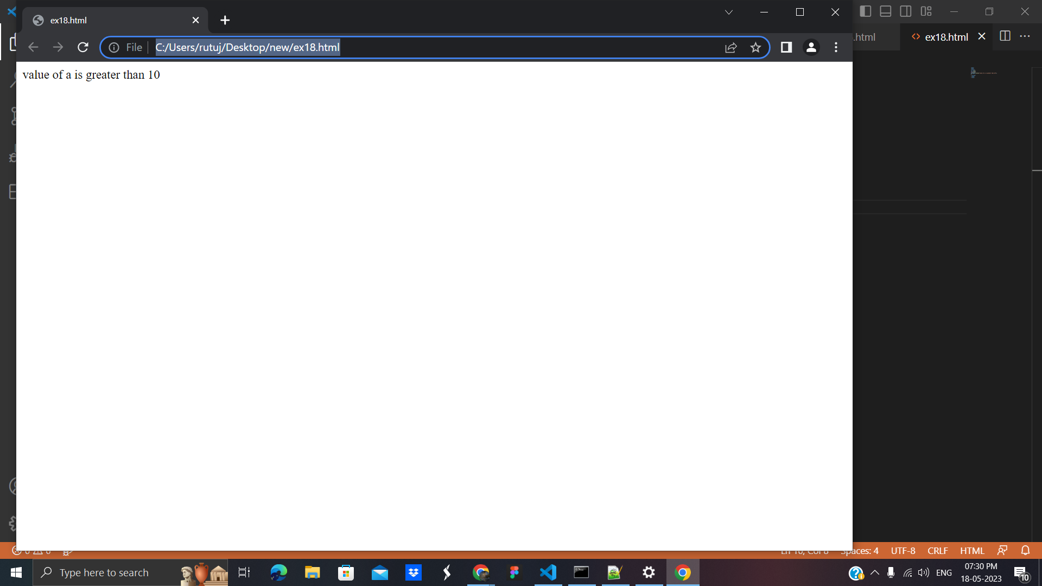

**2. If else statement:** It evaluates the content whether condition is true of false.

**Code**:

<html>

<body>

<script>

var a=20;

if(a%2==0){

document.write("a is even number");

}

else{

document.write("a is odd number");

}

</script>

</body>

</html>

**Output:**

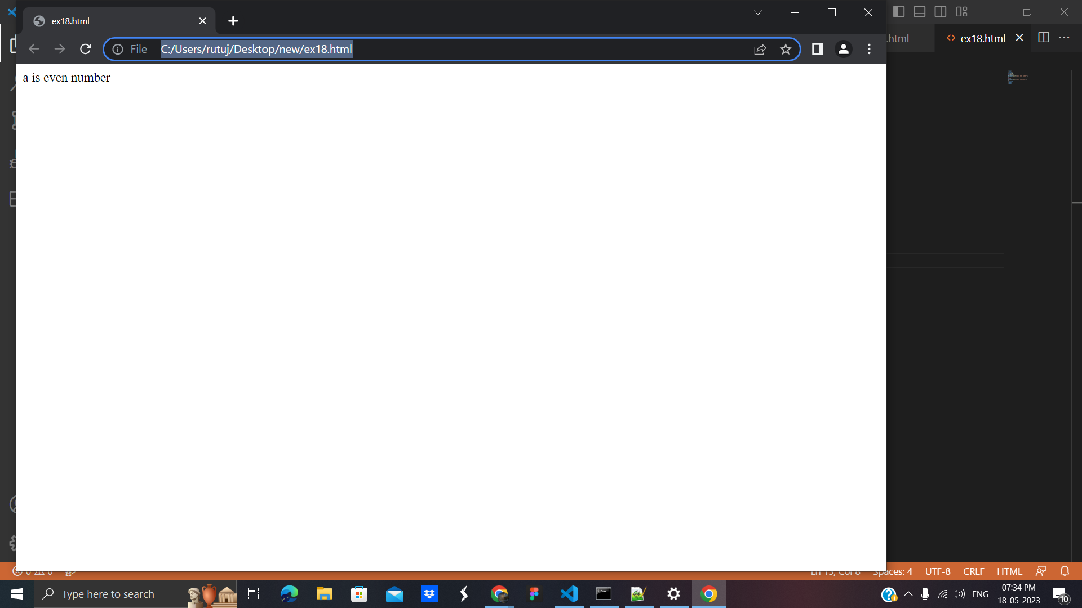

**3. if else if statement:** It evaluates the content only if expression is true from several expressions

**Code:**

<html>

<body>

<script>

var a=20;

if(a==10){

document.write("a is equal to 10");

}

else if(a==15){

document.write("a is equal to 15");

}

else if(a==20){

document.write("a is equal to 20");

}

else{

document.write("a is not equal to 10, 15 or 20");

}

</script>

</body>

</html>

**Output:**

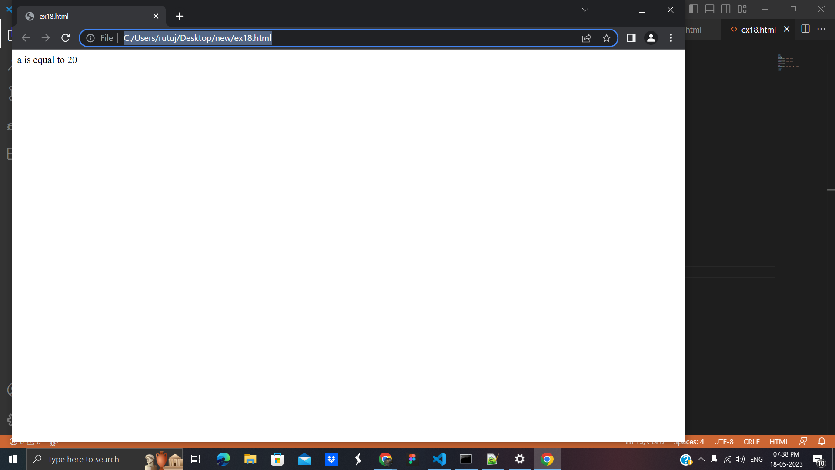

# **7. JavaScript Switch:** is used *to execute one code from multiple expressions*.

**Code** :basic example of switch statement

<!DOCTYPE html>

<html>

<body>

<script>

var grade='B';

var result;

switch(grade){

case 'A':

result="A Grade";

break;

case 'B':

result="B Grade";

break;

case 'C':

result="C Grade";

break;

default:

result="No Grade";

}

document.write(result);

</script>

</body>

</html>

**Output:**

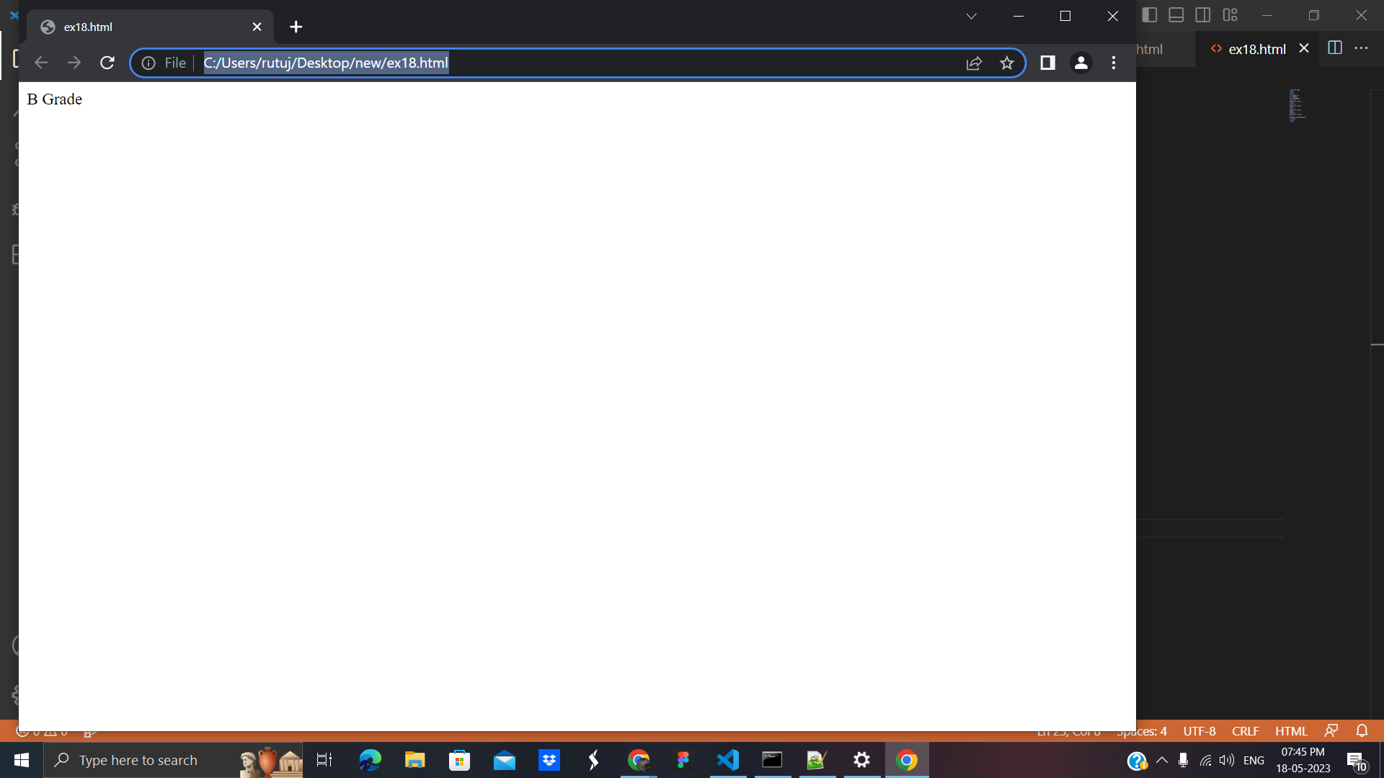

**Code:** now understand the behavior of switch statement in JavaScript.

<!DOCTYPE html>

<html>

<body>

<script>

var grade='B';

var result;

switch(grade){

case 'A':

result+=" A Grade";

case 'B':

result+=" B Grade";

case 'C':

result+=" C Grade";

default:

result+=" No Grade";

}

document.write(result);

</script>

</body>

</html>

**Output :**

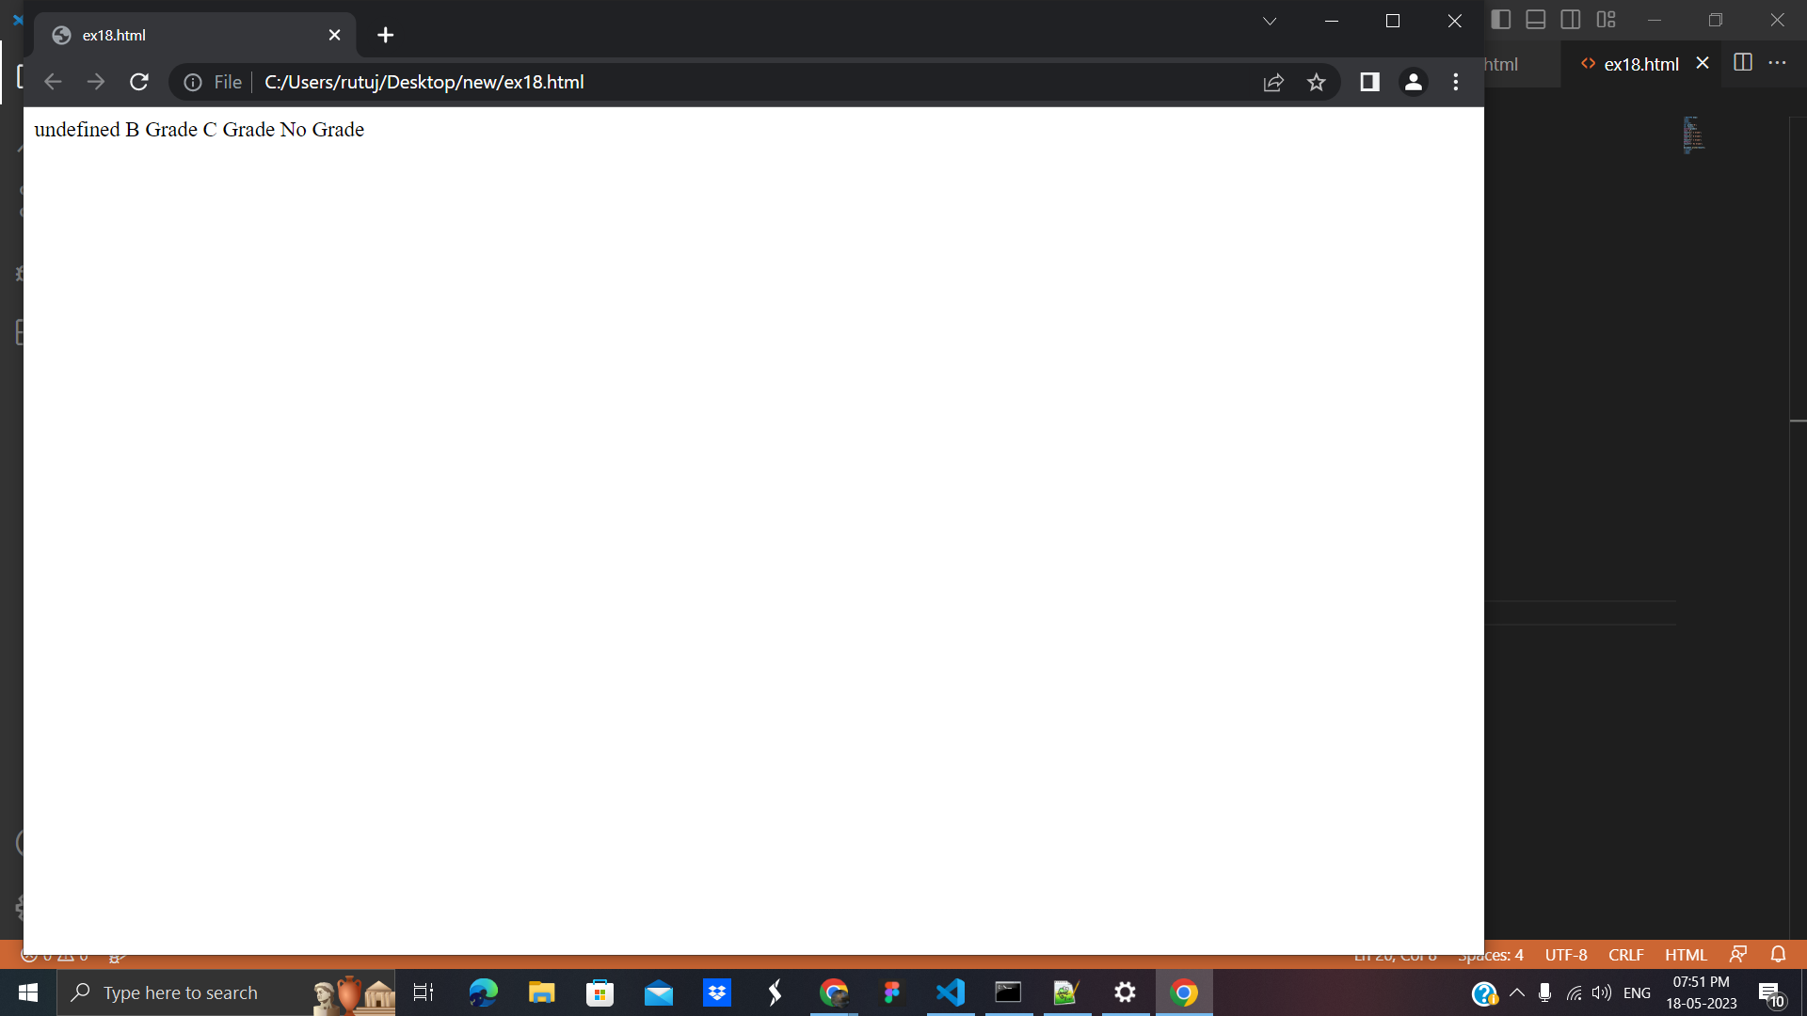

# **8. JavaScript Loops:**are used *to iterate the piece of code* using for, while, do while or for-in loops. It makes the code compact. It is mostly used in array.

There are four types of loops in JavaScript.

1. for loop
2. while loop
3. do-while loop
4. for-in loop

## **1) JavaScript For loop**

The **JavaScript for loop** *iterates the elements for the fixed number of times*. It should be used if number of iteration is known. The syntax of for loop is given below.

**Code:**

<!DOCTYPE html>

<html>

<body>

<script>

for (i=1; i<=5; i++)

{

document.write(i + "<br/>")

}

</script>

</body>

</html>

**Output**:

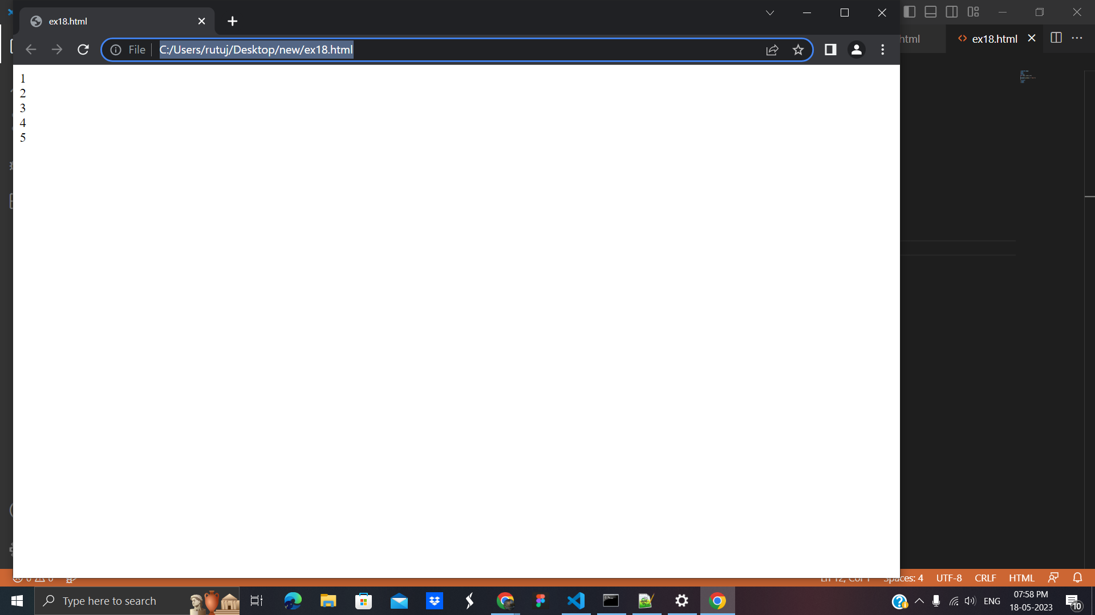

**2. Javascript while loop:** *iterates the elements for the infinite number of times*. It should be used if number of iteration is not known. The syntax of while loop is given below.

**Code:**

<!DOCTYPE html>

<html>

<body>

<script>

var i=11;

while (i<=15)

{

document.write(i + "<br/>");

i++;

}

</script>

</body>

</html>

**Output**:

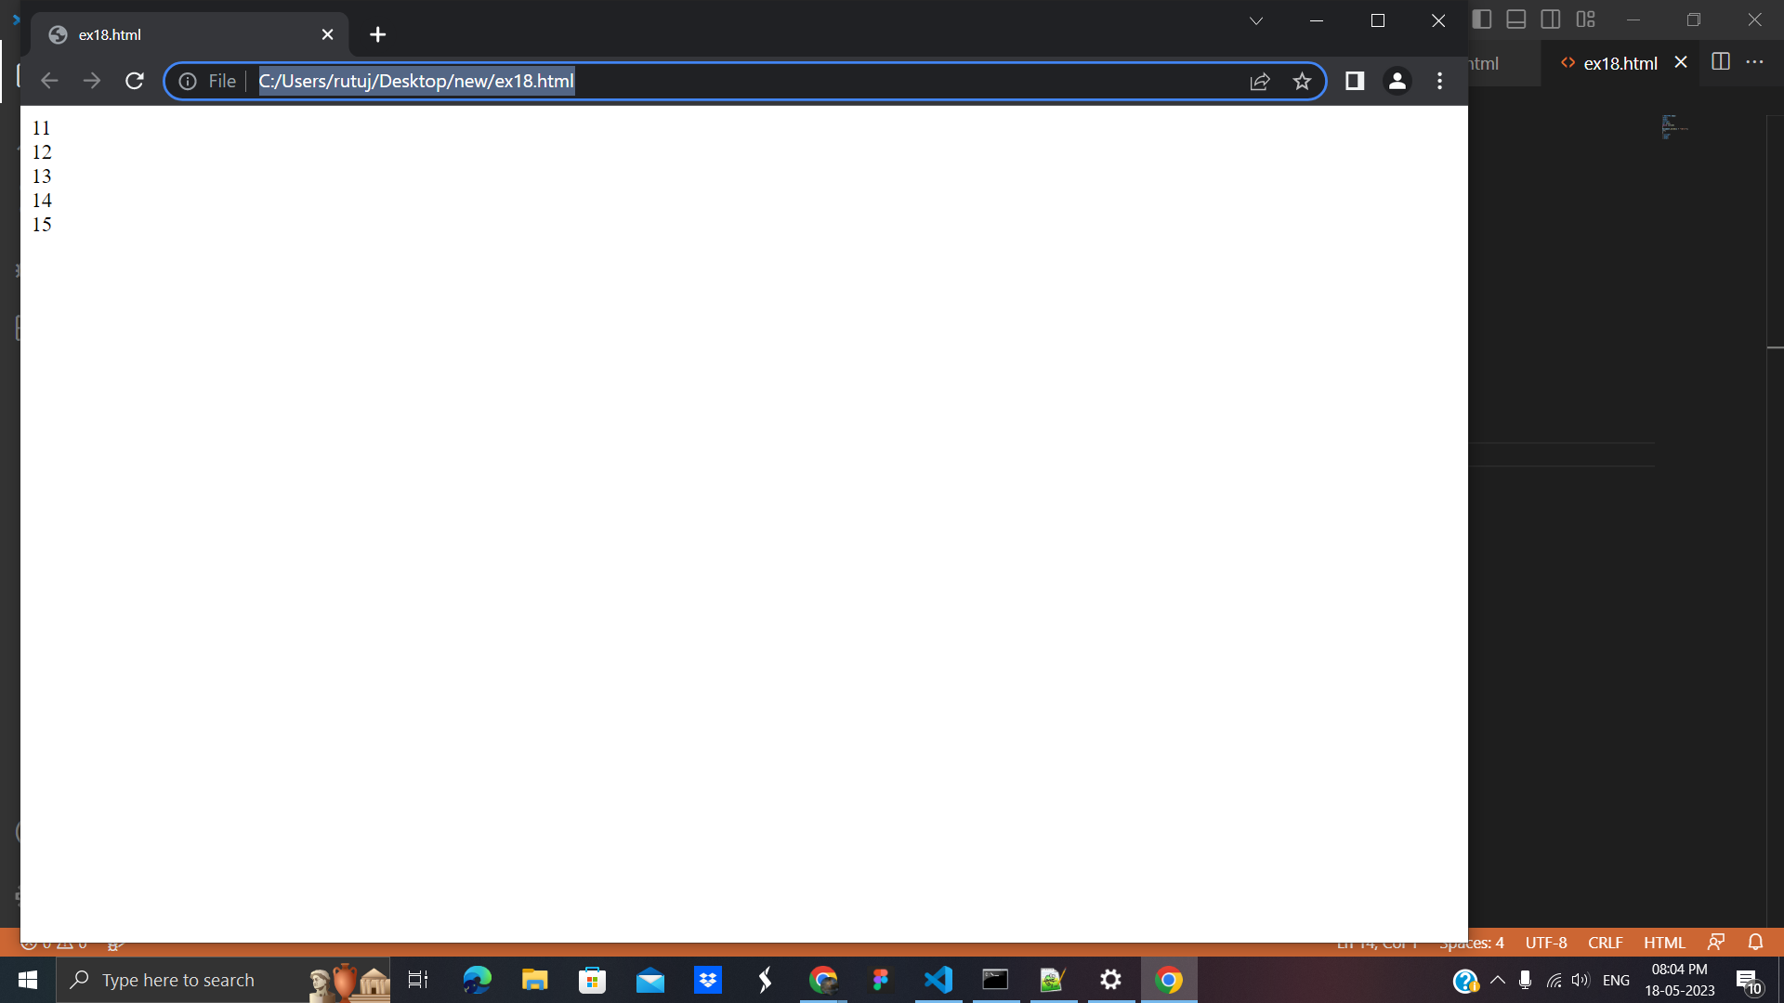

**3. do-while loop:** *iterates the elements for the infinite number of times* like while loop. But, code is *executed at least* once whether condition is true or false. The syntax of do while loop is given below

**Code**:

<!DOCTYPE html>

<html>

<body>

<script>

var i=21;

do{

document.write(i + "<br/>");

i++;

}while (i<=25);

</script>

</body>

</html>

**Output**:

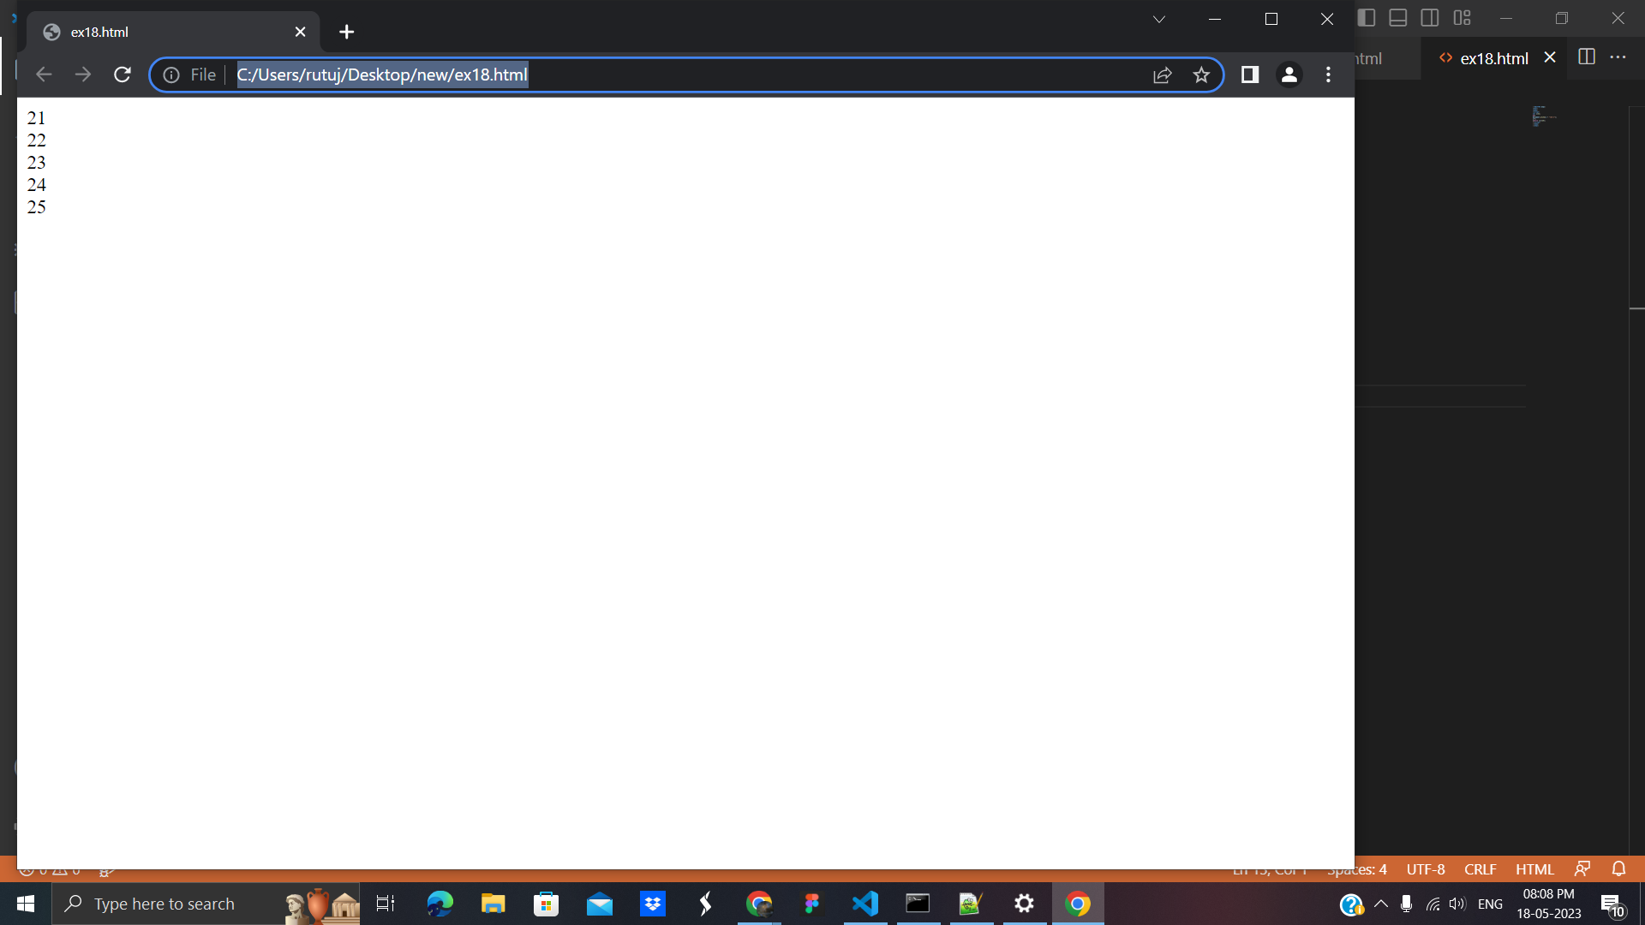

**4. for-in loop:** is used *to iterate the properties of an object*.

**Code**:

<html>

<body>

<p id="val"></p>

<script>

//declaring a object employee

const courses = {firstCourse:'JavaScript',

secondCourse:'React',

thirdCourse:'Angular'};

let value = '';

//using for in loop

for (let item in courses) {

value += courses[item] + '<br>';

}

document.getElementById("val").innerHTML = value;

</script>

</body>

</html>

**Output:**

: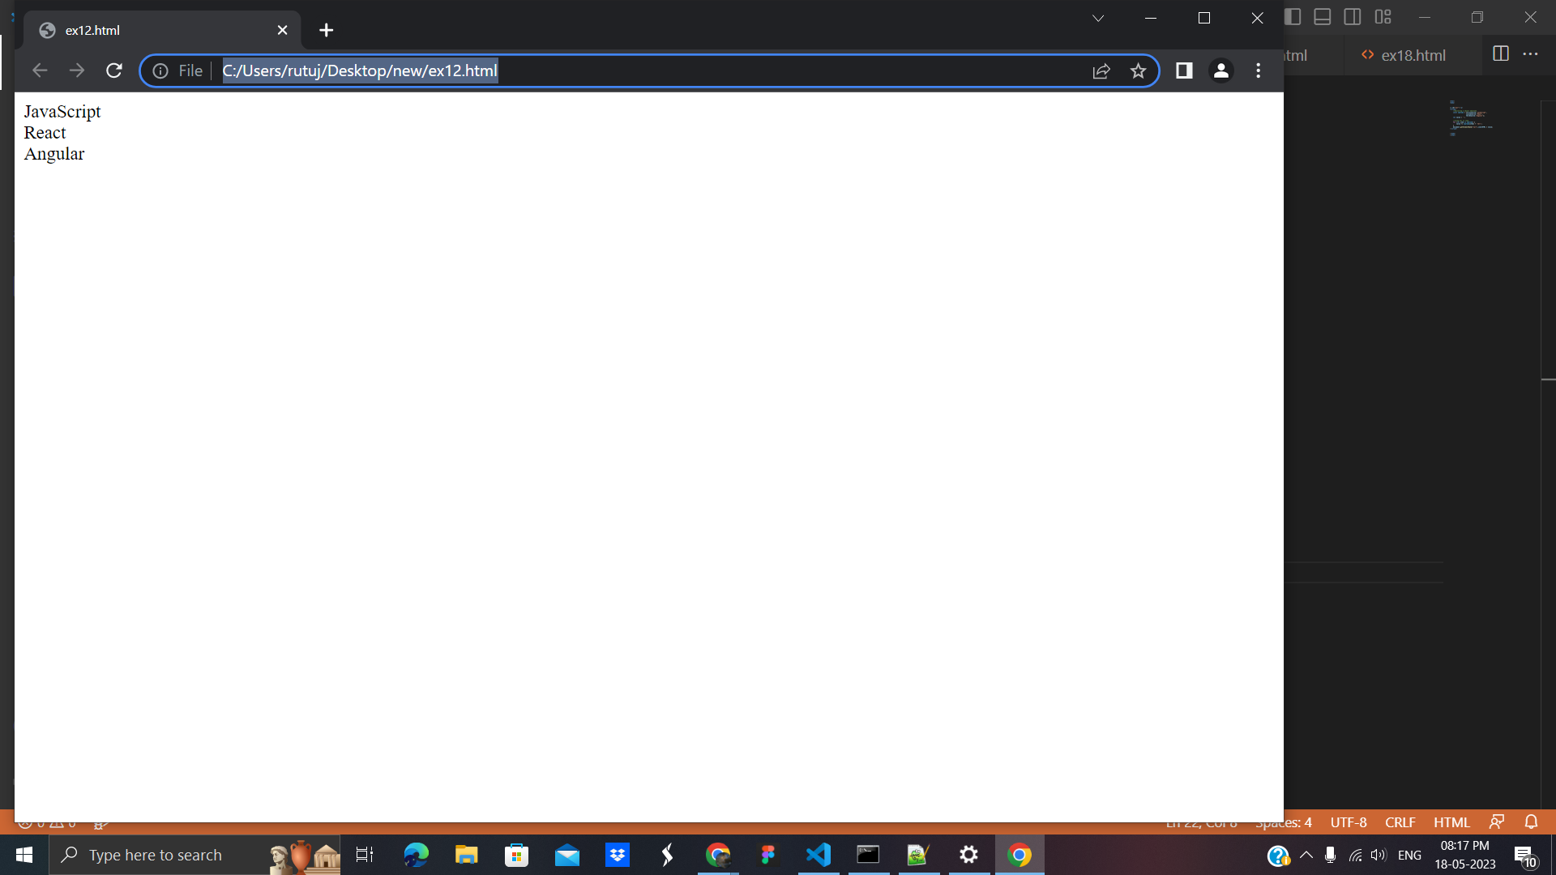

# **9. JavaScript Functions:**are used to perform operations. We can call JavaScript function many times to reuse the code.

There are mainly two advantages of JavaScript functions.

1. Code reusability.
2. Less coding

## **JavaScript Function Example with no argument:**

<html>

<body>

<script>

function msg(){

alert("hello! Welcome");

}

</script>

<input type="button" onclick="msg()" value="call function"/>

</body>

</html>

**Output:**

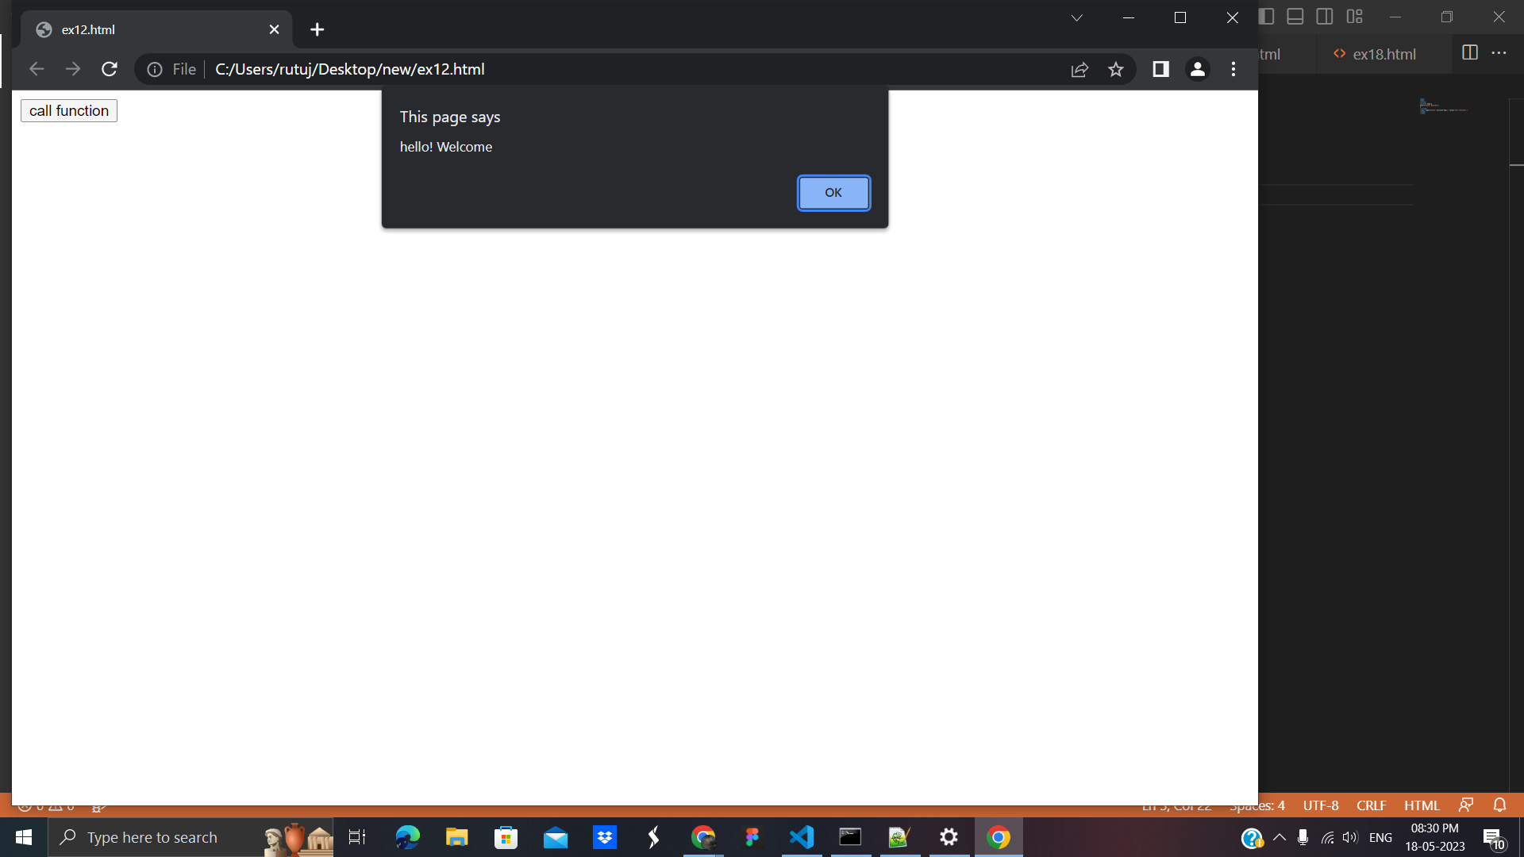

## **10. JavaScript Function with Arguments**

<html>

<body>

<script>

function getcube(number){

alert(number*number*number);

}

</script>

<form>

<input type="button" value="click" onclick="getcube(4)"/>

</form>

</body>

</html>

**Output**:

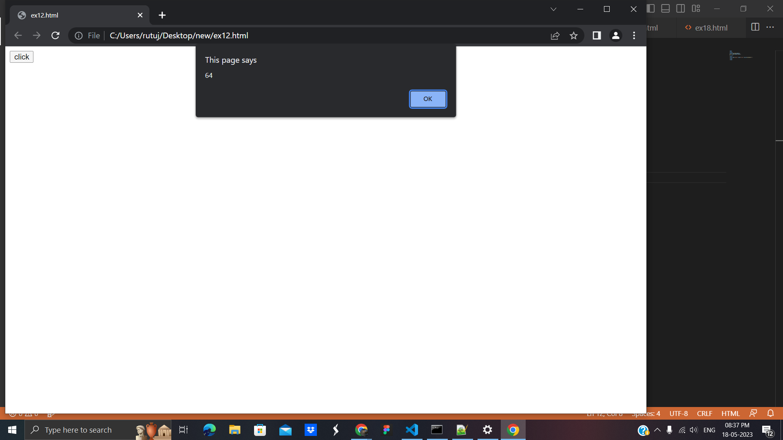

## **Function with Return Value**

<html>

<body>

<script>

function getInfo(){

return "hello Rutuja How r u?";

}

</script>

<script>

document.write(getInfo());

</script>

</body>

</html>

**Output**:

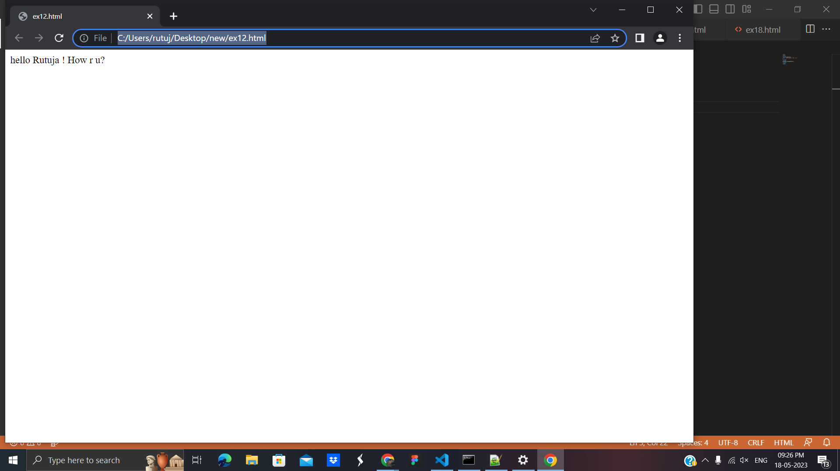

## **JavaScript Function Object:** In JavaScript, the purpose of Function constructor is to create a new Function object. It executes the code globally. However, if we call the constructor directly, a function is created dynamically but in an unsecured way.

## **Syntax :** new Function ([arg1[, arg2[, ....argn]],] functionBody) .

# **11. JavaScript Objects:**is an entity having state and behavior (properties and method). For example: car, pen, bike, chair, glass, keyboard, monitor etc.

## **Creating Objects in JavaScript**: There are 3 ways to create objects.

1. By object literal
2. By creating instance of Object directly (using new keyword)
3. By using an object constructor (using new keyword)

**1.By object literal:**

**Example:**

<html>

<body>

<script>

emp={id:102,name:"Rutuja Khedkar",salary:40000}

document.write(emp.id+" "+emp.name+" "+emp.salary);

</script>

</body>

</html>

**Output:**

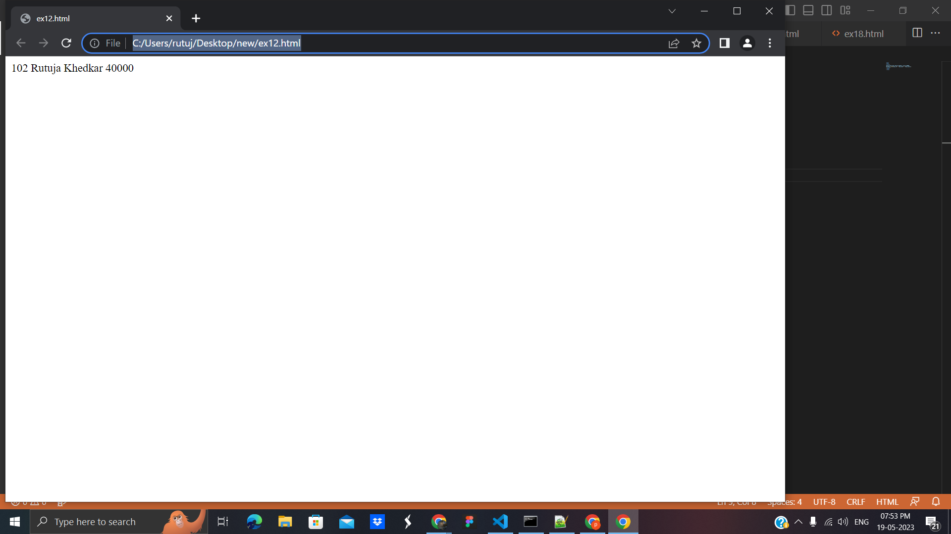

**2.By creating instance of Object directly (using new keyword)**

**Example :**

<html>

<body>

<script>

var emp=new Object();

emp.id=101;

emp.name="Rutuja Khedkar";

emp.salary=50000;

document.write(emp.id+" "+emp.name+" "+emp.salary);

</script>

</body>

</html>

**Output:**

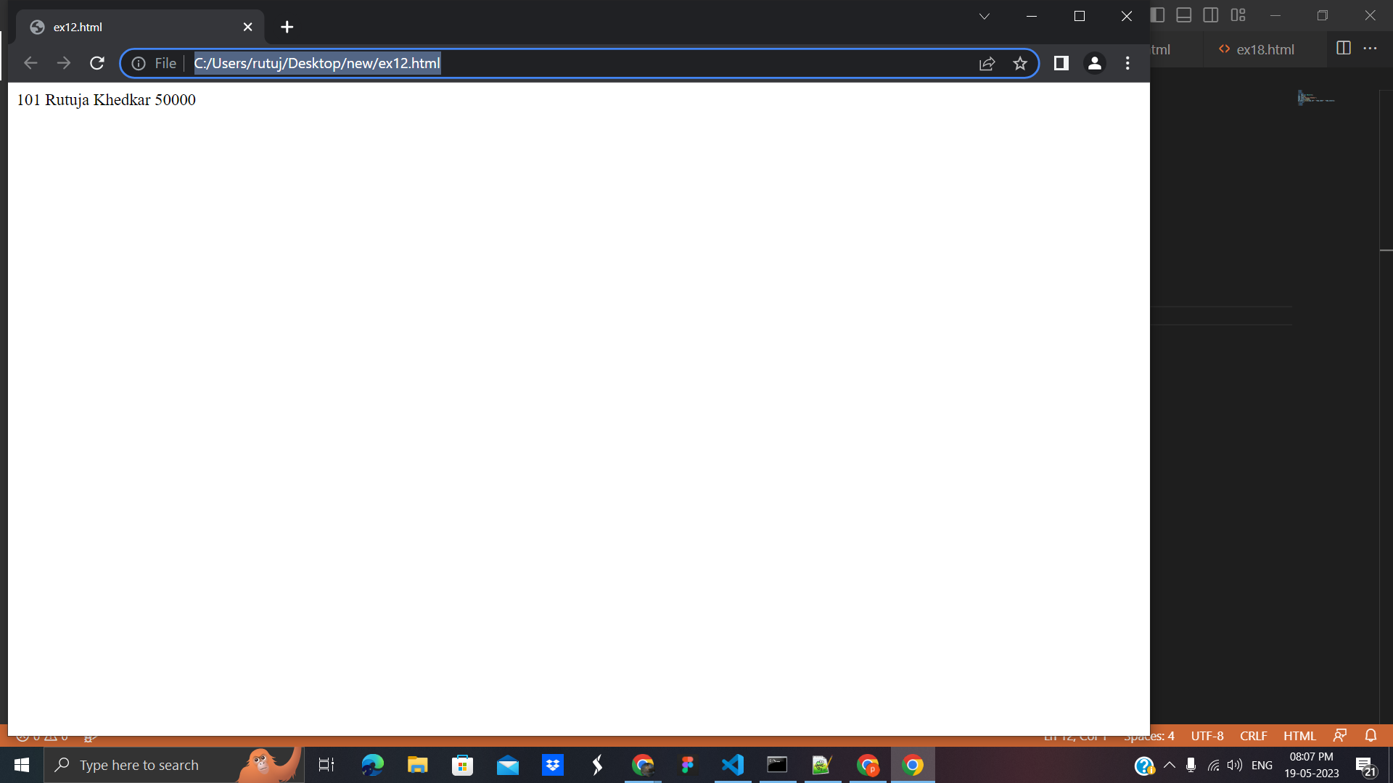

**3.By using an object constructor (using new keyword):**

**Example**:

<html>

<body>

<script>

function emp(id,name,salary){

this.id=id;

this.name=name;

this.salary=salary;

}

e=new emp(103,"Rutuja Khedkarl",30000);

document.write(e.id+" "+e.name+" "+e.salary);

</script>

</body>

</html>

**Output**:

: 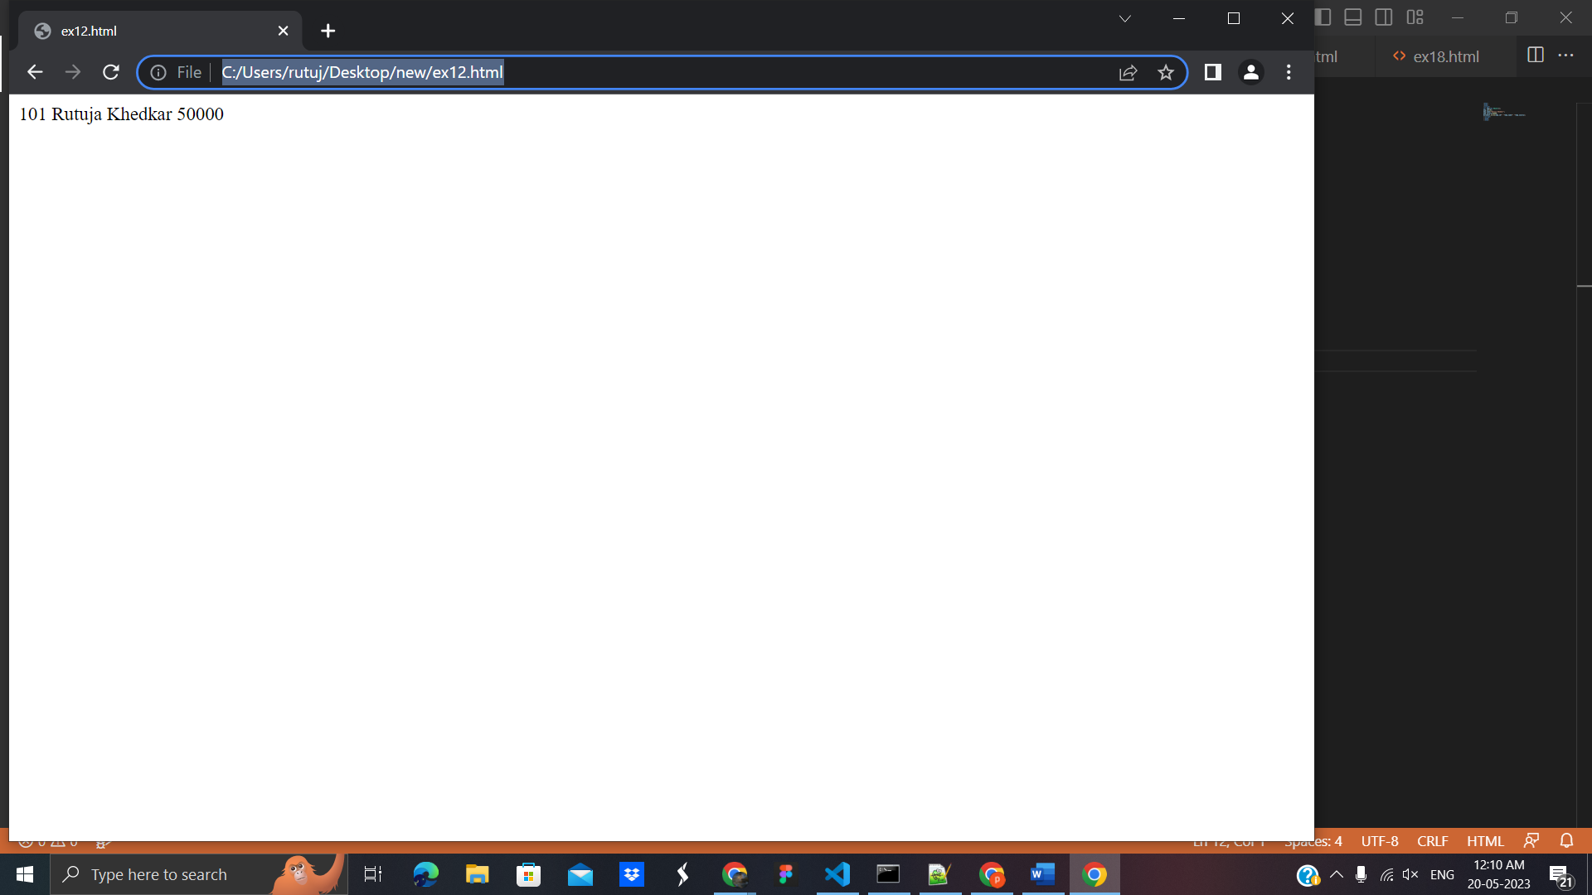

## **12. Defining method in JavaScript Object:**

We can define method in JavaScript object. But before defining a method, we need to add property in the function with same name as method.

**Example**:

<html>

<body>

<script>

function emp(id,name,salary){

this.id=id;

this.name=name;

this.salary=salary;

this.changeSalary=changeSalary;

function changeSalary(otherSalary){

this.salary=otherSalary;

}

}

e=new emp(103,"Rutuja Khedkar",30000);

document.write(e.id+" "+e.name+" "+e.salary);

e.changeSalary(45000);

document.write("<br>"+e.id+" "+e.name+" "+e.salary);

</script>

</body>

</html>

**Output**:

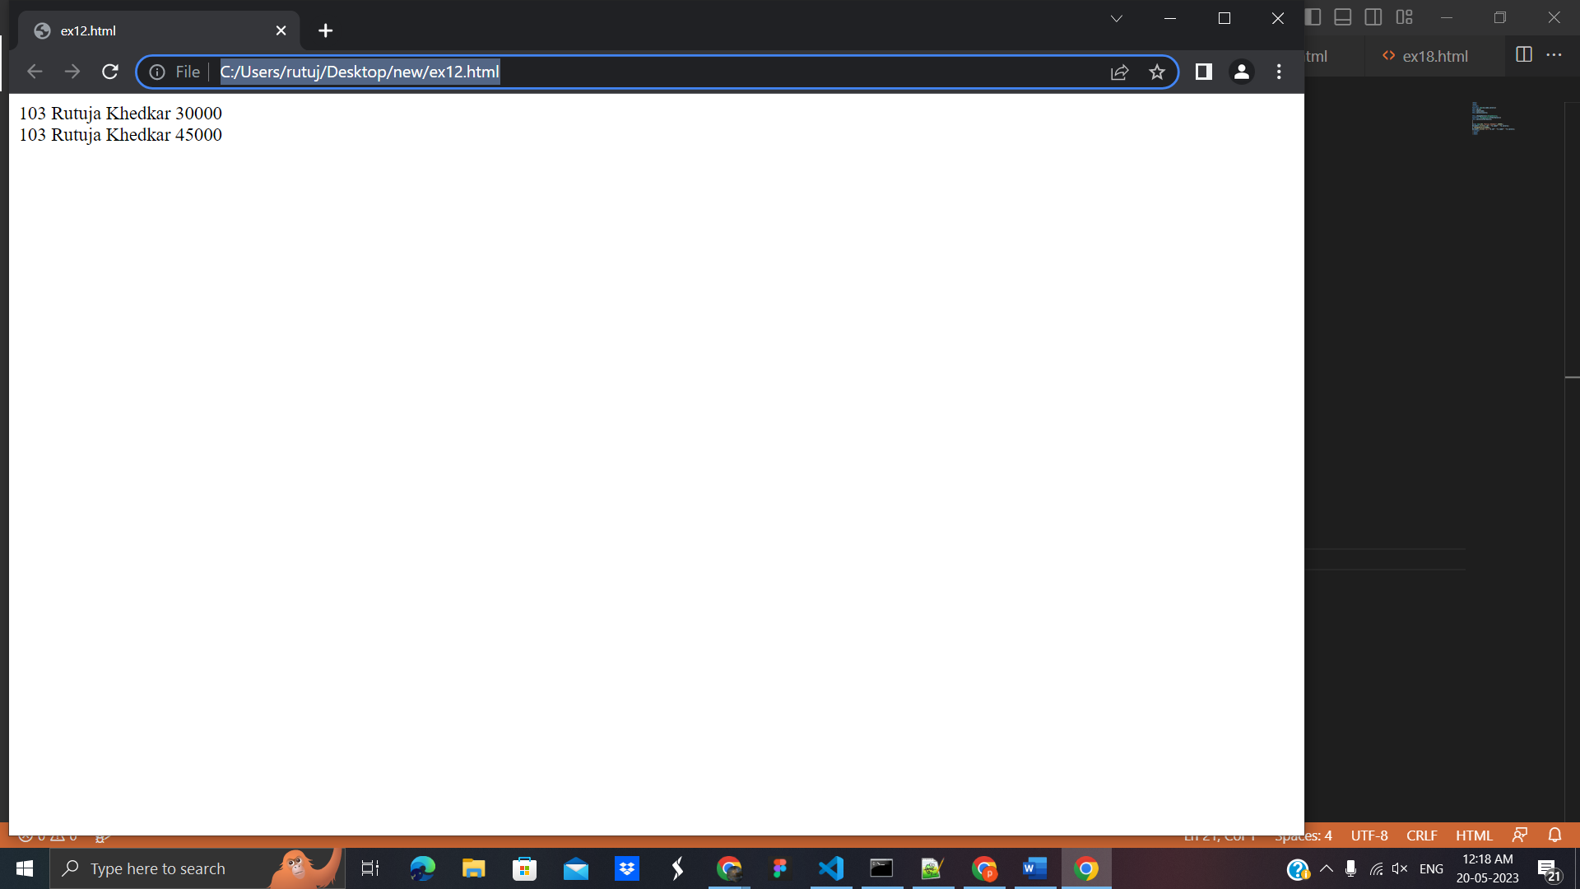

**13. Javascript Array :** is an object that represents a collection of similar type of elements.

There are 3 ways to construct array in JavaScript

1. By array literal
2. By creating instance of Array directly (using new keyword)
3. By using an Array constructor (using new keyword)

## **1) JavaScript array literal**

**Example:**

<html>

<body>

<script>

var emp=["Rutuja","Khedkar","Ratan"];

for (i=0;i<emp.length;i++){

document.write(emp[i] + "<br/>");

}

</script>

</body>

</html>

**Output**:

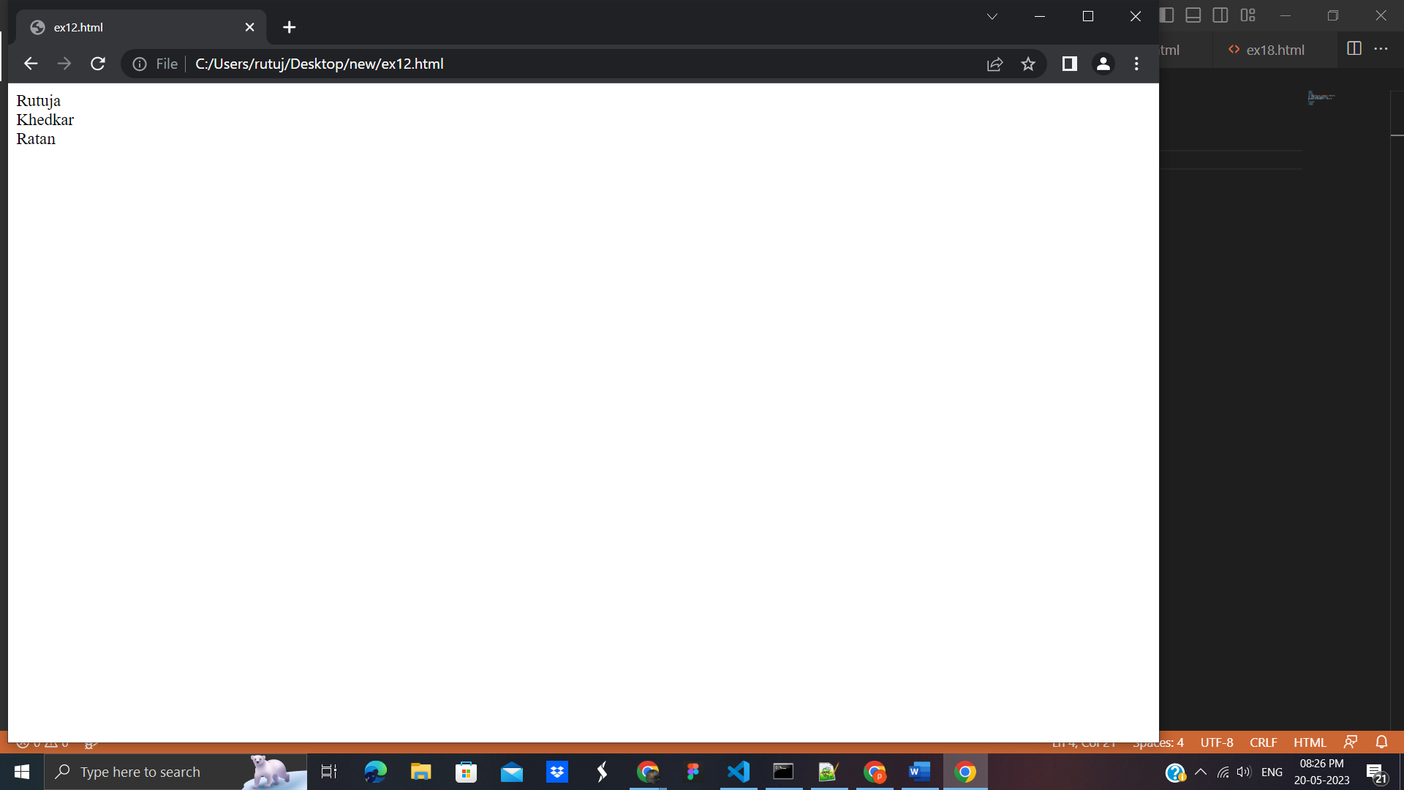

## **2) JavaScript Array directly (new keyword):**

<html>

<body>

<script>

var i;

var emp = new Array();

emp[0] = "Rutu";

emp[1] = "AANi";

emp[2] = "ANU";

for (i=0;i<emp.length;i++){

document.write(emp[i] + "<br>");

}

</script>

</body>

</html>

**Output**:

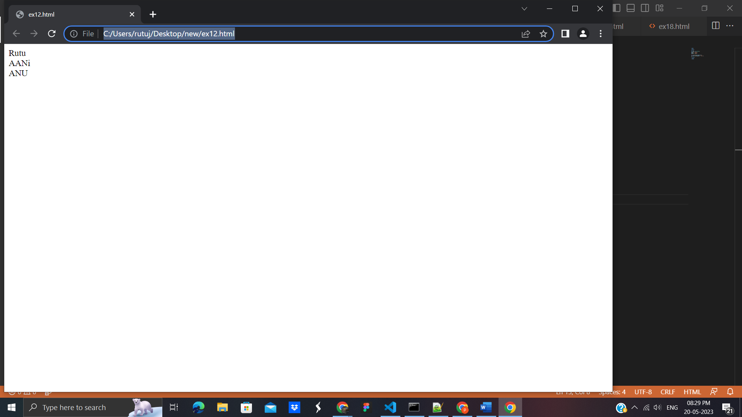

## **3) JavaScript array constructor (new keyword):** Here, you need to createinstance of array by passing arguments in constructor so that we don't have to provide value explicitly.

**Example**:

<html>

<body>

<script>

var emp=new Array("Jai","Vijay","Smith");

for (i=0;i<emp.length;i++){

document.write(emp[i] + "<br>");

}

</script>

</body>

</html>

**Output**:

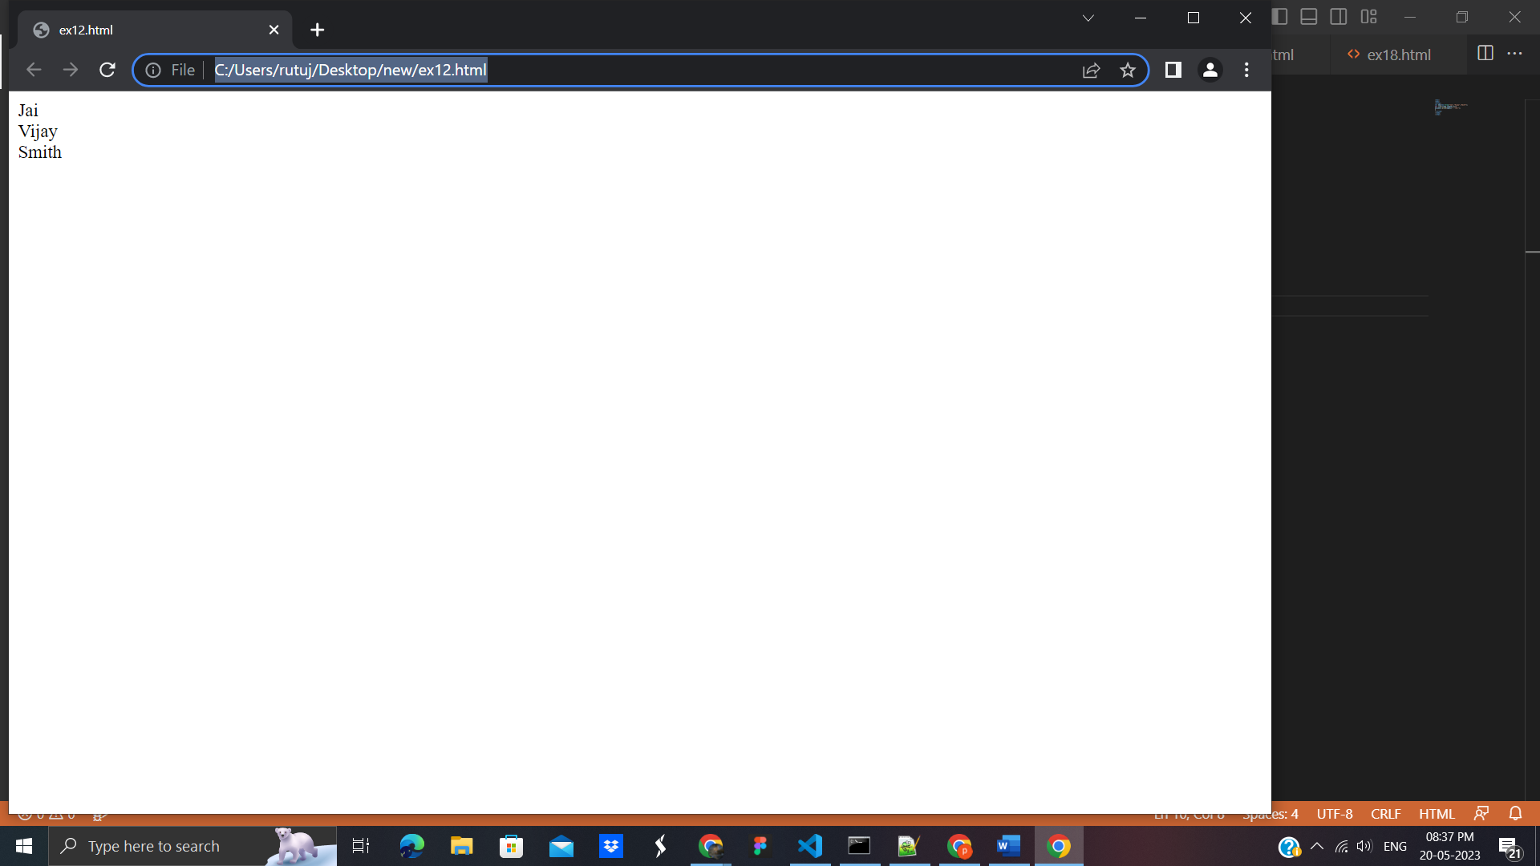

# **14. JavaScript String:** The JavaScript string is an object that represents a sequence of characters**.**

There are 2 ways to create string in JavaScript

1. By string literal
2. By string object (using new keyword)

## 1) By string literal

The string literal is created using double quotes

**Example**:

<!DOCTYPE html>

<html>

<body>

<script>

var str="This is string literal";

document.write(str);

</script>

</body>

</html>

**Output**:

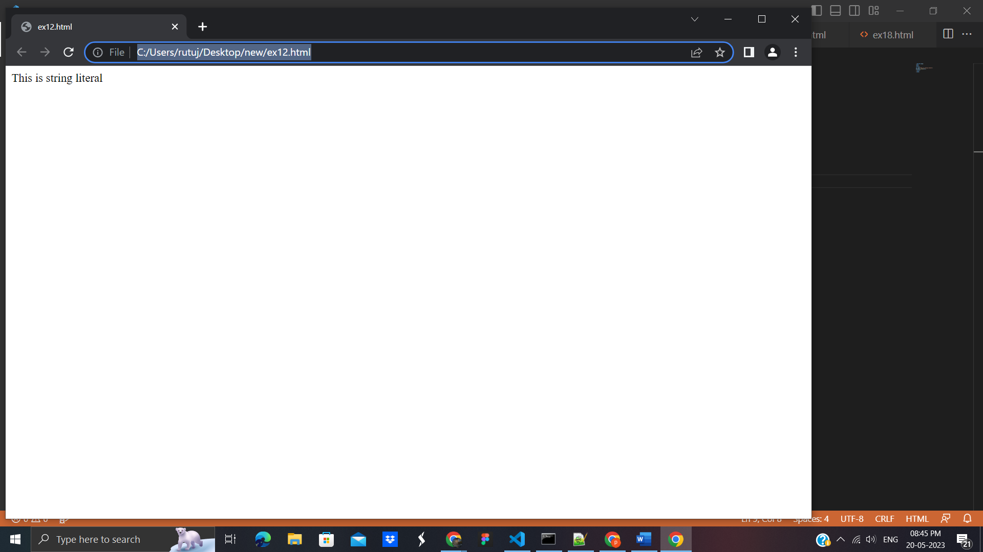

## **2) By string object (using new keyword)**

**Example**:

<!DOCTYPE html>

<html>

<body>

<script>

var stringname=new String("hello javascript string");

document.write(stringname);

</script>

</body>

</html>

**Output**:

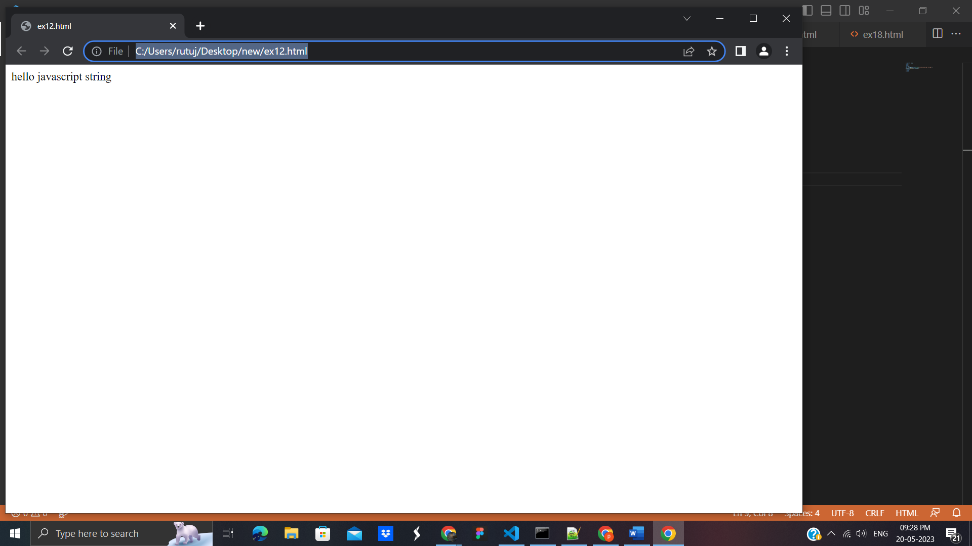

## 1) JavaScript String charAt(index) Method

**Example** :

<!DOCTYPE html>

<html>

<body>

<script>

var str="javascript";

document.write(str.charAt(2));

</script>

</body>

</html>

**Output**:

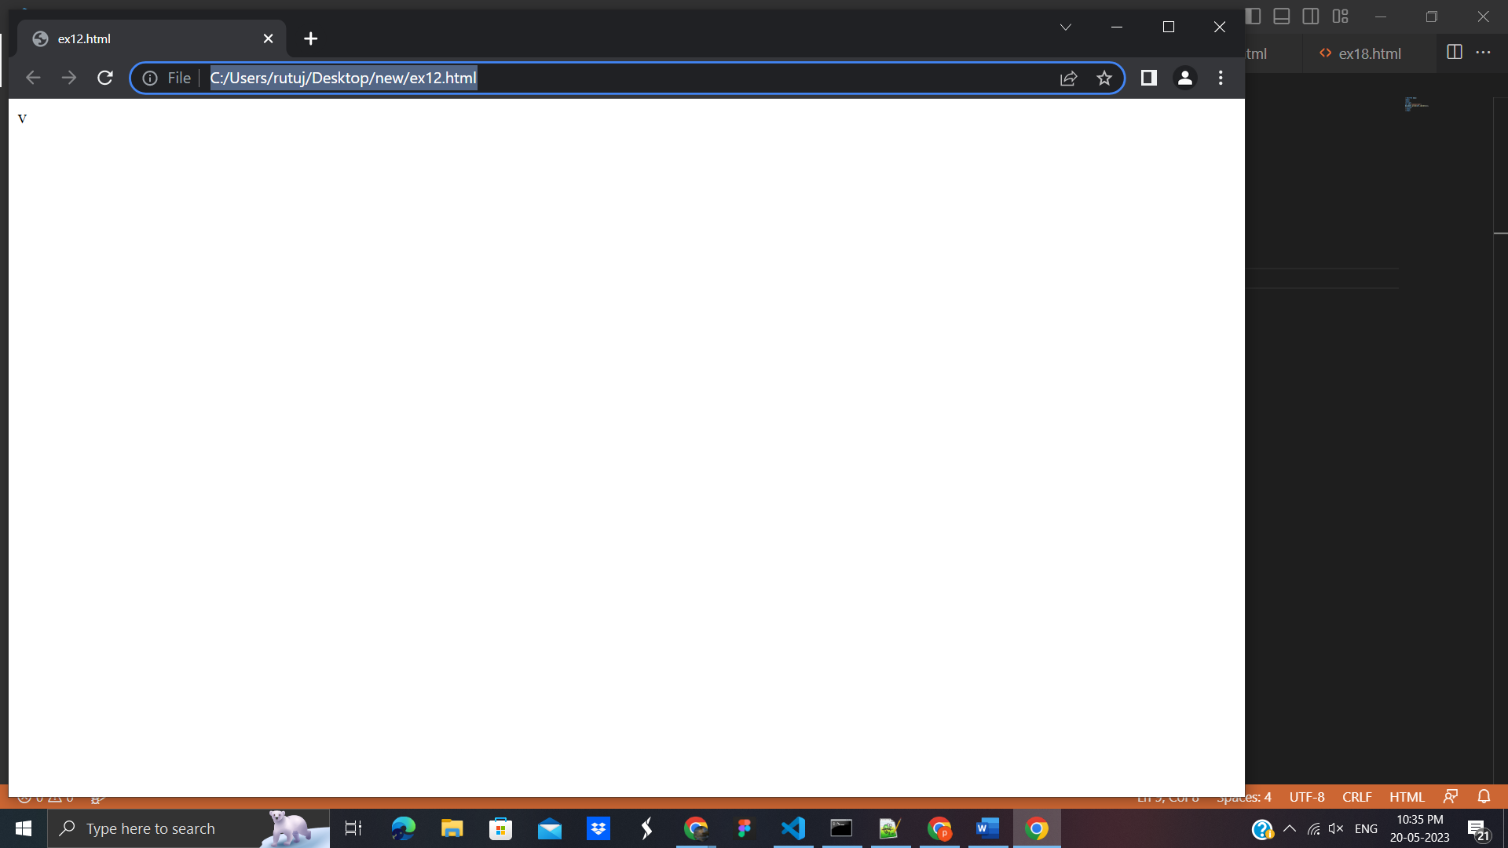

## 2) JavaScript String concat(str) Method

**Example**:

<!DOCTYPE html>

<html>

<body>

<script>

var s1="javascript ";

var s2="concat example";

var s3=s1+s2;

document.write(s3);

</script>

</body>

</html>

**Output**:

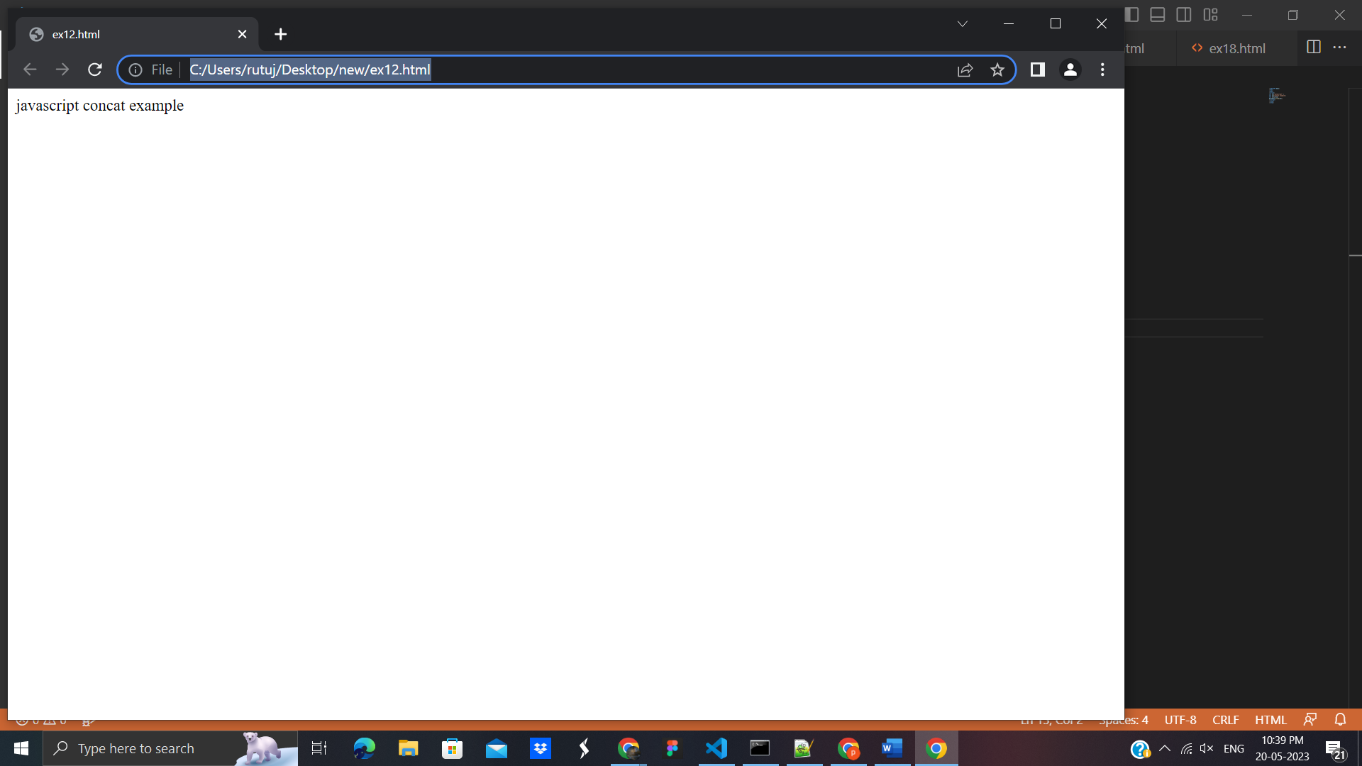

## **15. JavaScript BOM**

The **Browser Object Model** (BOM) is used to interact with the browser.

he default object of browser is window means you can call all the functions of window by specifying window or directly. For example:

window.alert("hello javatpoint");

is same as:

alert("hello javatpoint");

**1.Window Object:** Window is the object of browser, it is not the object of javascript. The javascript objects are string, array, date etc.

## **Methods of window object**

1.alert() in javascript

**Example**:

<!DOCTYPE html>

<html>

<body>

<script type="text/javascript">

function msg(){

alert("Hello Alert Box");

}

</script>

<input type="button" value="click" onclick="msg()"/>

</body>

</html>

**Output**:

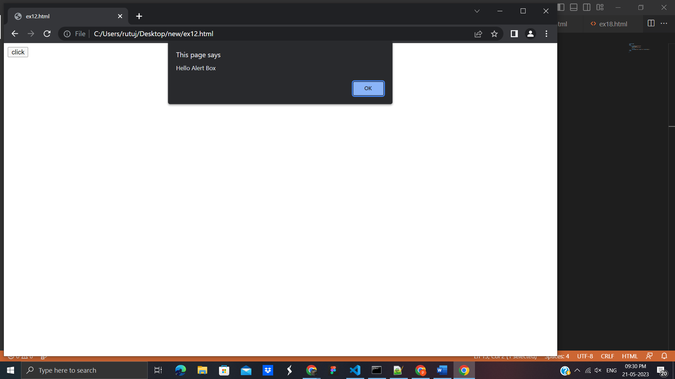

**2.confirm() in javascript:**

**Example:**

<script type="text/javascript">

function msg(){

var v= confirm("Are u sure?");

if(v==true){

alert("ok");

}

else{

alert("cancel");

}

}

</script>

<input type="button" value="delete record" onclick="msg()"/>

**Output:**

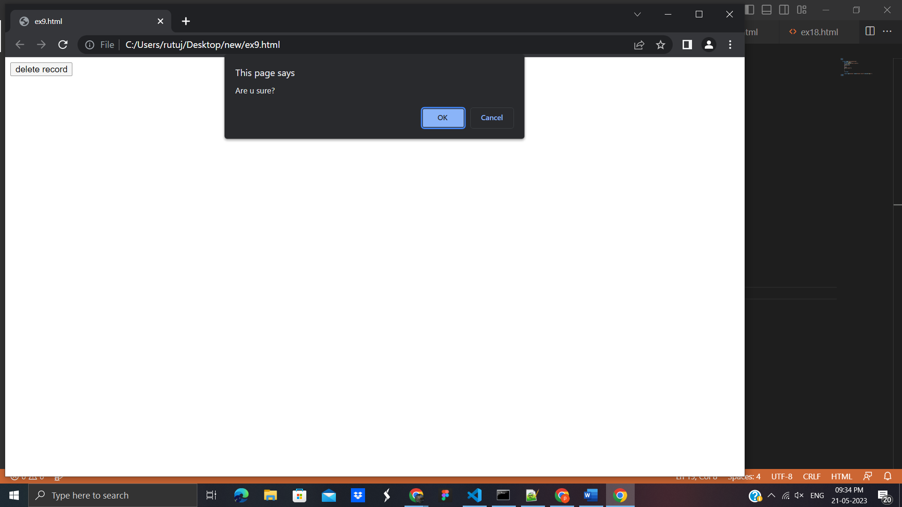

**3. prompt() in javascript**

<html>

<body>

<script type="text/javascript">

function msg(){

var v= prompt("Who are you?");

alert("I am "+v);

}

</script>

<input type="button" value="click" onclick="msg()"/>

</body>

</html>

**Output**:

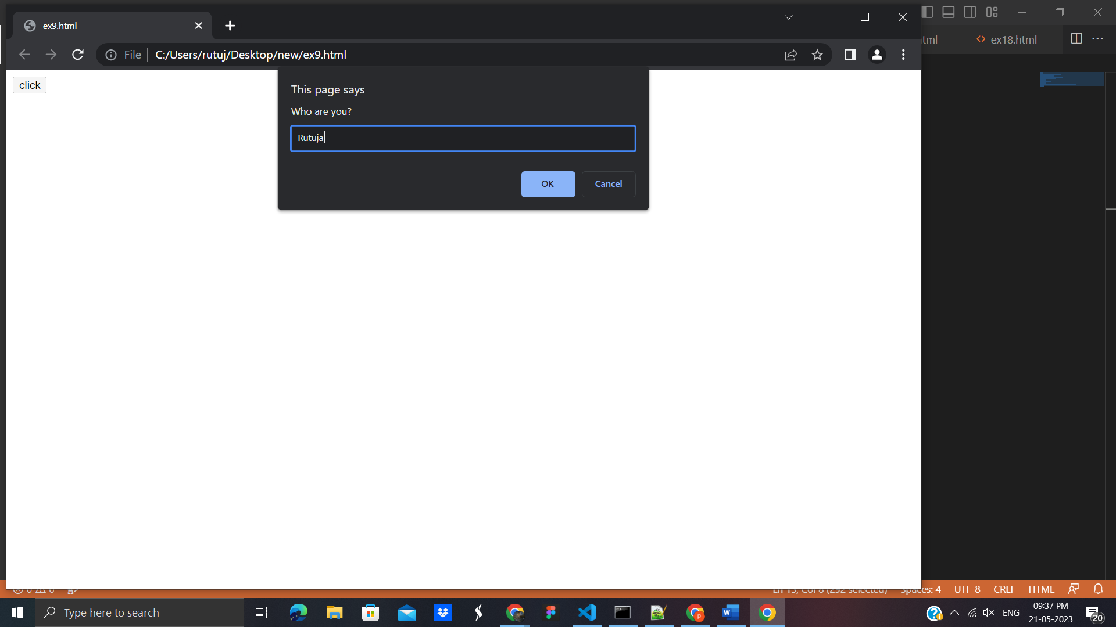

**4.open() in javascript**

<html>

<body>

<script type="text/javascript">

function msg(){

open("http://www.ecerasystem.com"); }

</script>

<input type="button" value="javatpoint" onclick="msg()"/>

</body>

</html>

**Output**:

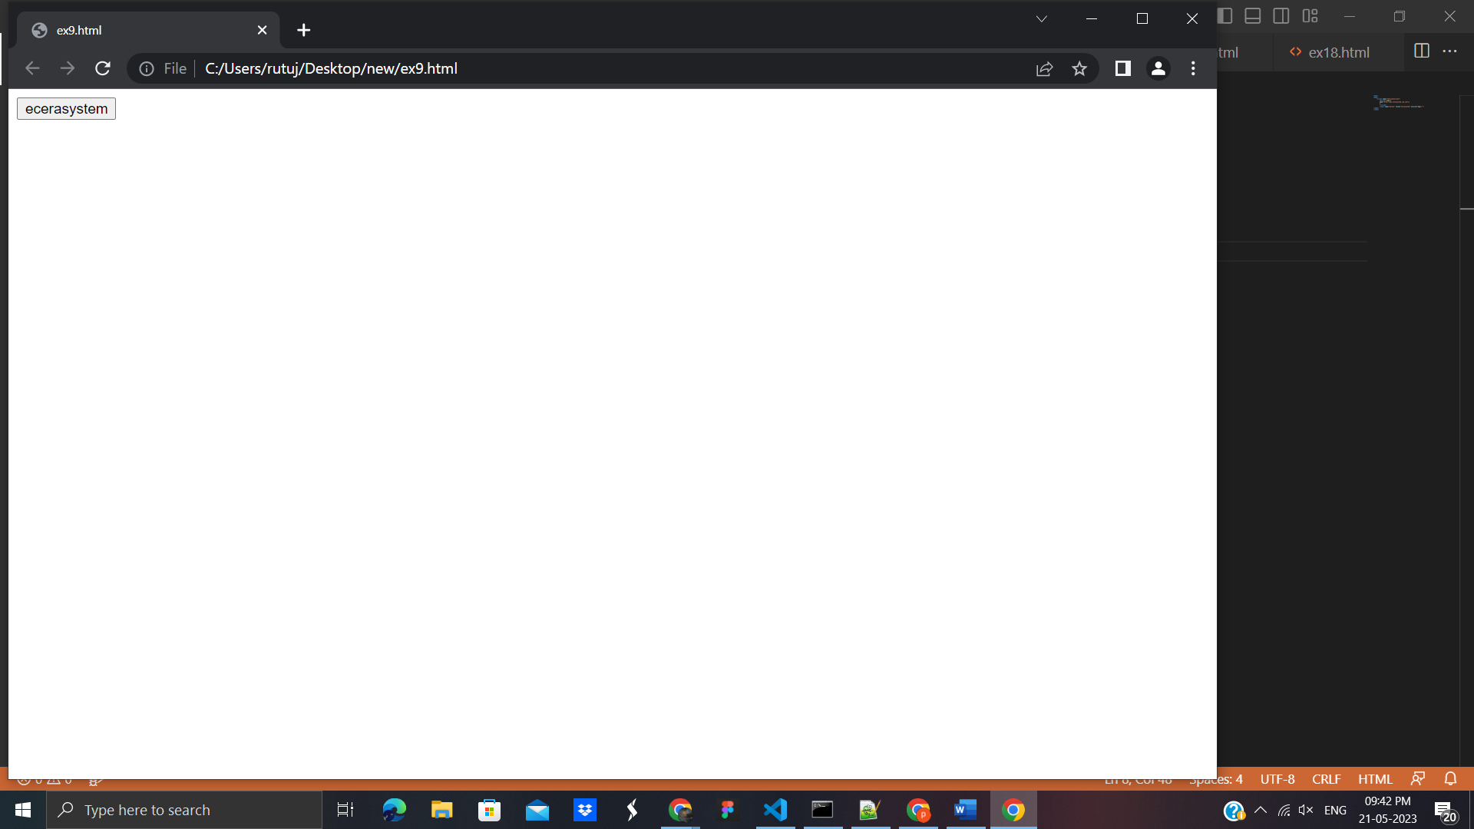

**5.setTimeout() in javascript:** It performs its task after the given milliseconds.

<html>

<body>

<script type="text/javascript">

function msg(){

setTimeout(

function(){

alert("Welcome to ecera system after 2 seconds")

},2000);

}

</script>

<input type="button" value="click" onclick="msg()"/>

</body>

</html>

**Output**:

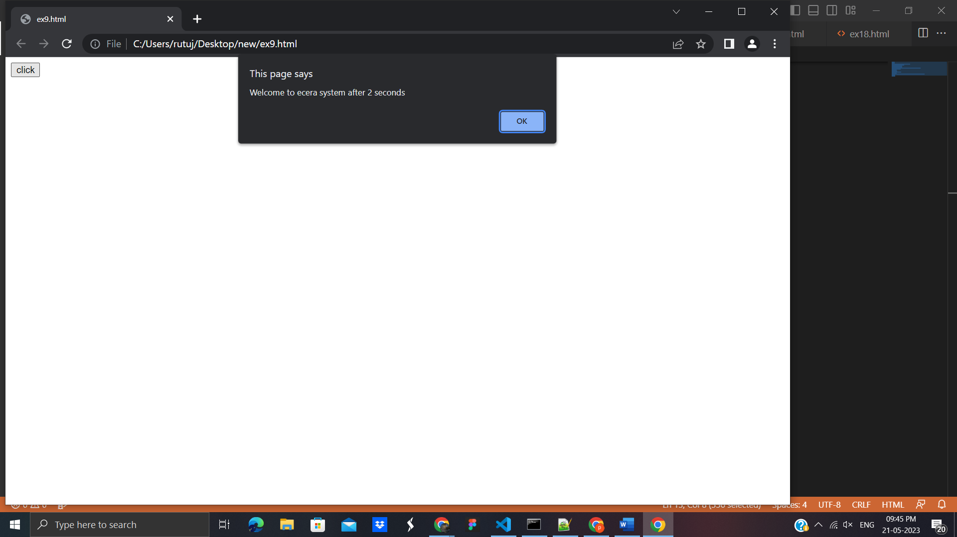



**2.JavaScript History Object**

The JavaScript history object represents an array of URLs visited by the user. By using this object, you can load previous, forward or any particular page.

## 

**Example:**

<!DOCTYPE html>

<html>

<body>

<h1>The Window History Object</h1>

<h2>The history.length Property</h2>

<p>Number of URLs in history list:</p>

<p id="demo"></p>

<p>Since this is a new window frame, history.length will always return 1.</p>

<script>

let length = history.length;

document.getElementById("demo").innerHTML = length;

</script>

</body>

</html>

**Output**:

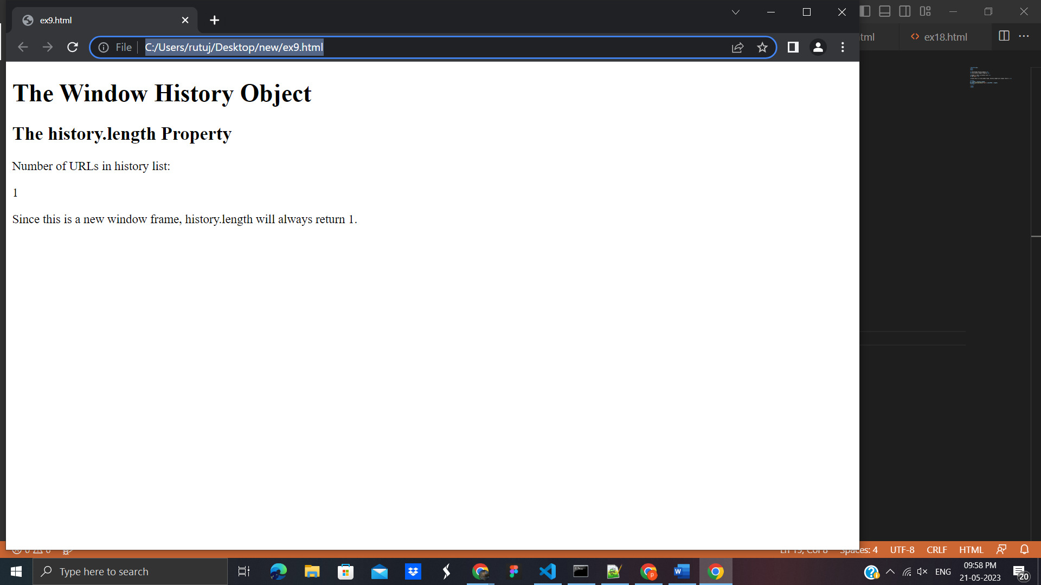

**1.Window history.back()**

**Example:**

<!DOCTYPE html>

<html>

<body>

<h1>The Window History Object</h1>

<h2>The history.back() Method</h2>

<button onclick="history.back()">Go Back</button>

<p>Clicking "Go Back" will not result in any action, because there is no previous page in the history list.</p>

</body>

</html>

**Output:**

<!DOCTYPE html>

<html>

<body>

<h1>The Window History Object</h1>

<h2>The history.back() Method</h2>

<button onclick="history.back()">Go Back</button>

<p>Clicking "Go Back" will not result in any action, because there is no previous page in the history list.</p>

</body>

</html>

**Output:**

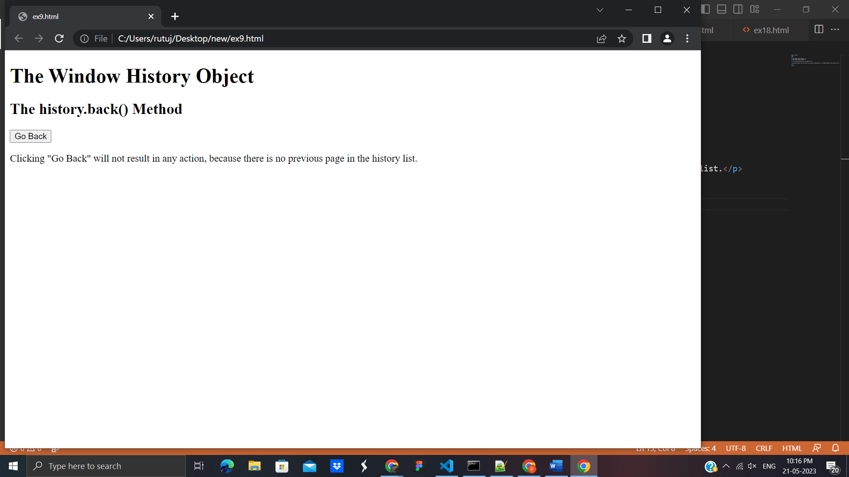

**2.Window history.forward()**

<!DOCTYPE html>

<html>

<body>

<h1>The Window History Object</h1>

<h2>The history.forward Method</h2>

<button onclick="history.forward()">Go Forward</button>

<p>Clicking "Go Forward" will not result in any action, because there is no next page in the history list.</p>

</body>

</html>

**Output**:

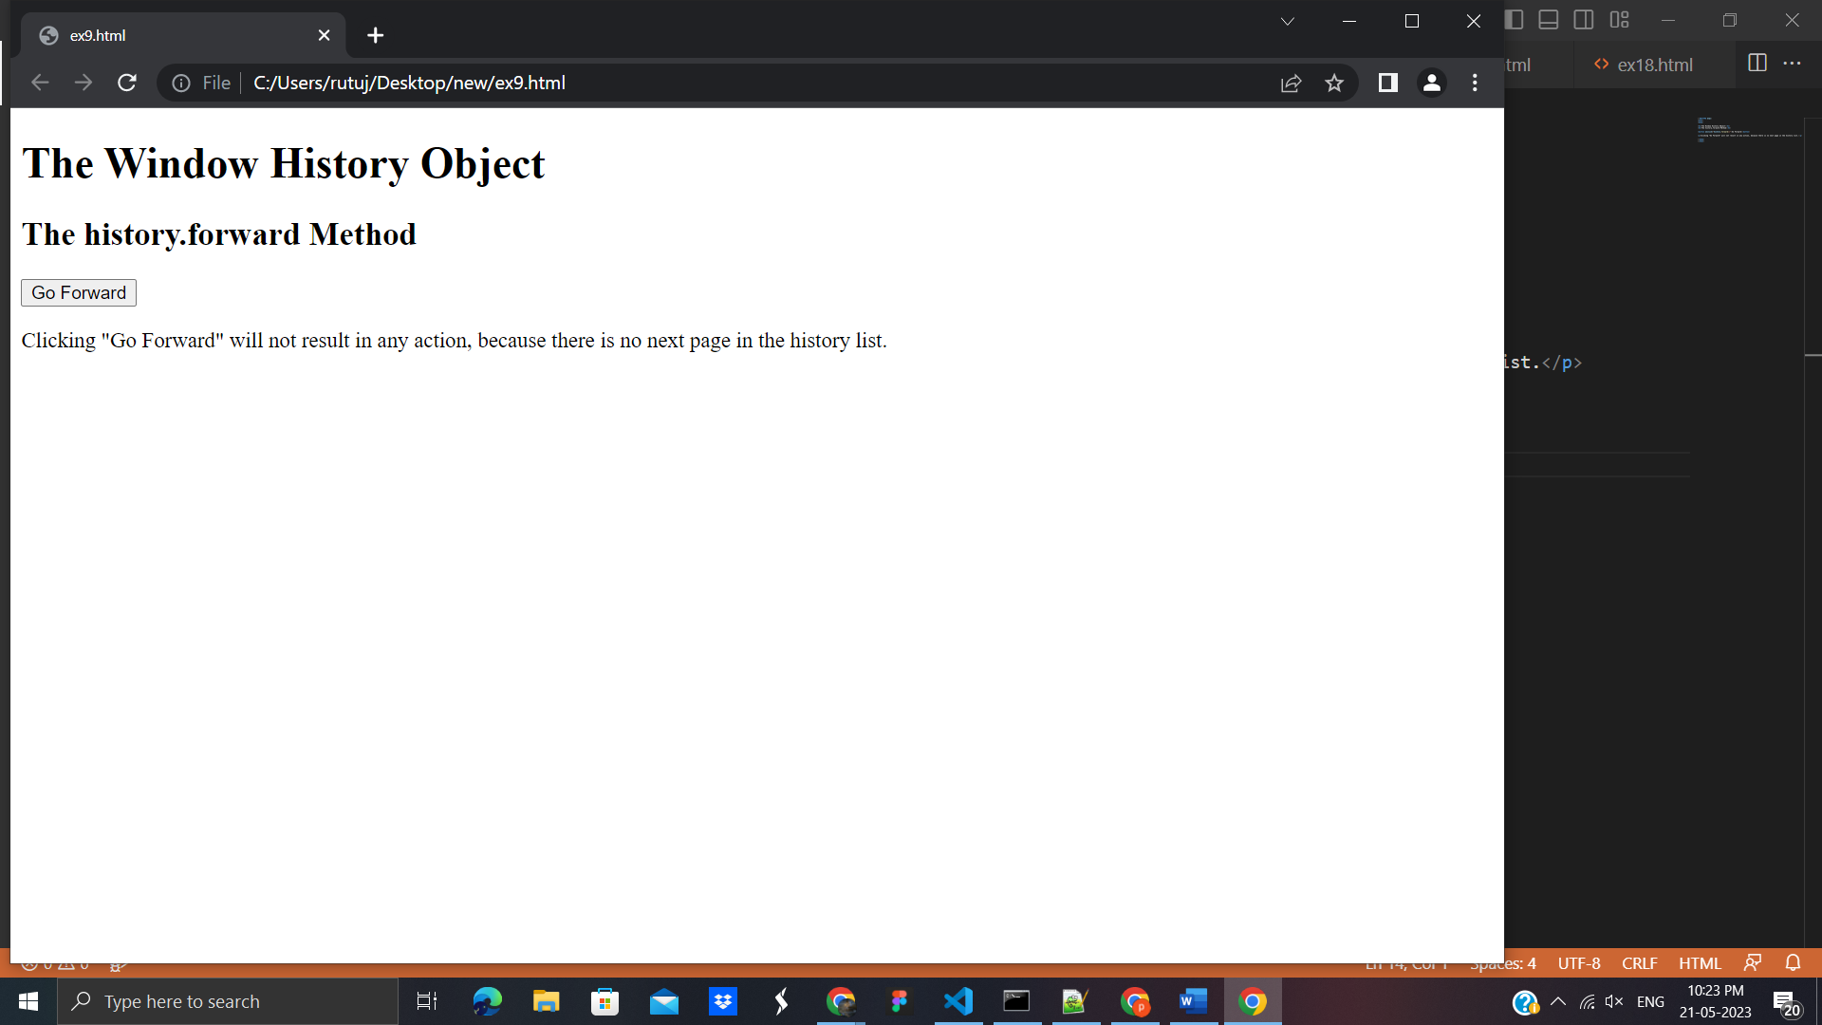

**3.Window history.go()**

**Example**:

<!DOCTYPE html>

<html>

<body>

<h1>The Window History Object</h1>

<h2>The history.go() Method</h2>

<button onclick="history.go(-2)">Go 2 pages back</button>

<p>Clicking on the "Go 2 pages back" will not result in any action, because there is no previous page in the history list.</p>

</body>

</html>

**Output:**

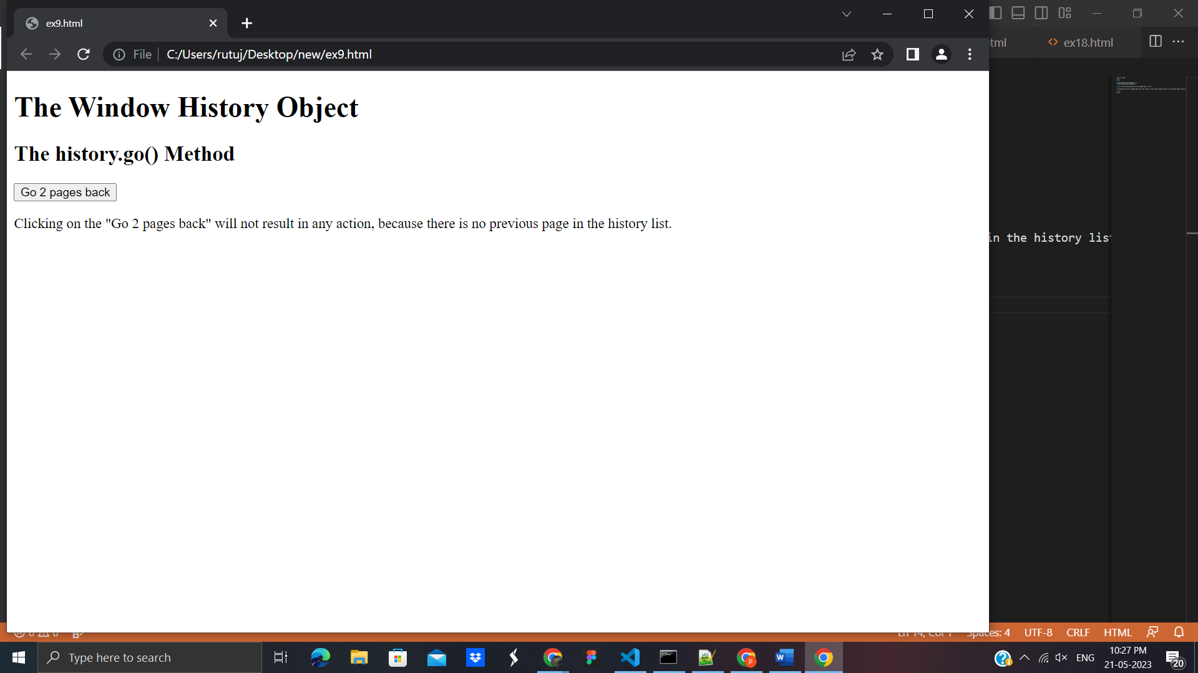

**16 .JavaScript Navigator Object**

The JavaScript navigator object is used for browser detection. It can be used to get browser information such as appName, appCodeName, userAgent etc.

#### Example of navigator object

<html>

<body>

<h2>JavaScript Navigator Object</h2>

<script>

document.writeln("<br/>navigator.appCodeName: "+navigator.appCodeName);

document.writeln("<br/>navigator.appName: "+navigator.appName);

document.writeln("<br/>navigator.appVersion: "+navigator.appVersion);

document.writeln("<br/>navigator.cookieEnabled: "+navigator.cookieEnabled);

document.writeln("<br/>navigator.language: "+navigator.language);

document.writeln("<br/>navigator.userAgent: "+navigator.userAgent);

document.writeln("<br/>navigator.platform: "+navigator.platform);

document.writeln("<br/>navigator.onLine: "+navigator.onLine);

</script>

</body>

</html>

**Output**:

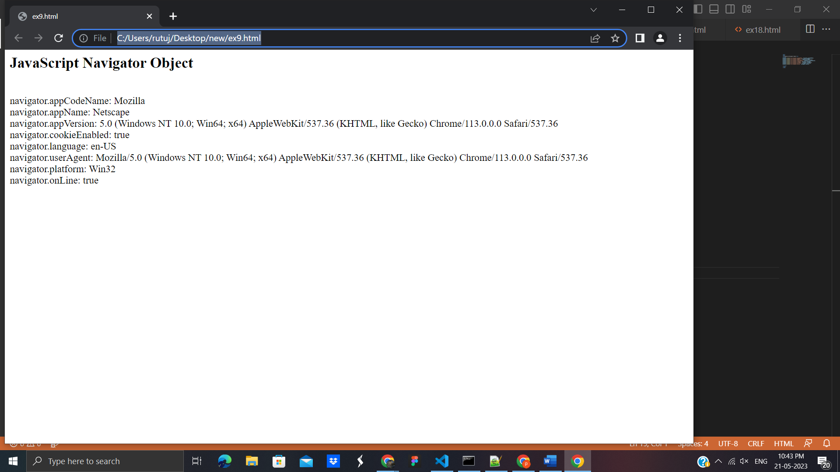

**17.JavaScript Screen Object**

The **JavaScript screen object** holds information of browser screen. It can be used to display screen width, height, colorDepth, pixelDepth etc.

#### Example of JavaScript Screen Object

<html>

<body>

<script>

document.writeln("<br/>screen.width: "+screen.width);

document.writeln("<br/>screen.height: "+screen.height);

document.writeln("<br/>screen.availWidth: "+screen.availWidth);

document.writeln("<br/>screen.availHeight: "+screen.availHeight);

document.writeln("<br/>screen.colorDepth: "+screen.colorDepth);

document.writeln("<br/>screen.pixelDepth: "+screen.pixelDepth);

</script>

</body>

</html>

**Output**:

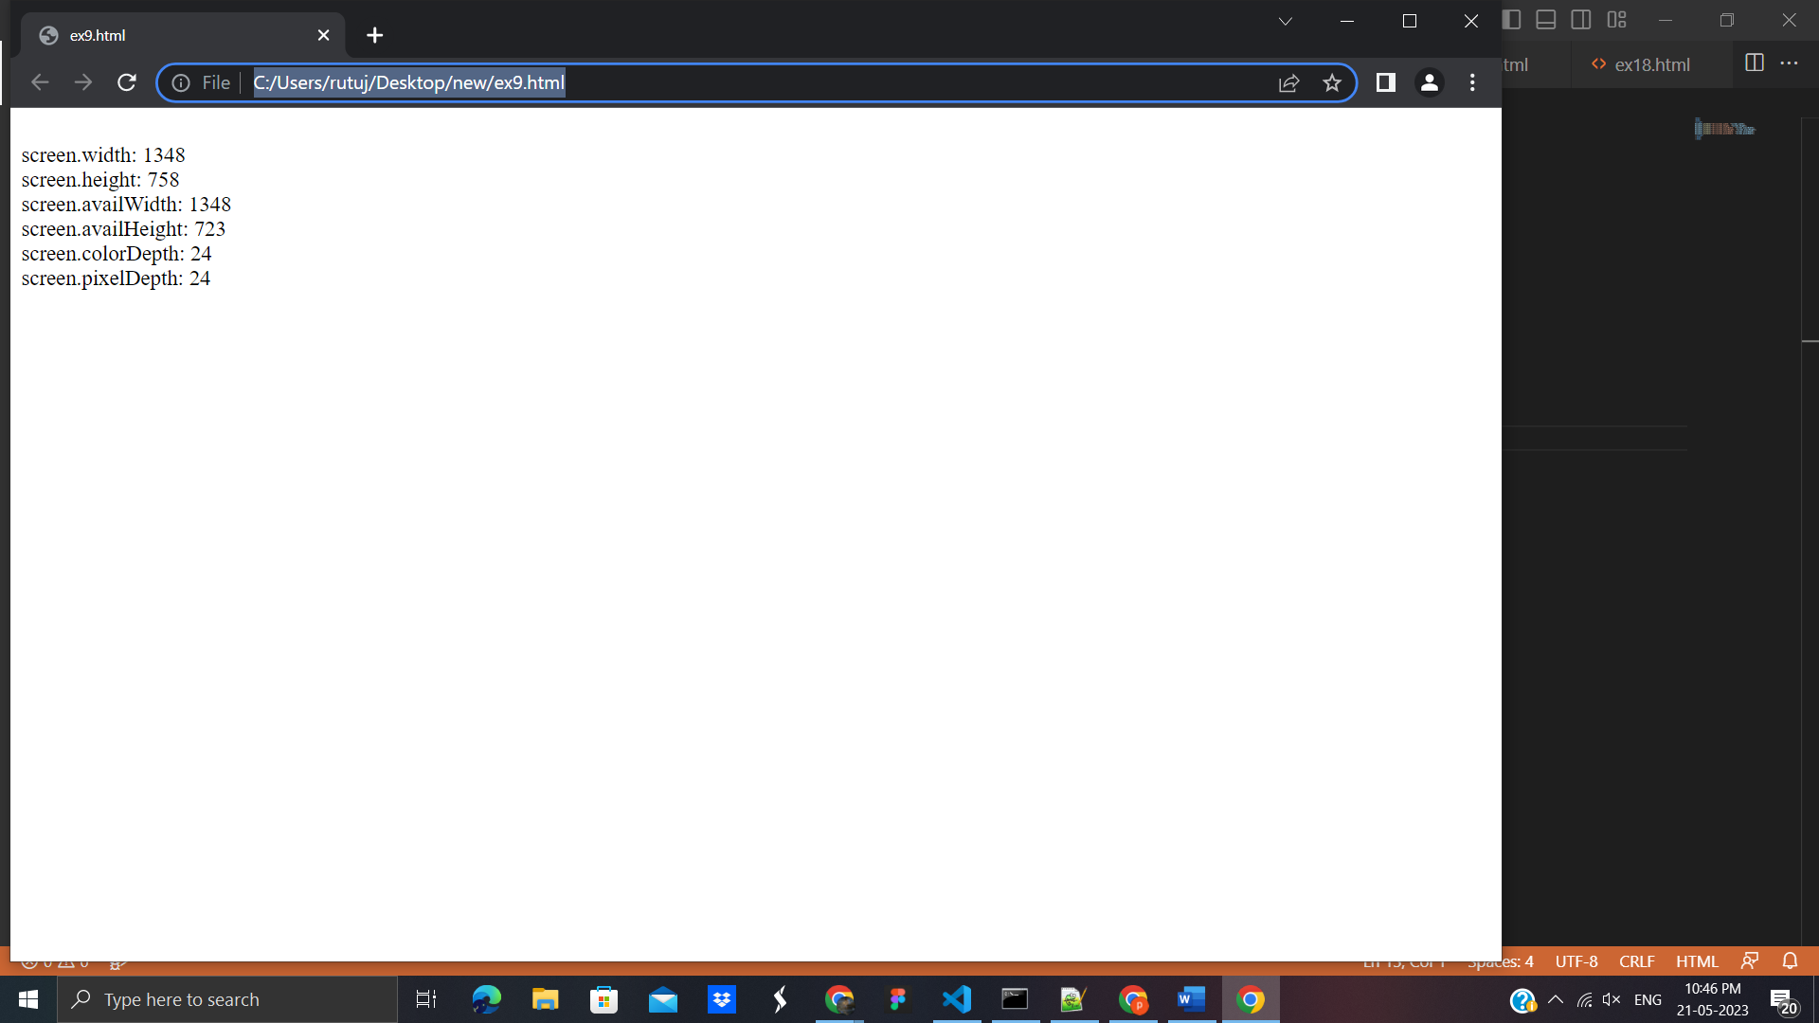

## **18 JavaScript DOM**

**1.Document Object Model**

When html document is loaded in the browser, it becomes a document object. It is the **root element** that represents the html document. It has properties and methods. By the help of document object, we can add dynamic content to our web page.

Let's see the simple example of document object that prints name with welcome message

<html>

<body>

<script type="text/javascript">

function printvalue(){

var name=document.form1.name.value;

alert("Welcome: "+name);

}

</script>

<form name="form1">

Enter Name:<input type="text" name="name"/>

<input type="button" onclick="printvalue()" value="print name"/>

</form>

</body>

</html>

**Output:**

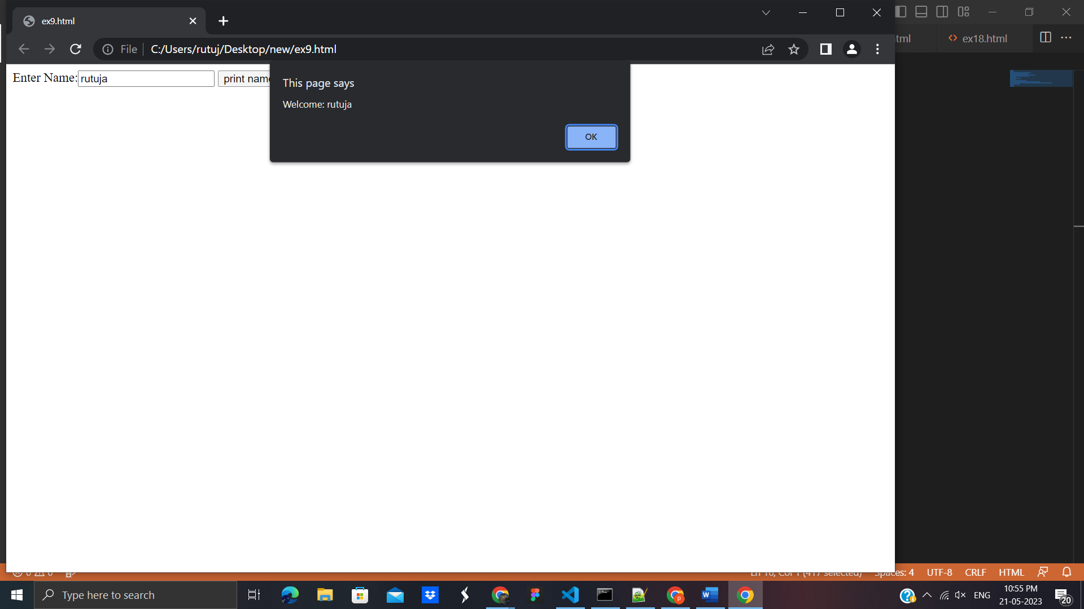

**2. Javascript - document.getElementById() method**

The document.getElementById() method returns the element of specified id.

<html>

<body>

<script type="text/javascript">

function getcube(){

var number=document.getElementById("number").value;

alert(number*number*number);

}

</script>

<form>

Enter No:<input type="text" id="number" name="number"/><br/>

<input type="button" value="cube" onclick="getcube()"/>

</form>

</body>

</html>

**Output:**

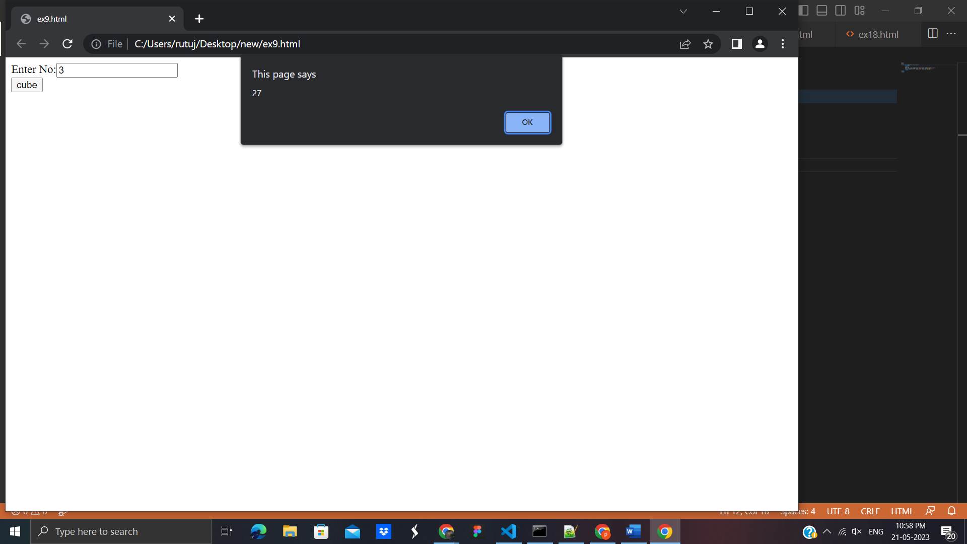

**3. GetElementsByClassName()**

The getElementsByClassName() method is used for selecting or getting the elements through their class name value.

**Example:**

<html>

<head> <h5>DOM Methods </h5> </head>

<body>

<div class="Class">

This is a simple class implementation

</div>

<script type="text/javascript">

var x=document.getElementsByClassName('Class');

document.write("On calling x, it will return an arrsy-like object: <br>"+x);

</script>

</body>

</html>

**Output:**

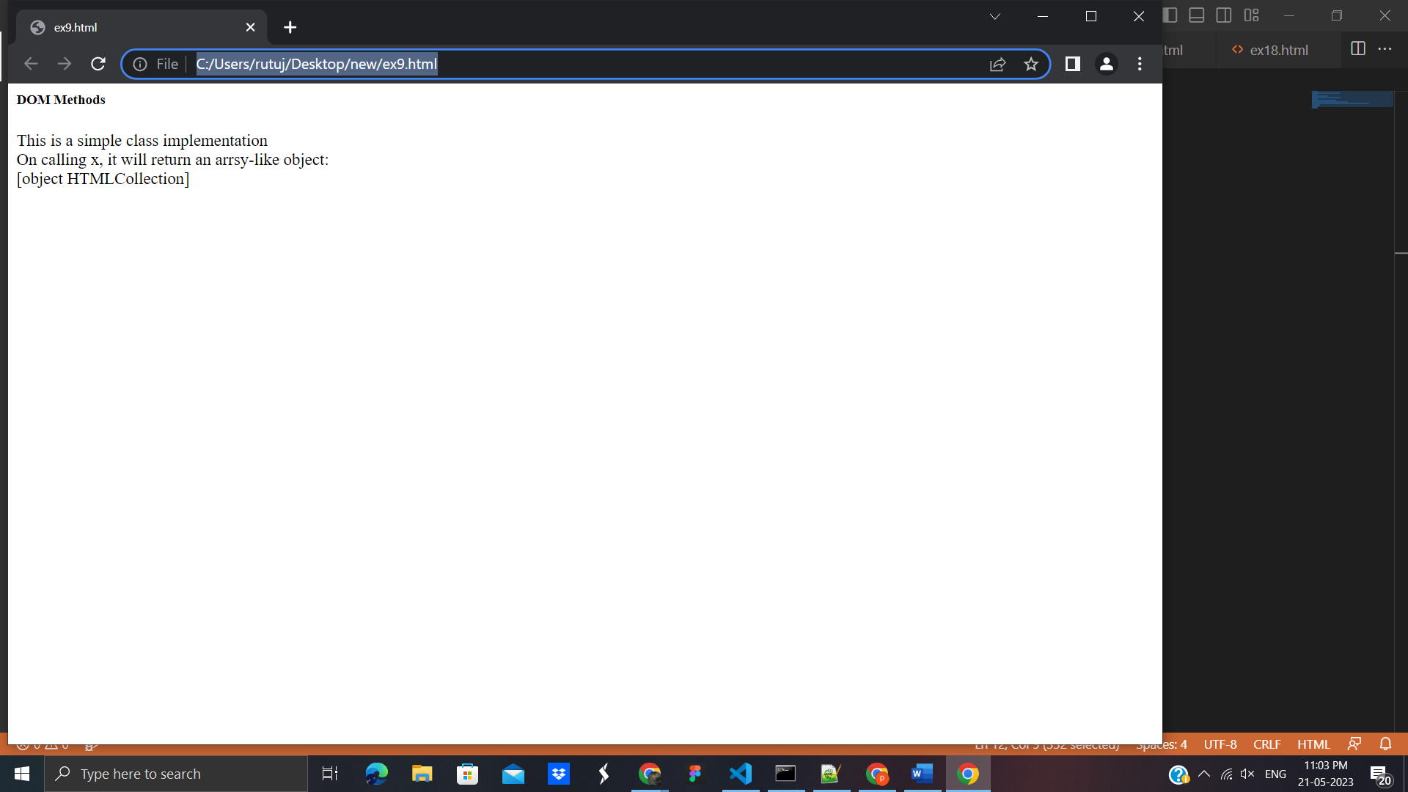

**4.Javascript - document.getElementsByName() method**

In this example, we going to count total number of genders. Here, we are using getElementsByName() method to get all the genders.

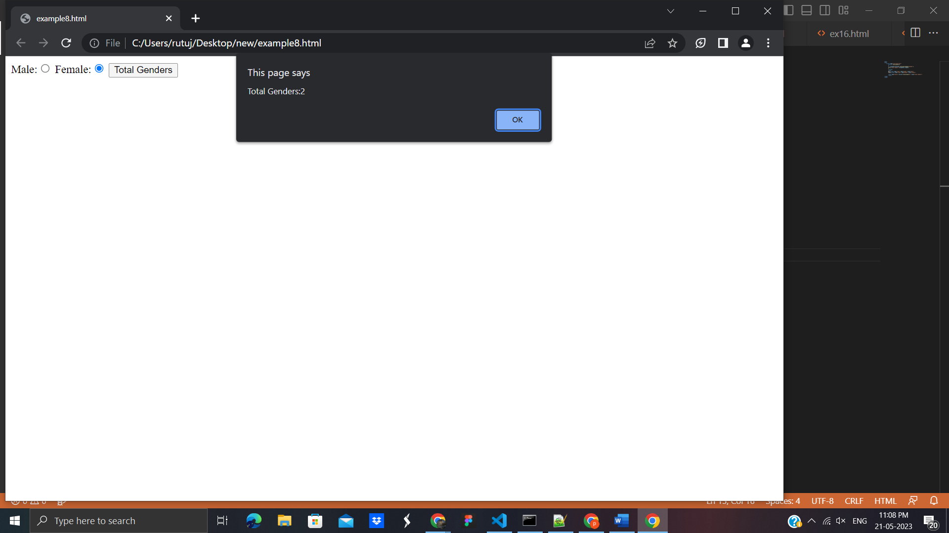

## **19. JavaScript Validation**

# **JavaScript Form Validation**

JavaScript provides facility to validate the form on the client-side so data processing will be faster than server-side validation. Most of the web developers prefer JavaScript form validation.

## JavaScript Form Validation Example

<html>

<body>

<script>

function validateform(){

var name=document.myform.name.value;

var password=document.myform.password.value;

if (name==null || name==""){

alert("Name can't be blank");

return false;

}else if(password.length<6){

alert("Password must be at least 6 characters long.");

return false;

}

}

</script>

<body>

<form name="myform" method="post" action="http://www.javatpoint.com/javascriptpages/valid.jsp" onsubmit="return validateform()" >

Name: <input type="text" name="name"><br/>

Password: <input type="password" name="password"><br/>

<input type="submit" value="register">

</form>

</body>

</html>

**Output**:

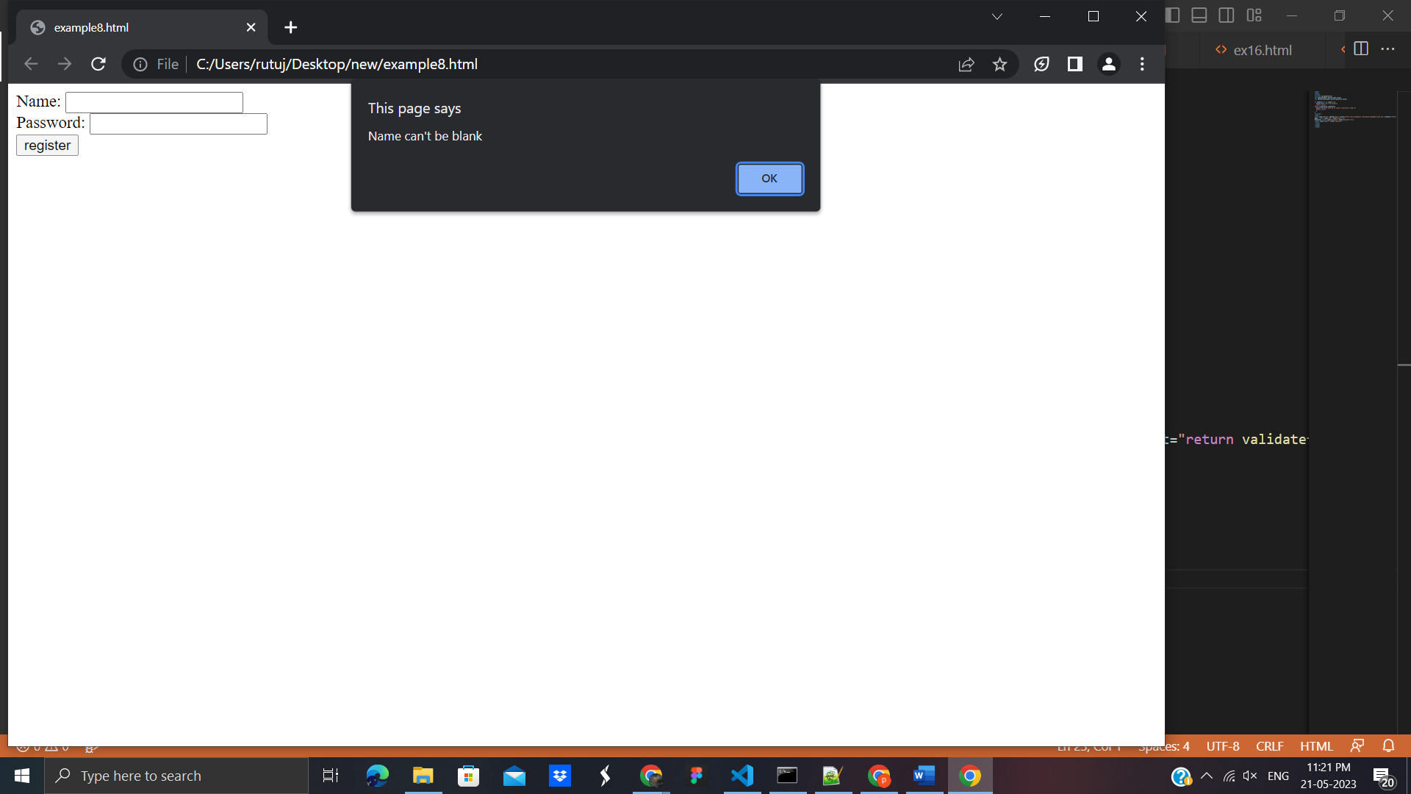

## **JavaScript Retype Password Validation**

Example:

<!DOCTYPE html>

<html>

<head>

<script type="text/javascript">

function matchpass(){

var firstpassword=document.f1.password.value;

var secondpassword=document.f1.password2.value;

if(firstpassword==secondpassword){

return true;

}

else{

alert("password must be same!");

return false;

}

}

</script>

</head>

<body>

<form name="f1" action="http://www.javatpoint.com/javascriptpages/valid.jsp" onsubmit="return matchpass()">

Password:<input type="password" name="password" /><br/>

Re-enter Password:<input type="password" name="password2"/><br/>

<input type="submit">

</form>

</body>

</html>

**Output:**

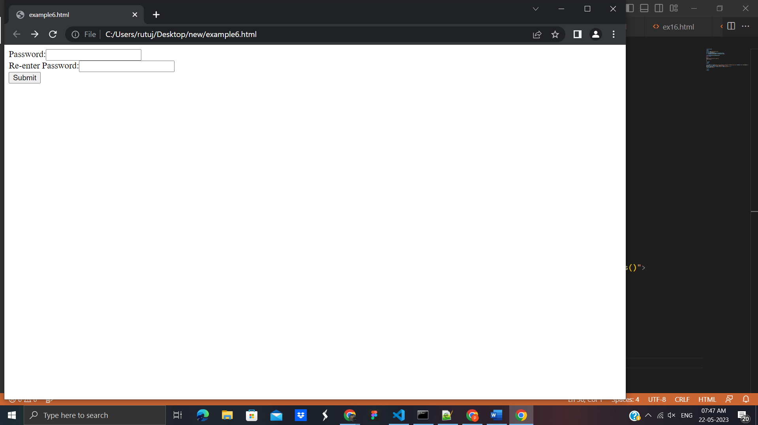

## 20. JavaScript Number Validation

Let's validate the textfield for numeric value only. Here, we are using isNaN() function.

<!DOCTYPE html>

<html>

<head>

<script>

function validate(){

var num=document.myform.num.value;

if (isNaN(num)){

document.getElementById("numloc").innerHTML="Enter Numeric value only";

return false;

}else{

return true;

}

}

</script>

</head>

<body>

<form name="myform" action="http://www.javatpoint.com/javascriptpages/valid.jsp" onsubmit="return validate()" >

Number: <input type="text" name="num"><span id="numloc"></span><br/>

<input type="submit" value="submit">

</form>

</body>

</html>

**Output:**

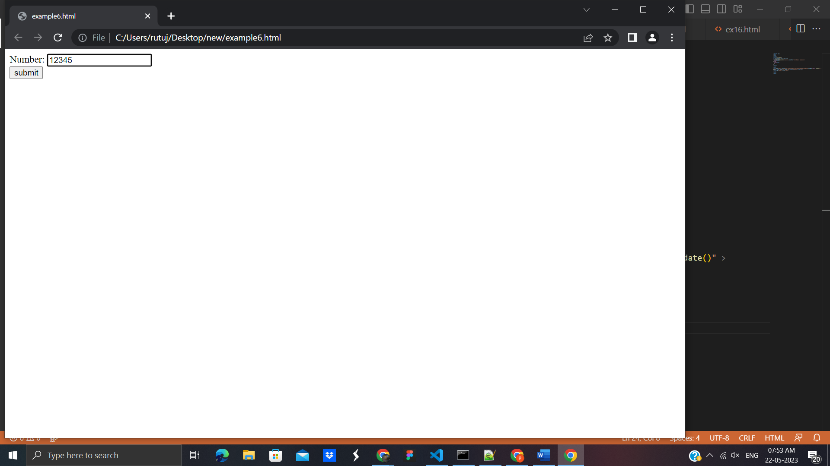

## JavaScript validation with image

Let’s see an interactive JavaScript form validation example that displays correct and incorrect image if input is correct or incorrect.

**Example**:

<html>

<body>

<script type="text/javascript">

function validate(){

var name=document.f1.name.value;

var passwordlength=document.f1.password.value.length;

var status=false;

if(name==""){

document.getElementById("namelocation").innerHTML=

" <img src='http://www.javatpoint.com/javascriptpages/images/unchecked.gif'/> Please enter your name";

status=false;

}else{

document.getElementById("namelocation").innerHTML=" <img src='http://www.javatpoint.com/javascriptpages/images/checked.gif'/>";

status=true;

}

if(passwordlength<6){

document.getElementById("passwordlocation").innerHTML=

" <img src='http://www.javatpoint.com/javascriptpages/images/unchecked.gif'/> Password must be greater than 6";

status=false;

}else{

document.getElementById("passwordlocation").innerHTML=" <img src='http://www.javatpoint.com/javascriptpages/images/checked.gif'/>";

}

return status;

}

</script>

<form name="f1" action="http://www.javatpoint.com/javascriptpages/valid.jsp" onsubmit="return validate()">

<table>

<tr><td>Name:</td><td><input type="text" name="name"/>

<span id="namelocation" style="color:red"></span></td></tr>

<tr><td>Password:</td><td><input type="password" name="password"/>

<span id="passwordlocation" style="color:red"></span></td></tr>

<tr><td colspan="2"><input type="submit" value="register"/> </td></tr>

</table>

</form>

</body>

</html>

**Output:**

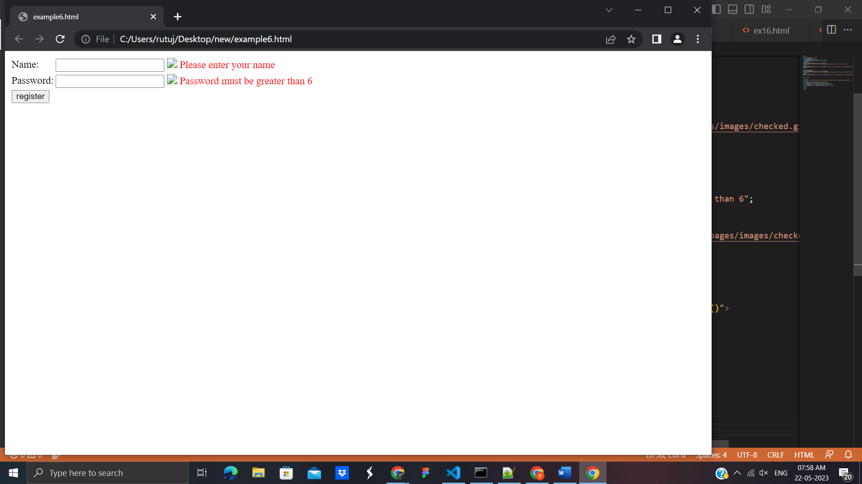

## JavaScript email validation

We can validate the email by the help of JavaScript.

There are many criteria that need to be follow to validate the email id such as:

* email id must contain the @ and . character
* There must be at least one character before and after the @.
* There must be at least two characters after . (dot).

Let's see the simple example to validate the email field.

<html>

<body>

<script>

function validateemail()

{

var x=document.myform.email.value;

var atposition=x.indexOf("@");

var dotposition=x.lastIndexOf(".");

if (atposition<1 || dotposition<atposition+2 || dotposition+2>=x.length){

alert("Please enter a valid e-mail address \n atpostion:"+atposition+"\n dotposition:"+dotposition);

return false;

}

}

</script>

<body>

<form name="myform" method="post" action="http://www.javatpoint.com/javascriptpages/valid.jsp" onsubmit="return validateemail();">

Email: <input type="text" name="email"><br/>

<input type="submit" value="register">

</form>

</body>

</html>

**Output:**

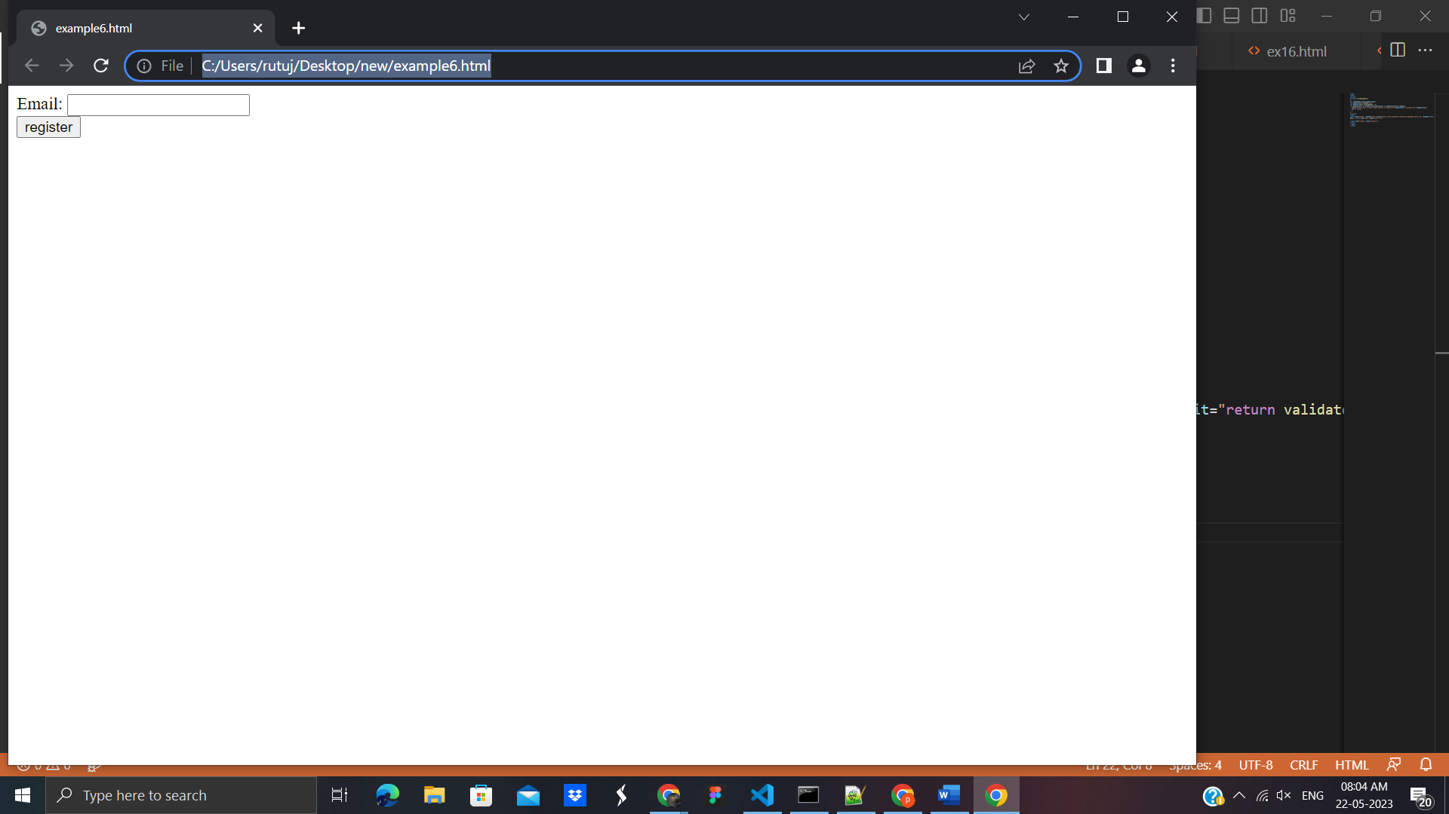

## **22. JavaScript OOPs**

In JavaScript, classes are the special type of functions. We can define the class just like function declarations and function expressions.

The class syntax contains two components:

* Class declarations
* Class expressions

A class can be defined by using a class declaration. A class keyword is used to declare a class with any particular name. According to JavaScript naming conventions, the name of the class always starts with an uppercase letter.

### **Class Declarations Example:**

<!DOCTYPE html>

<html>

<body>

<script>

//Declaring class

class Employee

{

//Initializing an object

constructor(id,name)

{

this.id=id;

this.name=name;

}

//Declaring method

detail()

{

document.writeln(this.id+" "+this.name+"<br>")

}

}

//passing object to a variable

var e1=new Employee(101,"Martin Roy");

var e2=new Employee(102,"Duke William");

e1.detail(); //calling method

e2.detail();

</script>

</body>

</html>

**Output:**

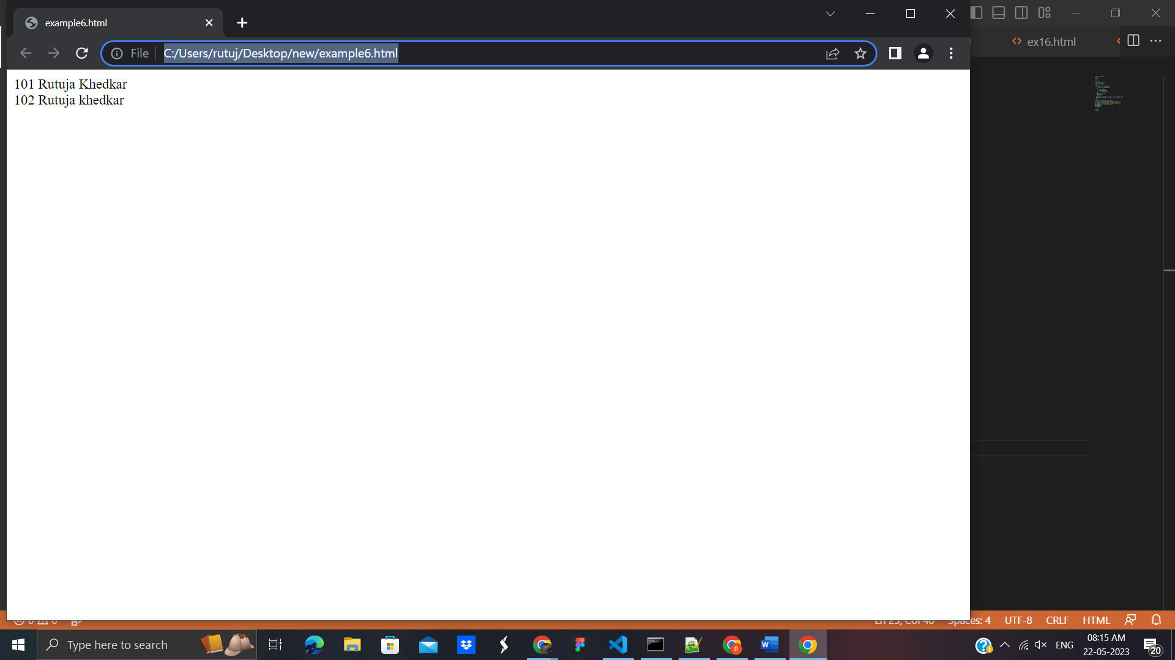

### **Class Declarations Example: Hoisting**

Unlike function declaration, the class declaration is not a part of JavaScript hoisting. So, it is required to declare the class before invoking it.

Let's see an example.

<!DOCTYPE html>

<html>

<body>

<script>

//Here, we are invoking the class before declaring it.

var e1=new Employee(101,"Martin Roy");

var e2=new Employee(102,"Duke William");

e1.detail(); //calling method

e2.detail();

//Declaring class

class Employee

{

//Initializing an object

constructor(id,name)

{

this.id=id;

this.name=name;

}

detail()

{

document.writeln(this.id+" "+this.name+"<br>")

}

}

</script>

</body>

</html>

**Output:**

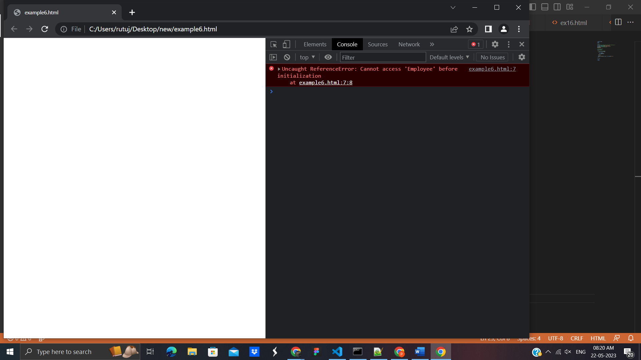

### **Class Declarations Example: Re-declaring Class**

A class can be declared once only. If we try to declare class more than one time, it throws an error.

Let's see an example.

<!DOCTYPE html>

<html>

<body>

<script>

//Declaring class

class Employee

{

//Initializing an object

constructor(id,name)

{

this.id=id;

this.name=name;

}

detail()

{

document.writeln(this.id+" "+this.name+"<br>")

}

}

//passing object to a variable

var e1=new Employee(101,"Martin Roy");

var e2=new Employee(102,"Duke William");

e1.detail(); //calling method

e2.detail();

//Re-declaring class

class Employee

{

}

</script>

</body>

</html>

**Output**:

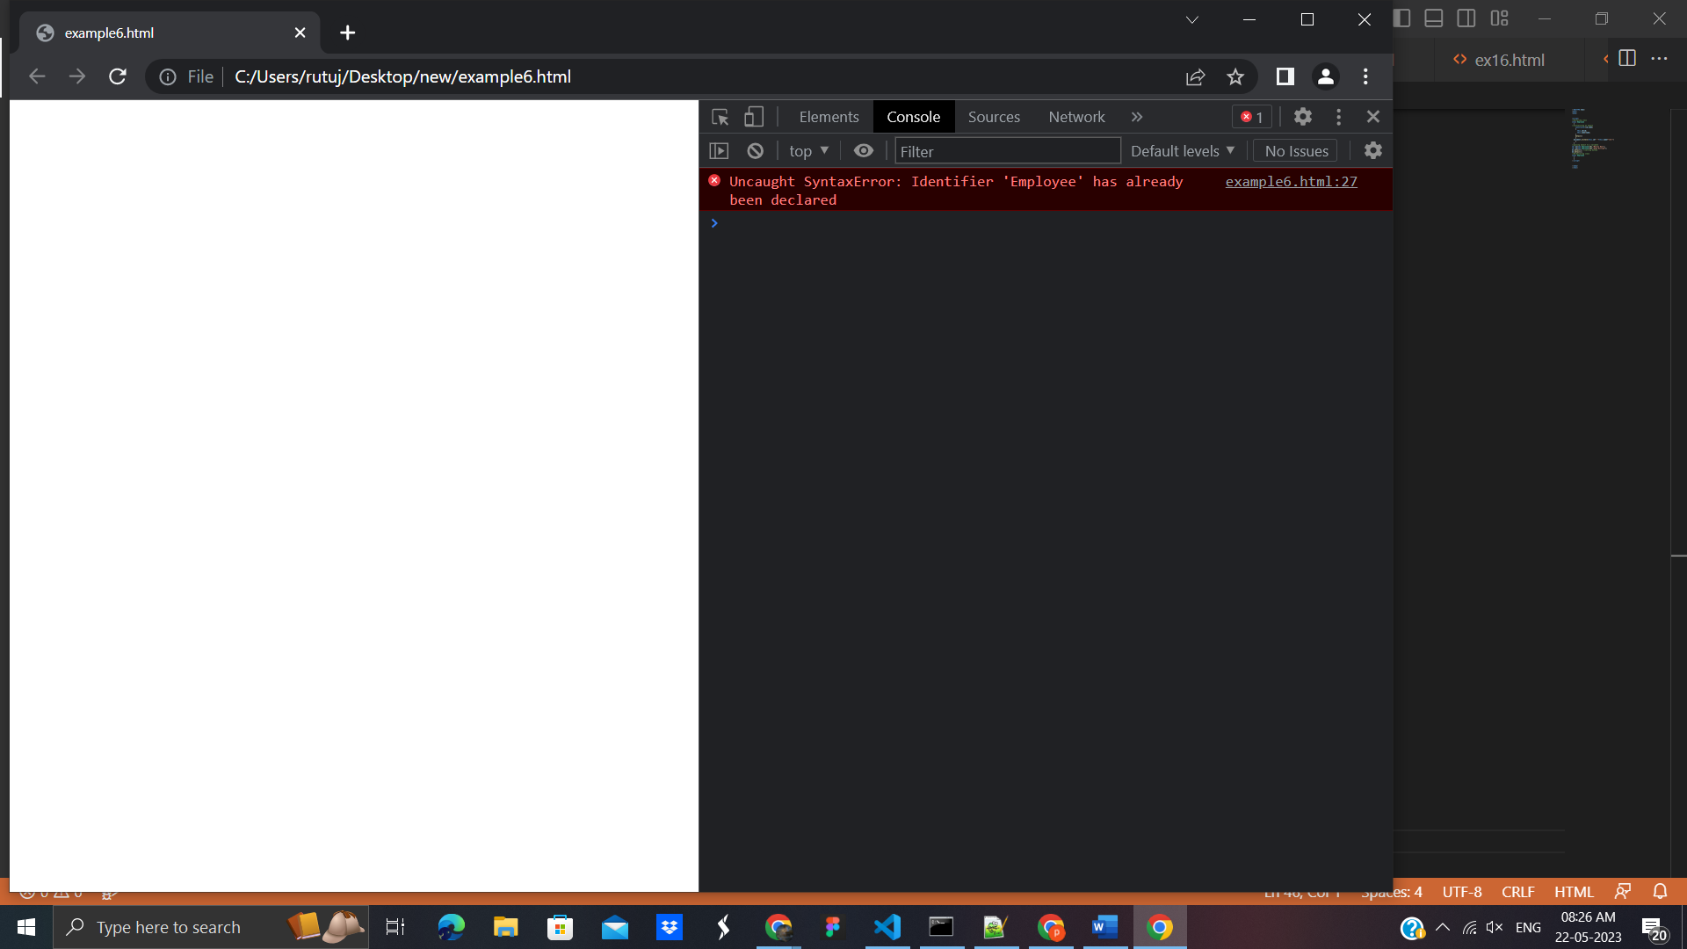

## 23. Class expressions

Another way to define a class is by using a class expression. Here, it is not mandatory to assign the name of the class. So, the class expression can be named or unnamed. The class expression allows us to fetch the class name. However, this will not be possible with class declaration.

### Unnamed Class Expression

The class can be expressed without assigning any name to it.

Let's see an example.

<!DOCTYPE html>

<html>

<body>

<script>

var emp = class {

constructor(id, name) {

this.id = id;

this.name = name;

}

};

document.writeln(emp.name);

</script>

</body>

</html>

**Output:**

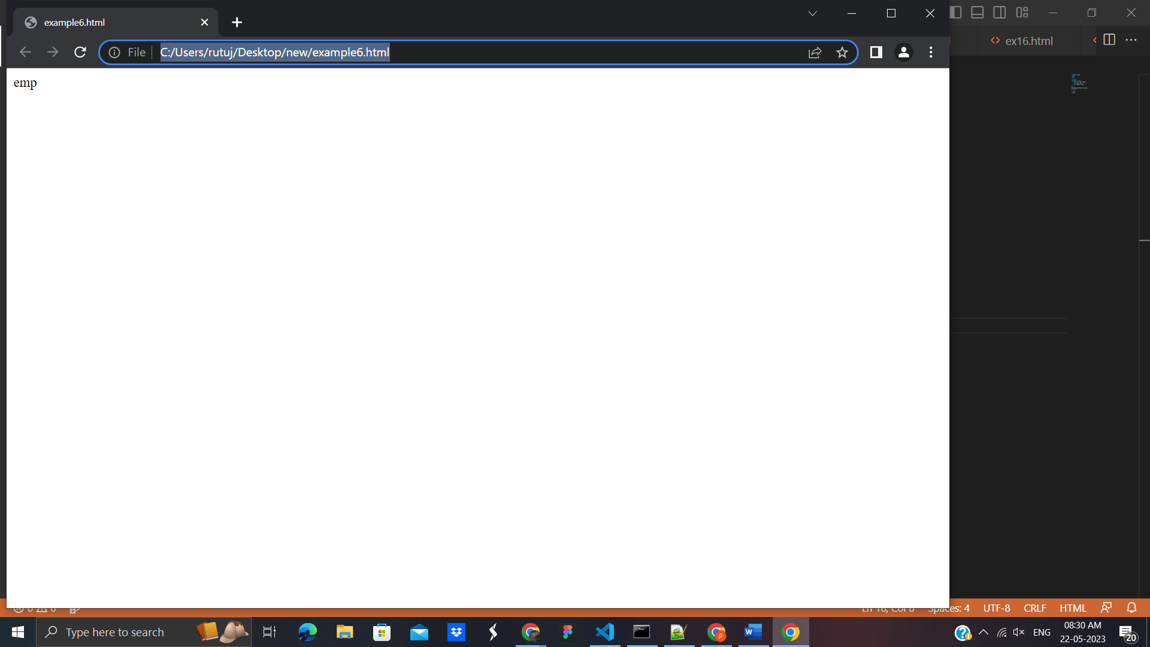

### Class Expression Example: Re-declaring Class

Unlike class declaration, the class expression allows us to re-declare the same class. So, if we try to declare the class more than one time, it throws an error.

<!DOCTYPE html>

<html>

<body>

<script>

//Declaring class

var emp=class

{

//Initializing an object

constructor(id,name)

{

this.id=id;

this.name=name;

}

//Declaring method

detail()

{

document.writeln(this.id+" "+this.name+"<br>")

}

}

//passing object to a variable

var e1=new emp(101,"Rutu");

var e2=new emp(102,"Rutu k");

e1.detail(); //calling method

e2.detail();

//Re-declaring class

var emp=class

{

//Initializing an object

constructor(id,name)

{

this.id=id;

this.name=name;

}

detail()

{

document.writeln(this.id+" "+this.name+"<br>")

}

}

//passing object to a variable

var e1=new emp(103,"Ruruja k");

var e2=new emp(104,"Rutuja kk");

e1.detail(); //calling method

e2.detail();

</script>

</body>

</html>

**Output:**

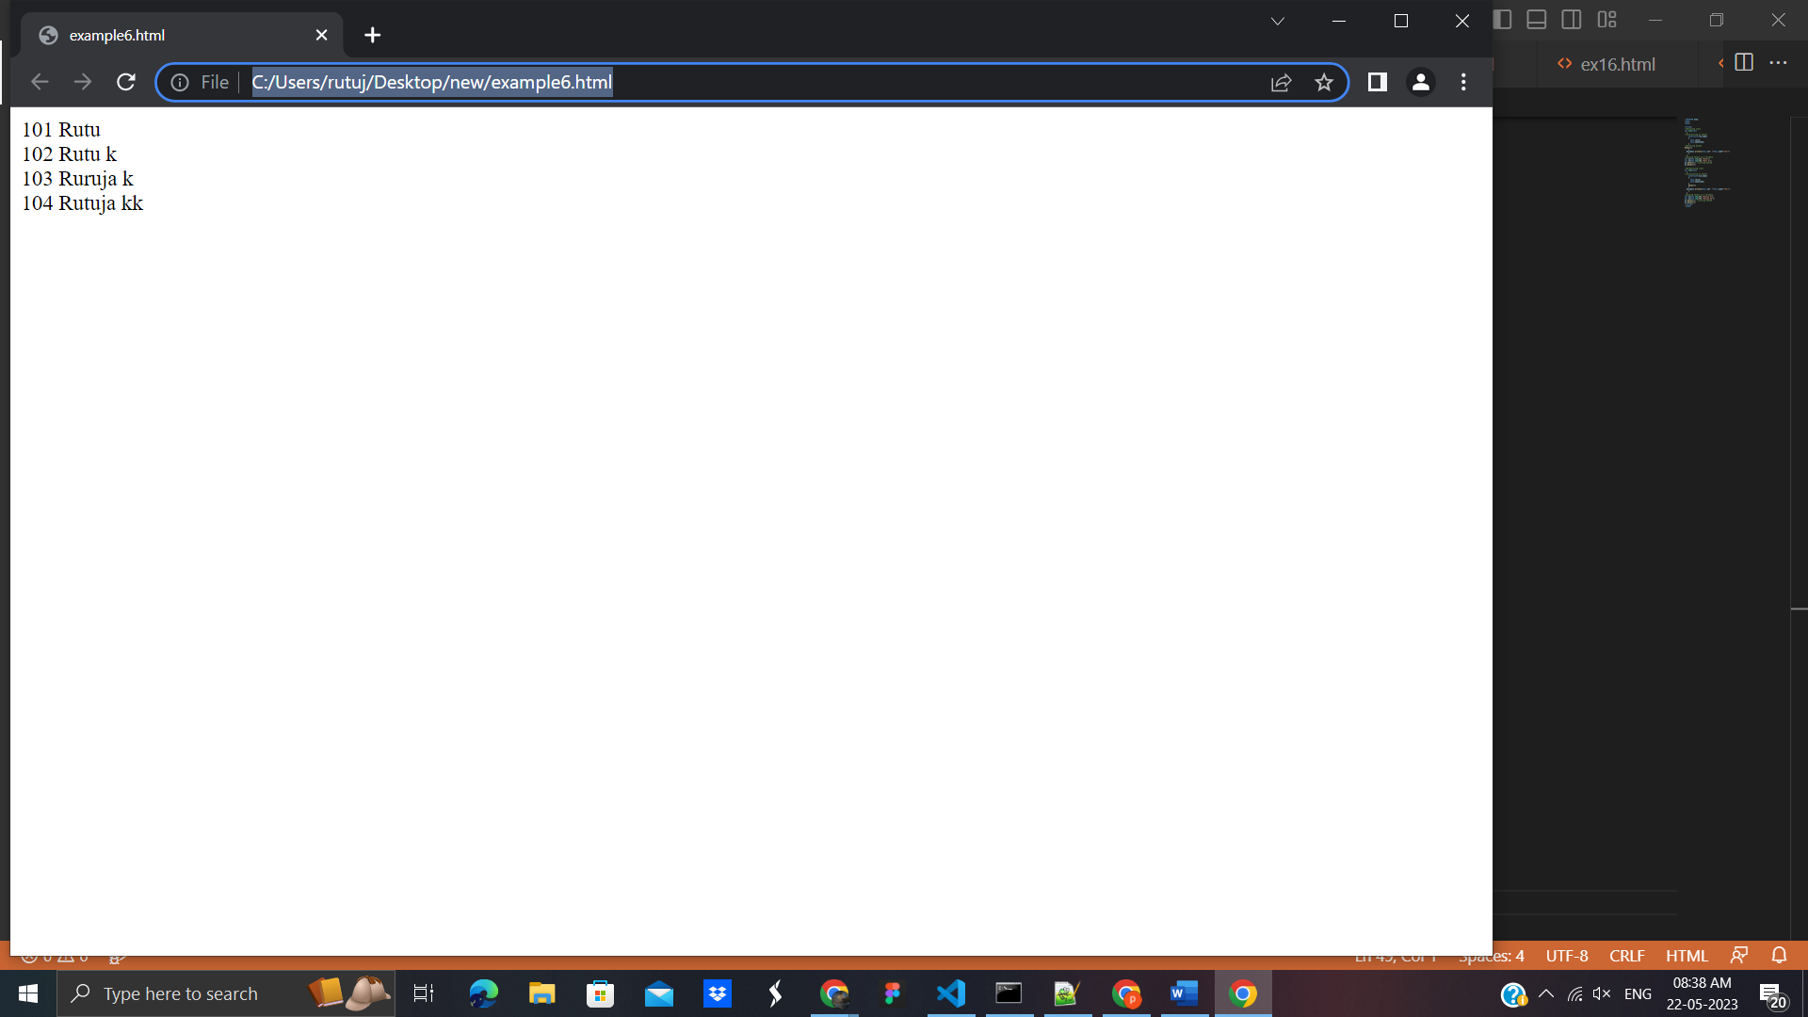

# **JavaScript Prototype Object :** JavaScript is a prototype-based language that facilitates the objects to acquire properties and features from one another. Here, each object contains a prototype object.

In JavaScript, whenever a function is created the prototype property is added to that function automatically. This property is a prototype object that holds a constructor property.

## Syntax: ClassName.prototype.methodName

## 24. What is the requirement of a prototype object?

Whenever an object is created in JavaScript, its corresponding functions are loaded into memory. So, a new copy of the function is created on each object creation.

## Prototype Chaining

In JavaScript, each object contains a prototype object that acquires properties and methods from it. Again an object's prototype object may contain a prototype object that also acquires properties and methods, and so on. It can be seen as prototype chaining.

### JavaScript Prototype Object Example

<!DOCTYPE html>

<html>

<body>

<script>

function Employee(firstName,lastName)

{

this.firstName=firstName;

this.lastName=lastName;

}

Employee.prototype.fullName=function()

{

return this.firstName+" "+this.lastName;

}

var employee1=new Employee("Martin","Roy");

var employee2=new Employee("Duke", "William");

document.writeln(employee1.fullName()+"<br>");

document.writeln(employee2.fullName());

</script>

</body>

</html>

**Output:**

## 

# **25. JavaScript Constructor Method**

A JavaScript constructor method is a special type of method which is used to initialize and create an object. It is called when memory is allocated for an object.

## Points to remember

* The constructor keyword is used to declare a constructor method.
* The class can contain one constructor method only.
* JavaScript allows us to use parent class constructor through super keyword.

### Constructor Method Example

<!DOCTYPE html>

<html>

<body>

<script>

class Employee {

constructor() {

this.id=101;

this.name = "Martin Roy";

}

}

var emp = new Employee();

document.writeln(emp.id+" "+emp.name);

</script>

</body>

</html>

**Output:**

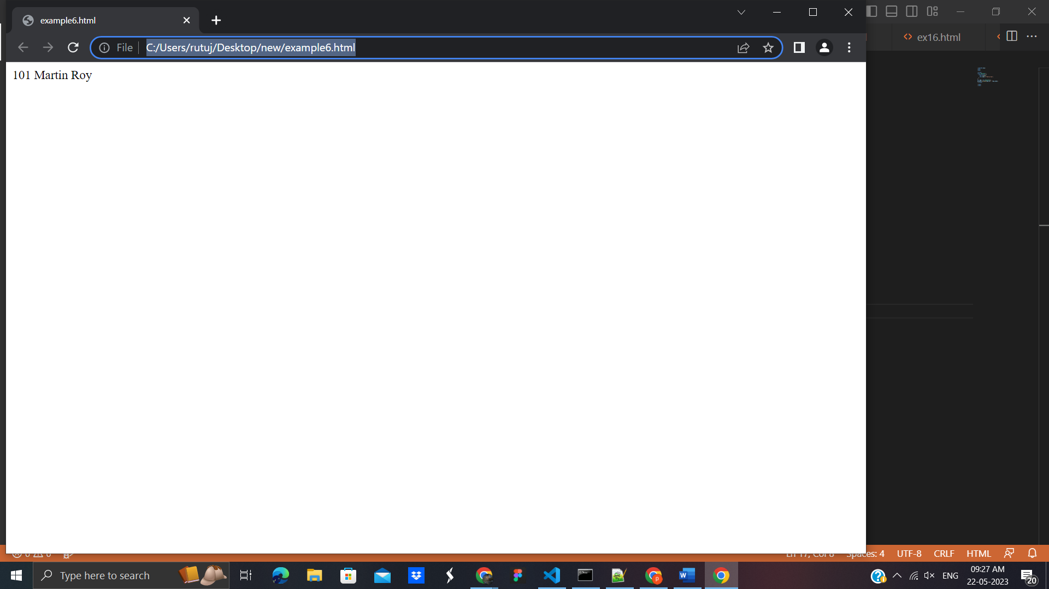

### Constructor Method Example: super keyword

The super keyword is used to call the parent class constructor. Let's see an example.

<!DOCTYPE html>

<html>

<body>

<script>

class CompanyName

{

constructor()

{

this.company="Javatpoint";

}

}

class Employee extends CompanyName {

constructor(id,name) {

super();

this.id=id;

this.name=name;

}

}

var emp = new Employee(1,"Rutuja");

document.writeln(emp.id+" "+emp.name+" "+emp.company);

</script>

</body>

</html>

Output:

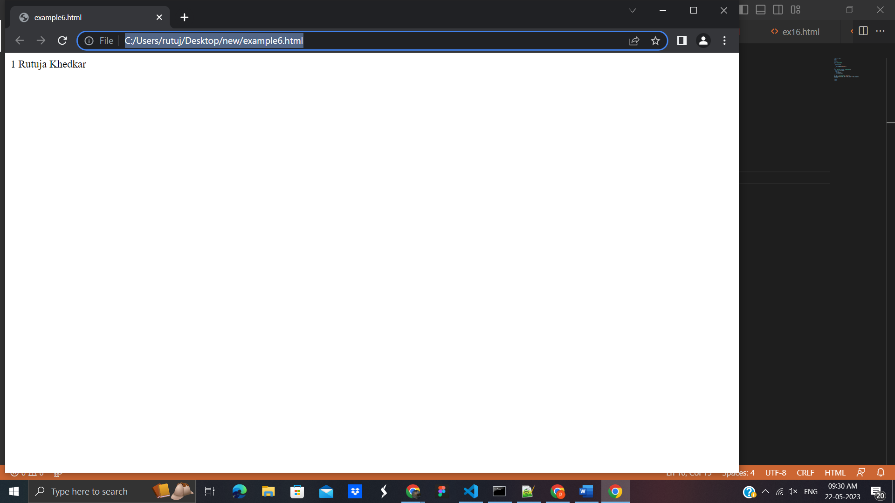

# 26. JavaScript static Method

The JavaScript provides static methods that belong to the class instead of an instance of that class. So, an instance is not required to call the static method. These methods are called directly on the class itself.

## Points to remember

* The static keyword is used to declare a static method.
* The static method can be of any name.
* A class can contain more than one static method.
* If we declare more than one static method with a similar name, the JavaScript always invokes the last one.
* The static method can be used to create utility functions.
* We can use this keyword to call a static method within another static method.
* We cannot use this keyword directly to call a static method within the non-static method. In such case, we can call the static method either using the class name or as the property of the constructor.

### JavaScript static Method Example

<!DOCTYPE html>

<html>

<body>

<script>

class Test

{

static display()

{

return "static method is invoked"

}

}

document.writeln(Test.display());

</script>

</body>

</html>

**Output:**

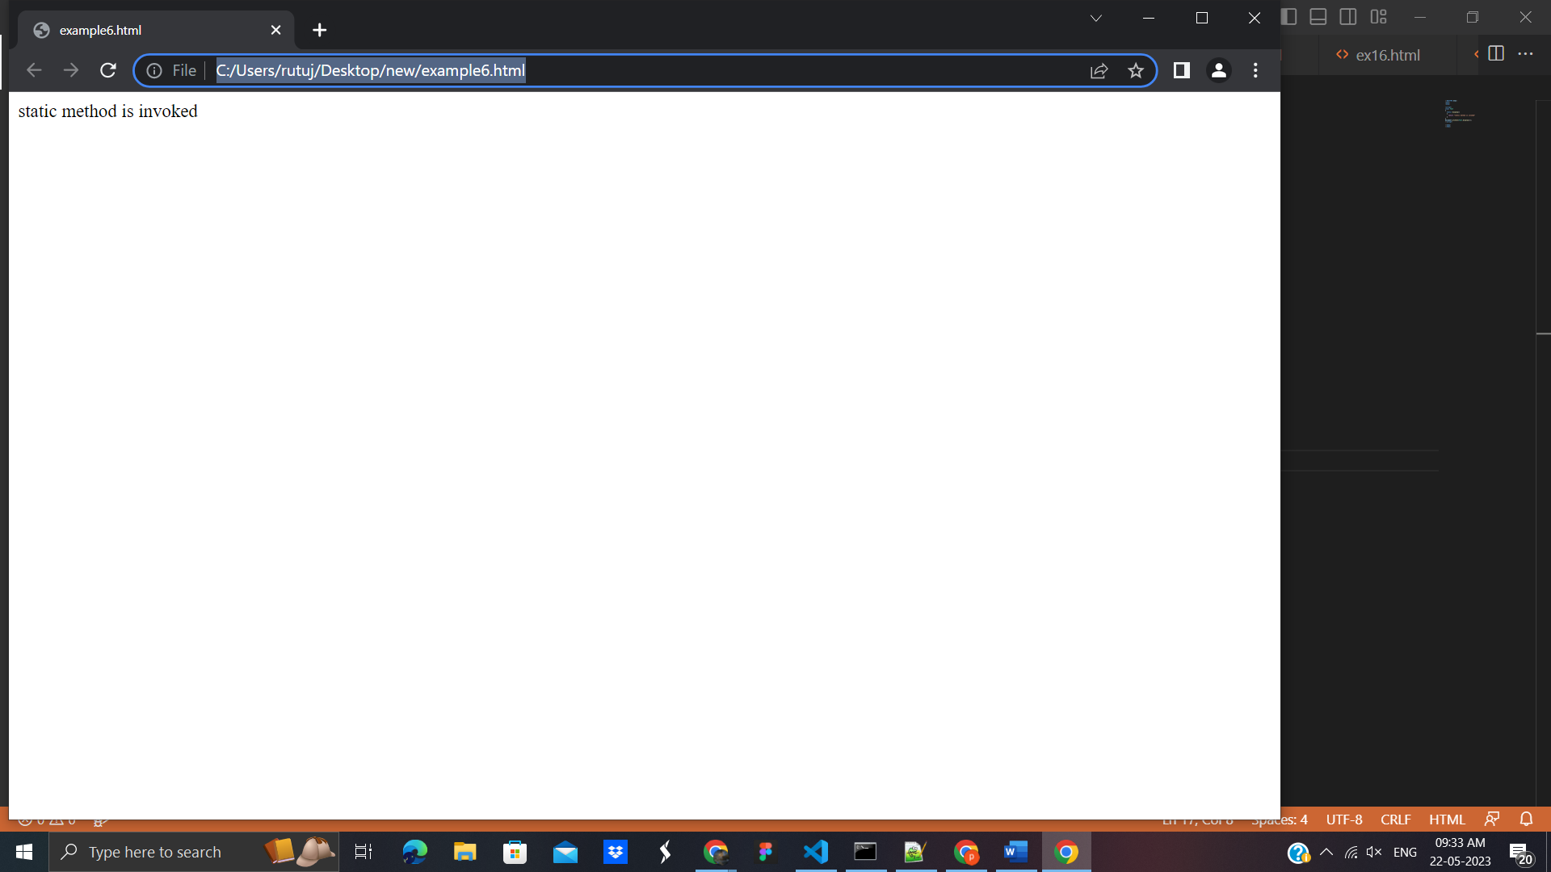

# 27. JavaScript Encapsulation

The JavaScript Encapsulation is a process of binding the data (i.e. variables) with the functions acting on that data. It allows us to control the data and validate it. To achieve an encapsulation in JavaScript: -

* Use var keyword to make data members private.
* Use setter methods to set the data and getter methods to get that data.

The encapsulation allows us to handle an object using the following properties:

**Read/Write** - Here, we use setter methods to write the data and getter methods read that data.

**Read Only** - In this case, we use getter methods only.

**Write Only** - In this case, we use setter methods only.

### JavaScript Encapsulation Example

Let's see a simple example of encapsulation that contains two data members with its setter and getter methods.

<script>

class Student

{

constructor()

{

var name;

var marks;

}

getName()

{

return this.name;

}

setName(name)

{

this.name=name;

}

getMarks()

{

return this.marks;

}

setMarks(marks)

{

this.marks=marks;

}

}

var stud=new Student();

stud.setName("John");

stud.setMarks(80);

document.writeln(stud.getName()+" "+stud.getMarks());

</script>

**OutPut:**

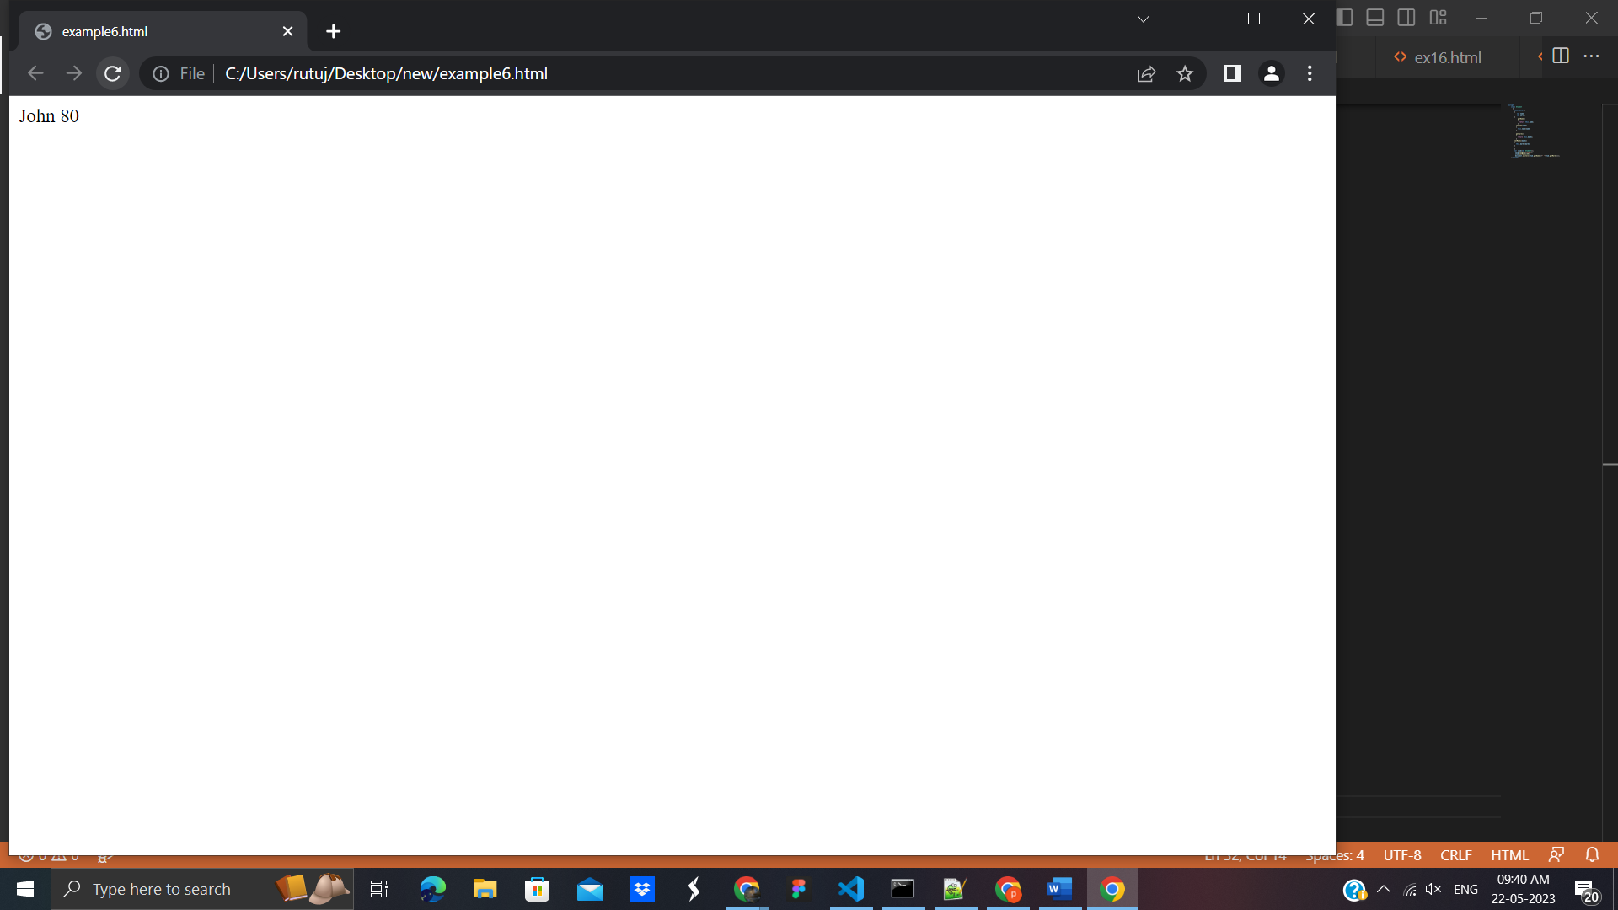

### JavaScript Encapsulation Example: Validate

<!DOCTYPE html>

<html>

<body>

<script>

class Student

{

constructor()

{

var name;

var marks;

}

getName()

{

return this.name;

}

setName(name)

{

this.name=name;

}

getMarks()

{

return this.marks;

}

setMarks(marks)

{

if(marks<0||marks>100)

{

alert("Invalid Marks");

}

else

{

this.marks=marks;

}

}

}

var stud=new Student();

stud.setName("John");

stud.setMarks(110);//alert() invokes

document.writeln(stud.getName()+" "+stud.getMarks());

</script>

</body>

</html>

**Output:**

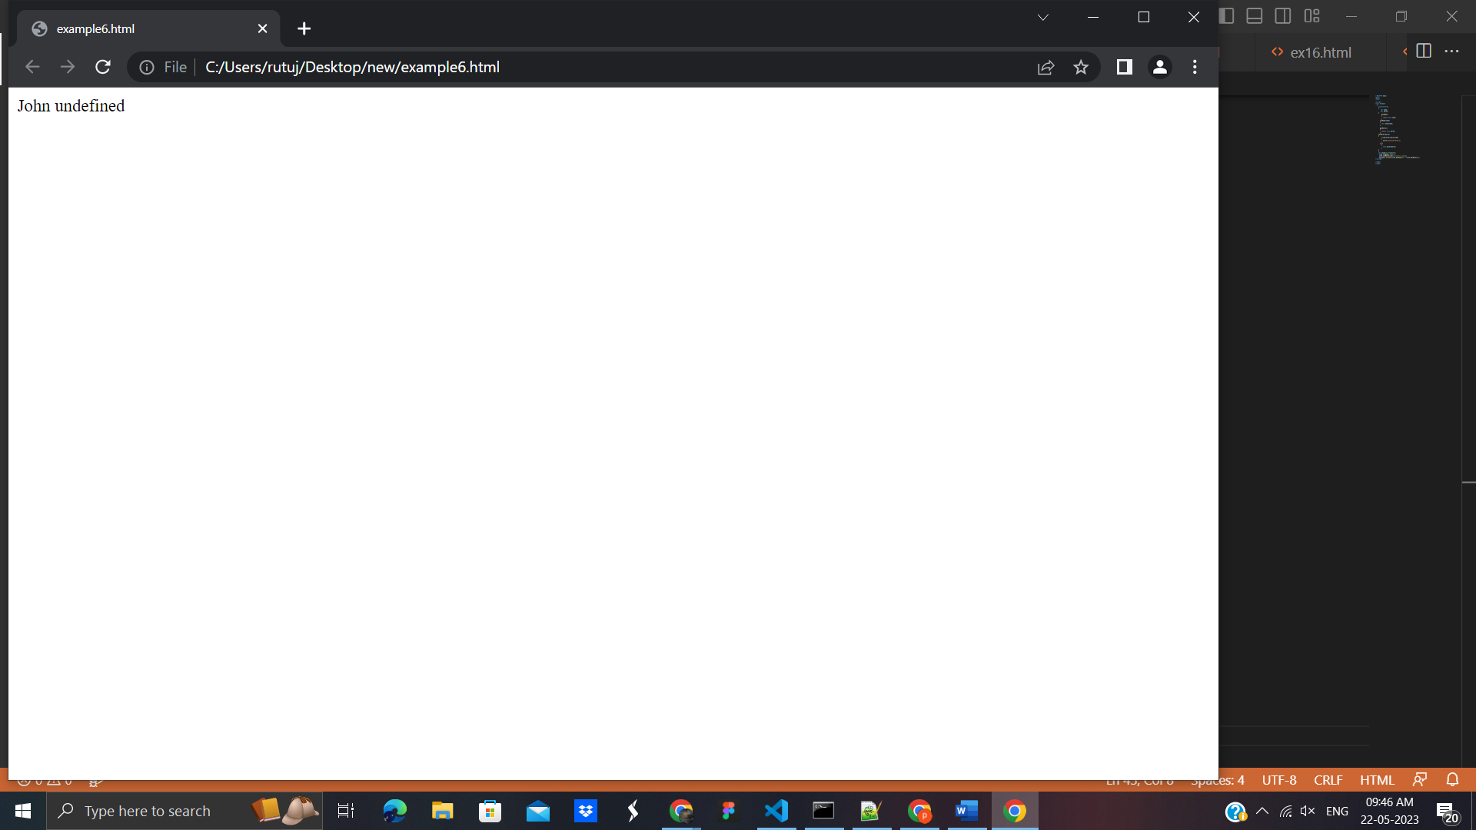

### JavaScript Encapsulation Example: Prototype-based approach

<!DOCTYPE html>

<html>

<body>

<script>

function Student(name,marks)

{

var s_name=name;

var s_marks=marks;

Object.defineProperty(this,"name",{

get:function()

{

return s_name;

},

set:function(s_name)

{

this.s_name=s_name;

}

});

Object.defineProperty(this,"marks",{

get:function()

{

return s_marks;

},

set:function(s_marks)

{

this.s_marks=s_marks;

}

});

}

var stud=new Student("John",80);

document.writeln(stud.name+" "+stud.marks);

</script>

</body>

</html>

Output:

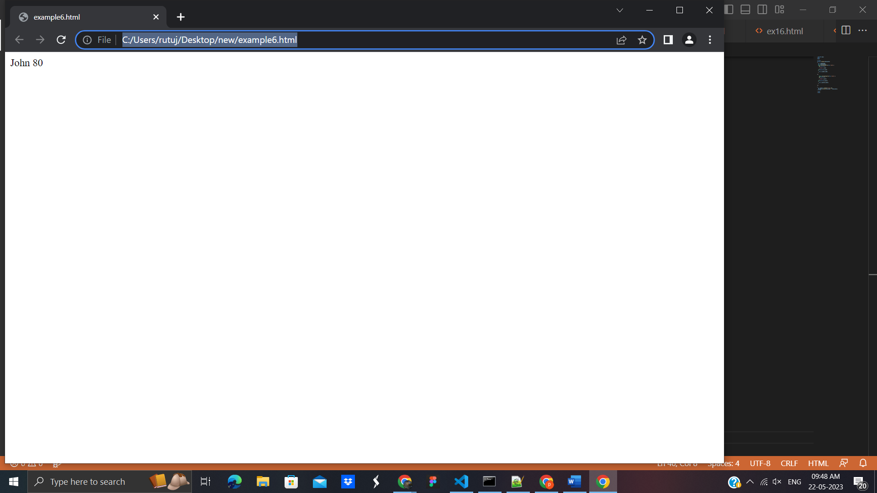

# 28. JavaScript Inheritance

The JavaScript inheritance is a mechanism that allows us to create new classes on the basis of already existing classes. It provides flexibility to the child class to reuse the methods and variables of a parent class.

The JavaScript **extends** keyword is used to create a child class on the basis of a parent class. It facilitates child class to acquire all the properties and behavior of its parent class.

## Points to remember

* It maintains an IS-A relationship.
* The extends keyword is used in class expressions or class declarations.
* Using extends keyword, we can acquire all the properties and behavior of the inbuilt object as well as custom classes.
* We can also use a prototype-based approach to achieve inheritance.

### JavaScript extends Example: inbuilt object

<!DOCTYPE html>

<html>

<body>

<script>

class Moment extends Date {

constructor() {

super();

}}

var m=new Moment();

document.writeln("Current date:")

document.writeln(m.getDate()+"-"+(m.getMonth()+1)+"-"+m.getFullYear());

</script>

</body>

</html>

**Output:**

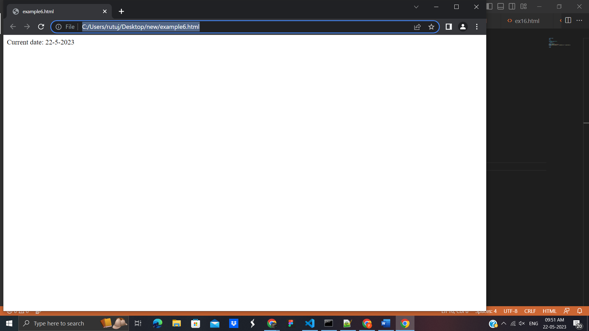

# 29. JavaScript Polymorphism

The polymorphism is a core concept of an object-oriented paradigm that provides a way to perform a single action in different forms. It provides an ability to call the same method on different JavaScript objects. As JavaScript is not a type-safe language, we can pass any type of data members with the methods.

### JavaScript Polymorphism Example

<!DOCTYPE html>

<html>

<body>

<script>

class A

{

display()

{

document.writeln("A is invoked");

}

}

class B extends A

{

}

var b=new B();

b.display();

</script>

</body>

</html>

**Output:**

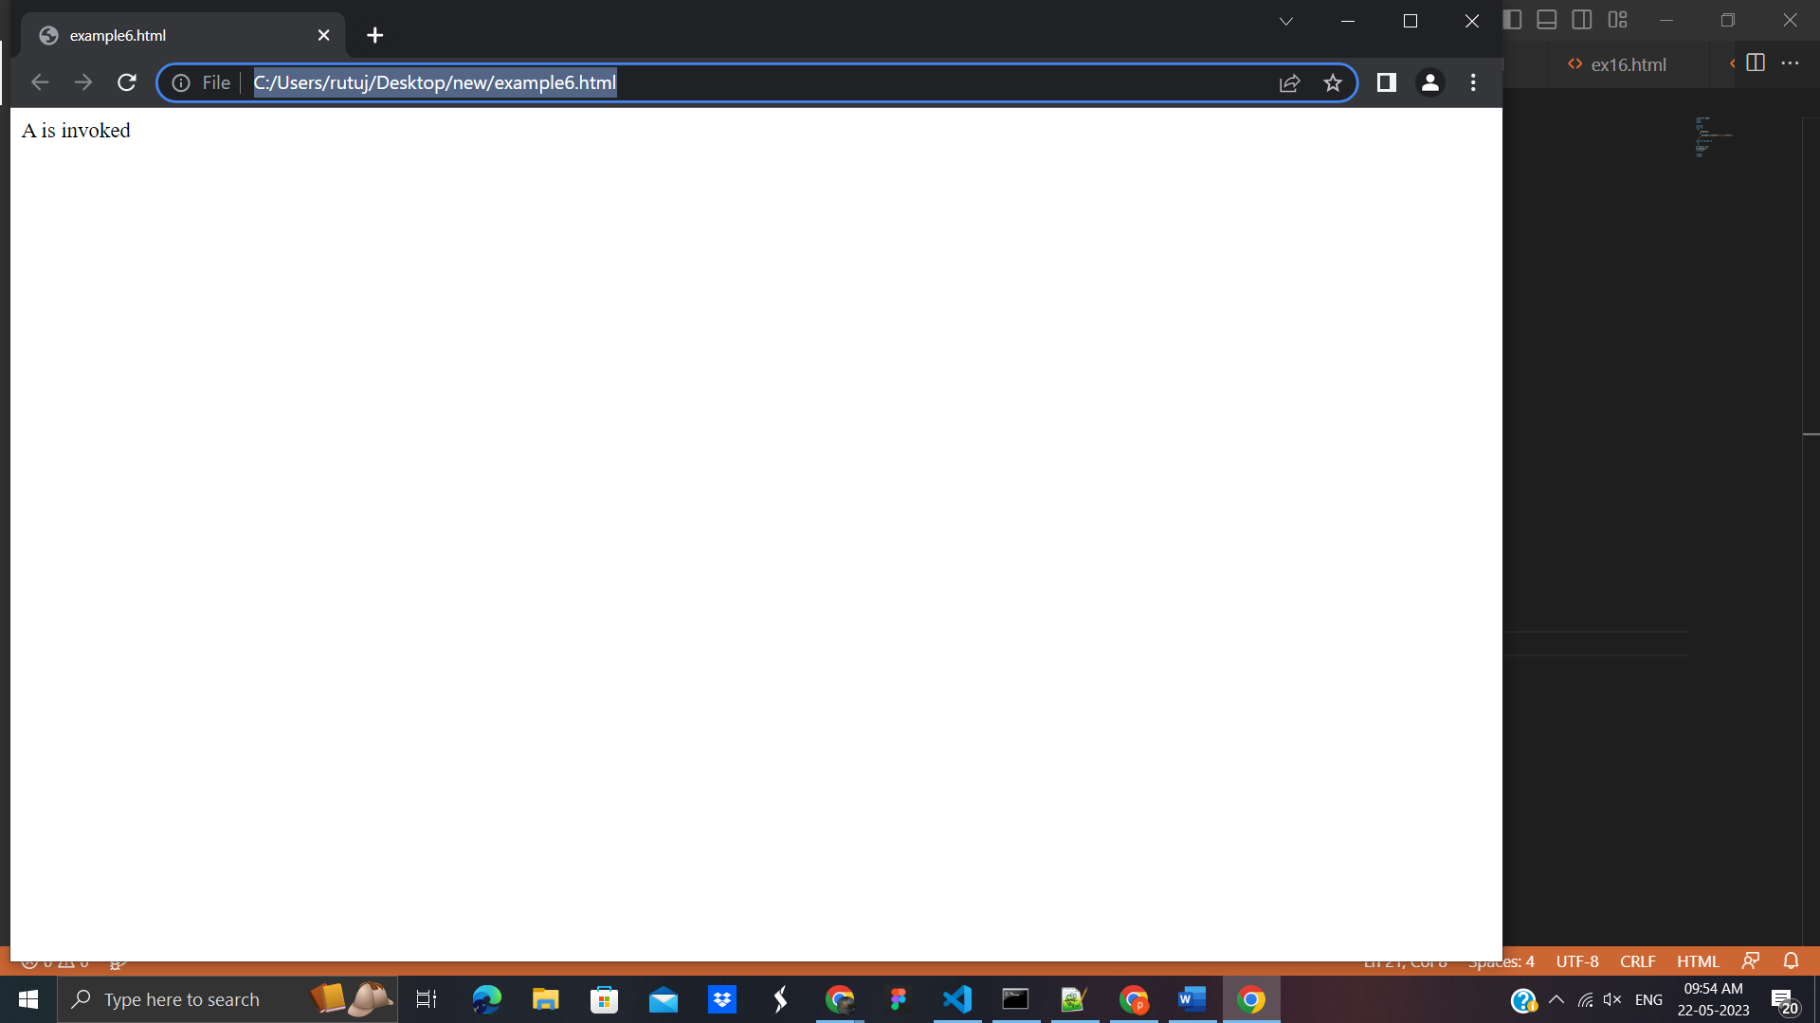

# 30. JavaScript Abstraction

An abstraction is a way of hiding the implementation details and showing only the functionality to the users. In other words, it ignores the irrelevant details and shows only the required one.

## Points to remember

* We cannot create an instance of Abstract Class.
* It reduces the duplication of code.

## JavaScript Abstraction Example

<!DOCTYPE html>

<html>

<body>

<script>

//Creating a constructor function

function Vehicle()

{

this.vehicleName="vehicleName";

throw new Error("You cannot create an instance of Abstract Class");

}

Vehicle.prototype.display=function()

{

return "Vehicle is: "+this.vehicleName;

}

//Creating a constructor function

function Bike(vehicleName)

{

this.vehicleName=vehicleName;

}

//Creating object without using the function constructor

Bike.prototype=Object.create(Vehicle.prototype);

var bike=new Bike("Honda");

document.writeln(bike.display());

</script>

</body>

</html>

**Output :**

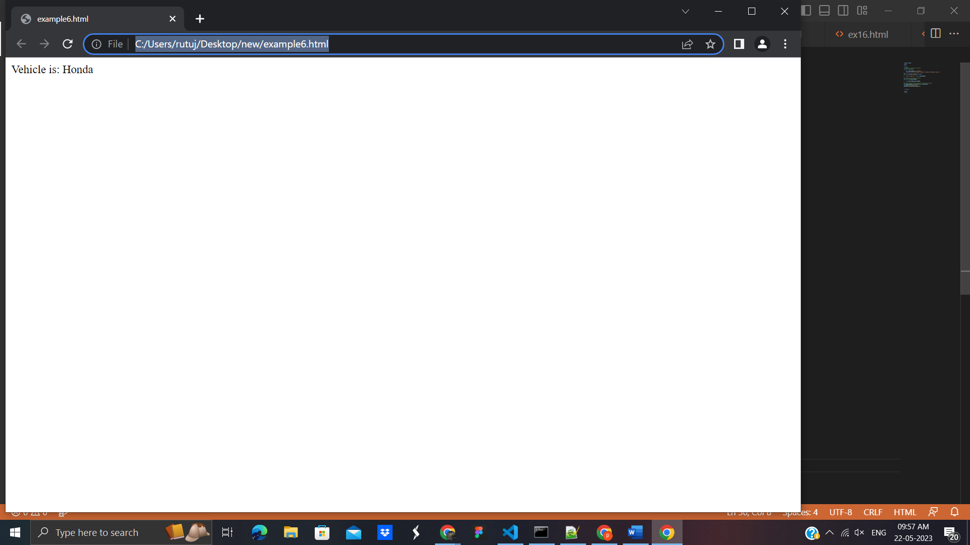

## **31. JavaScript Cookies**

A cookie is an amount of information that persists between a server-side and a client-side. A web browser stores this information at the time of browsing.

A cookie contains the information as a string generally in the form of a name-value pair separated by semi-colons. It maintains the state of a user and remembers the user's information among all the web pages.

## How Cookies Works?

* When a user sends a request to the server, then each of that request is treated as a new request sent by the different user.
* So, to recognize the old user, we need to add the cookie with the response from the server.
* browser at the client-side.
* Now, whenever a user sends a request to the server, the cookie is added with that request automatically. Due to the cookie, the server recognizes the users.

## How to create a Cookie in JavaScript?

In JavaScript, we can create, read, update and delete a cookie by using **document.cookie** property.

The following syntax is used to create a cookie:

1. document.cookie="name=value";

## JavaScript Cookie Example

<!DOCTYPE html>

<html>

<head>

</head>

<body>

<input type="button" value="setCookie" onclick="setCookie()">

<input type="button" value="getCookie" onclick="getCookie()">

<script>

function setCookie()

{

document.cookie="username=Duke Martin";

}

function getCookie()

{

if(document.cookie.length!=0)

{

alert(document.cookie);

}

else

{

alert("Cookie not available");

}

}

</script>

</body>

</html>

**Output**:

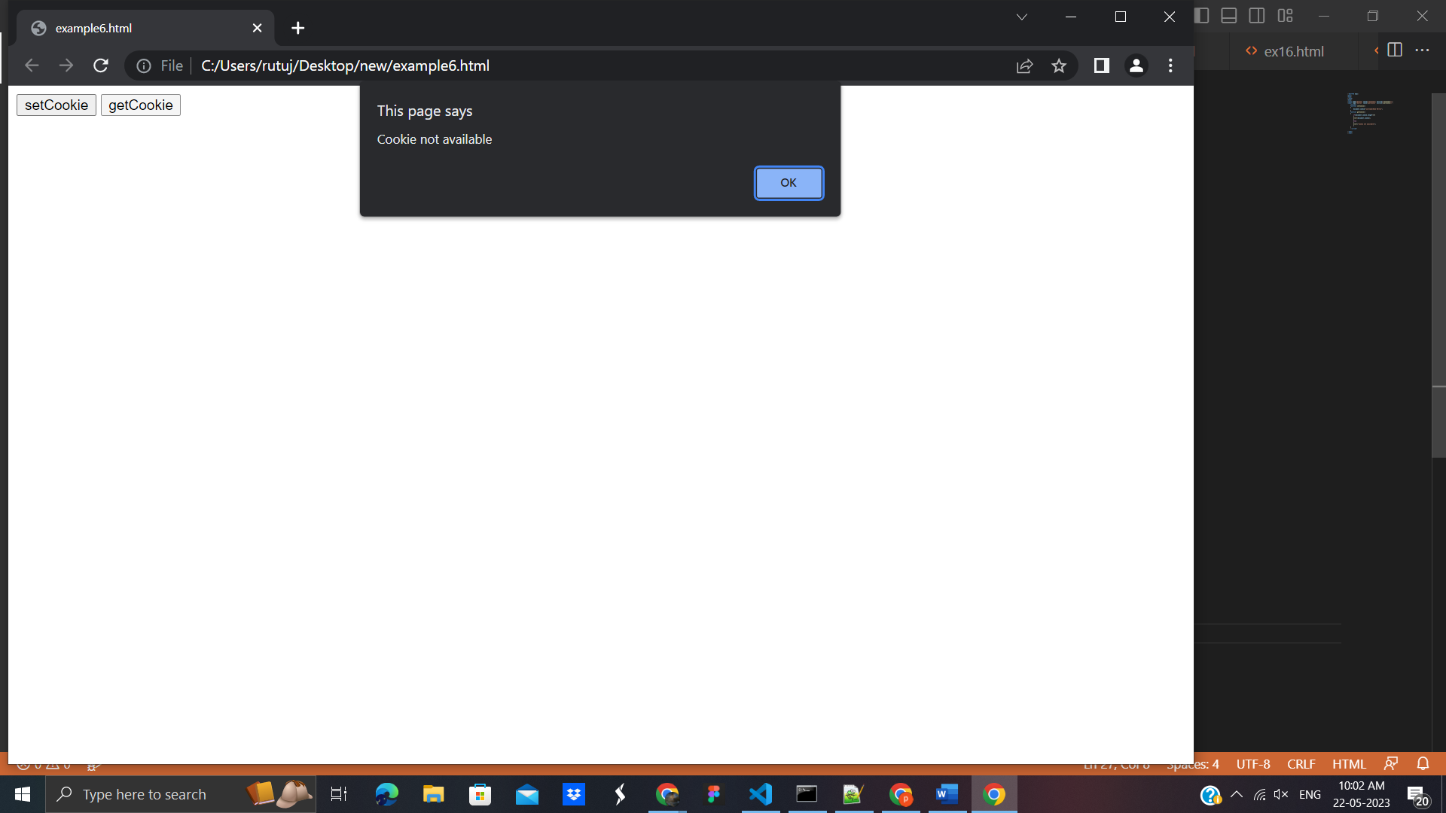

# 32. Deleting a Cookie in JavaScript

## **Different ways to delete a Cookie**

These are the following ways to delete a cookie:

* A cookie can be deleted by using expire attribute.
* A cookie can also be deleted by using max-age attribute.
* We can delete a cookie explicitly, by using a web browser.

## **32. JavaScript Events**

The change in the state of an object is known as an **Event**. In html, there are various events which represents that some activity is performed by the user or by the browser. When [javascript](https://www.javatpoint.com/javascript-tutorial) code is included in [HTML](https://www.javatpoint.com/html-tutorial), js react over these events and allow the execution. This process of reacting over the events is called **Event Handling**. Thus, js handles the HTML events via **Event Handlers**.

# JavaScript addEventListener()

The **addEventListener()** method is used to attach an event handler to a particular element. It does not override the existing event handlers. Events are said to be an essential part of the JavaScript. A web page responds according to the event that occurred. Events can be user-generated or generated by API's. An event listener is a JavaScript's procedure that waits for the occurrence of an event.

### Example

It is a simple example of using the addEventListener() method. We have to click the given [HTML button](https://www.javatpoint.com/html-button-tag) to see the effect.

<!DOCTYPE html>

<html>

<body>

<p> Example of the addEventListener() method. </p>

<p> Click the following button to see the effect. </p>

<button id = "btn"> Click me </button>

<p id = "para"></p>

<script>

document.getElementById("btn").addEventListener("click", fun);

function fun() {

document.getElementById("para").innerHTML = "Hello World" + "<br>" + "Welcome to the ecerasystem.com";

}

</script>

</body>

</html>

**Output**:

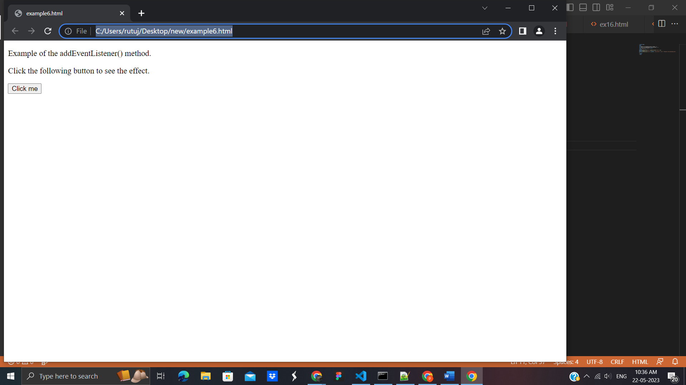

After clicking the given [HTML](https://www.javatpoint.com/html-tutorial) button, the output will be -

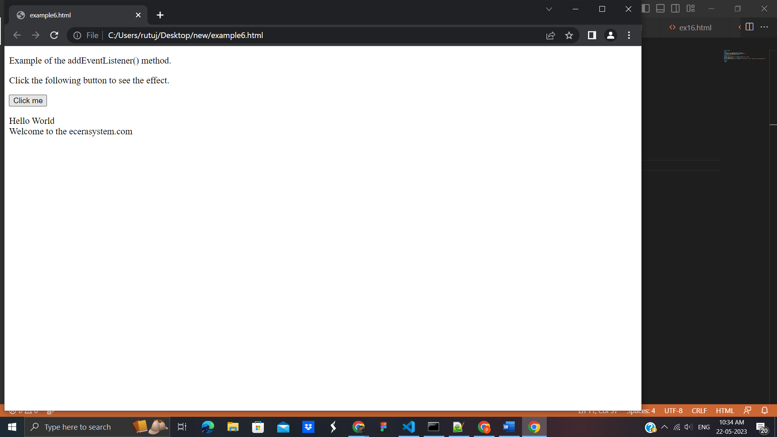

# JavaScript onclick event

The **onclick** event generally occurs when the user clicks on an element. It allows the programmer to execute a JavaScript's function when an element gets clicked. This event can be used for validating a form, warning messages and many more.

Using JavaScript, this event can be dynamically added to any element. It supports all HTML elements except [**<html>**](https://www.javatpoint.com/html-html-tag)**,** [**<head>**](https://www.javatpoint.com/html-head)**,** [**<title>**](https://www.javatpoint.com/html-title)**,** [**<style>**](https://www.javatpoint.com/html-style)**,** [**<script>**](https://www.javatpoint.com/html-script-tag)**,** [**<base>**](https://www.javatpoint.com/html-base-tag)**,** [**<iframe>**](https://www.javatpoint.com/html-iframes)**,** [**<bdo>**](https://www.javatpoint.com/html-bdo-tag)**,** [**<br>**](https://www.javatpoint.com/html-br-tag)**,** [**<meta>**](https://www.javatpoint.com/html-meta-tag)**,** and [**<param>**](https://www.javatpoint.com/html-param-tag). It means we cannot apply the **onclick** event on the given tags.

In HTML, we can use the **onclick** attribute and assign a [JavaScript function](https://www.javatpoint.com/javascript-function) to it. We can also use the JavaScript's **addEventListener()** method and pass a **click** event to it for greater flexibility.

Now, we see the syntax of using the **onclick** event in [HTML](https://www.javatpoint.com/html-tutorial) and in [javascript](https://www.javatpoint.com/javascript-tutorial) (without **addEventListener()** method or by using the **addEventListener()** method).

### In HTML

**<element** onclick = "fun()"**>**

### In JavaScript

object.onclick = function() { myScript };

### In JavaScript by using the addEventListener() method

object.addEventListener("click", myScript);

### Example1 - Using onclick attribute in HTML

<!DOCTYPE html>

<html>

<head>

<script>

function fun() {

alert("Welcome to the javaTpoint.com");

}

</script>

</head>

<body>

<h3> This is an example of using onclick attribute in HTML. </h3>

<p> Click the following button to see the effect. </p>

<button onclick = "fun()">Click me</button>

</body>

</html>

Output:

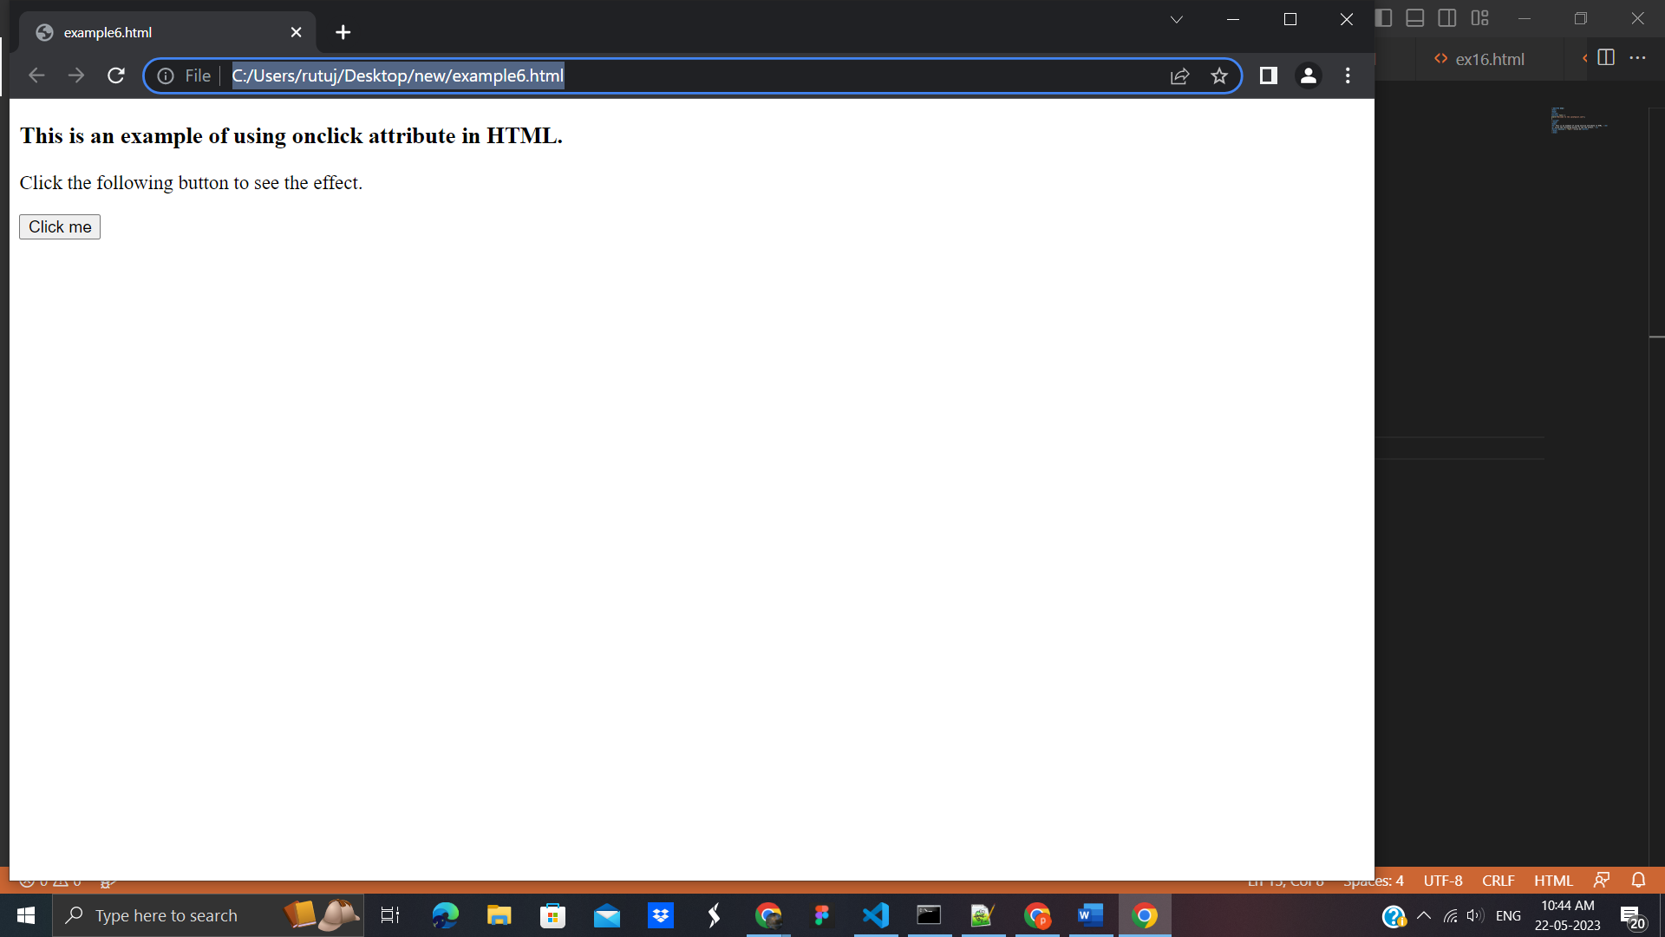

After clicking the given button, the output will be -

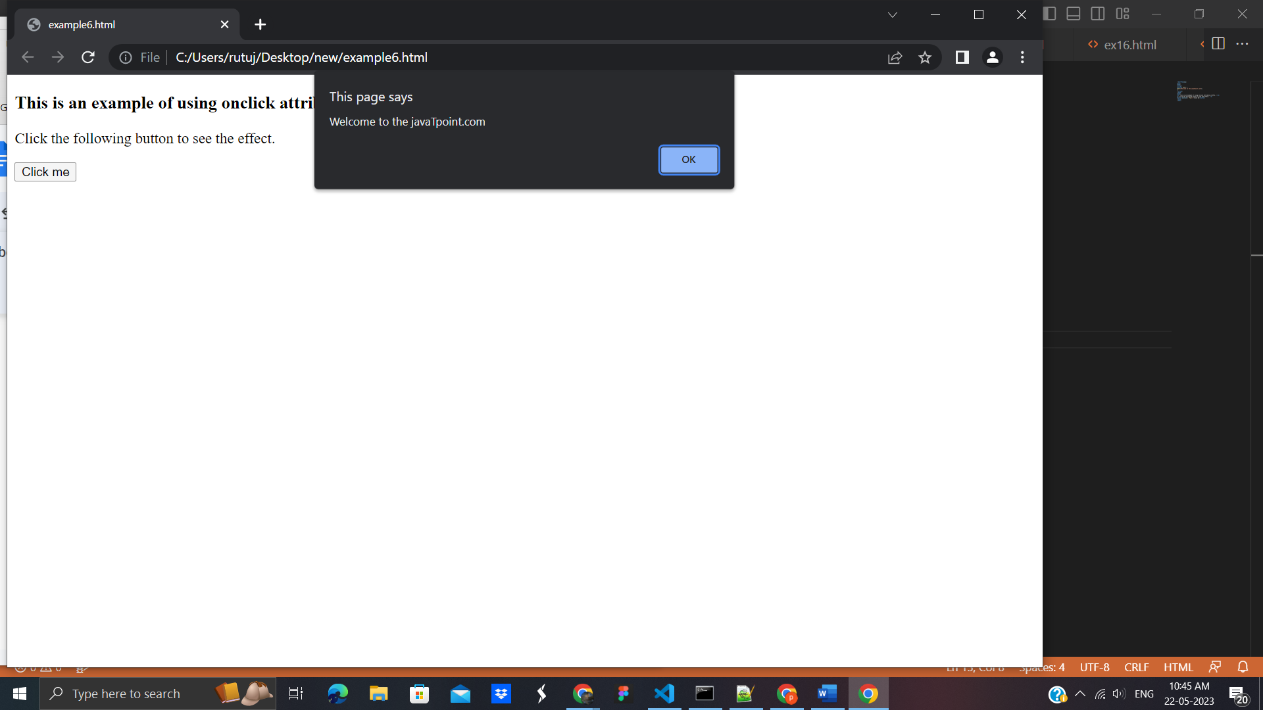

### Example2 - Using JavaScript

In this example, we are using JavaScript's **onclick** event. Here we are using the **onclick** event with the paragraph element.

When the user clicks on the [paragraph](https://www.javatpoint.com/html-paragraph) element, the corresponding function will get executed, and the text of the paragraph gets changed. On clicking the **<p>** element, the [background color](https://www.javatpoint.com/html-background-color), size, border, and color of the text will also get change.

<!DOCTYPE html>

<html>

<head>

<title> onclick event </title>

</head>

<body>

<h3> This is an example of using onclick event. </h3>

<p> Click the following text to see the effect. </p>

<p id = "para">Click me</p>

<script>

document.getElementById("para").onclick = function() {

fun()

};

function fun() {

document.getElementById("para").innerHTML = "Welcome to the javaTpoint.com";

document.getElementById("para").style.color = "blue";

document.getElementById("para").style.backgroundColor = "yellow";

document.getElementById("para").style.fontSize = "25px";

document.getElementById("para").style.border = "4px solid red";

}

</script>

</body>

</html>

**Output**:

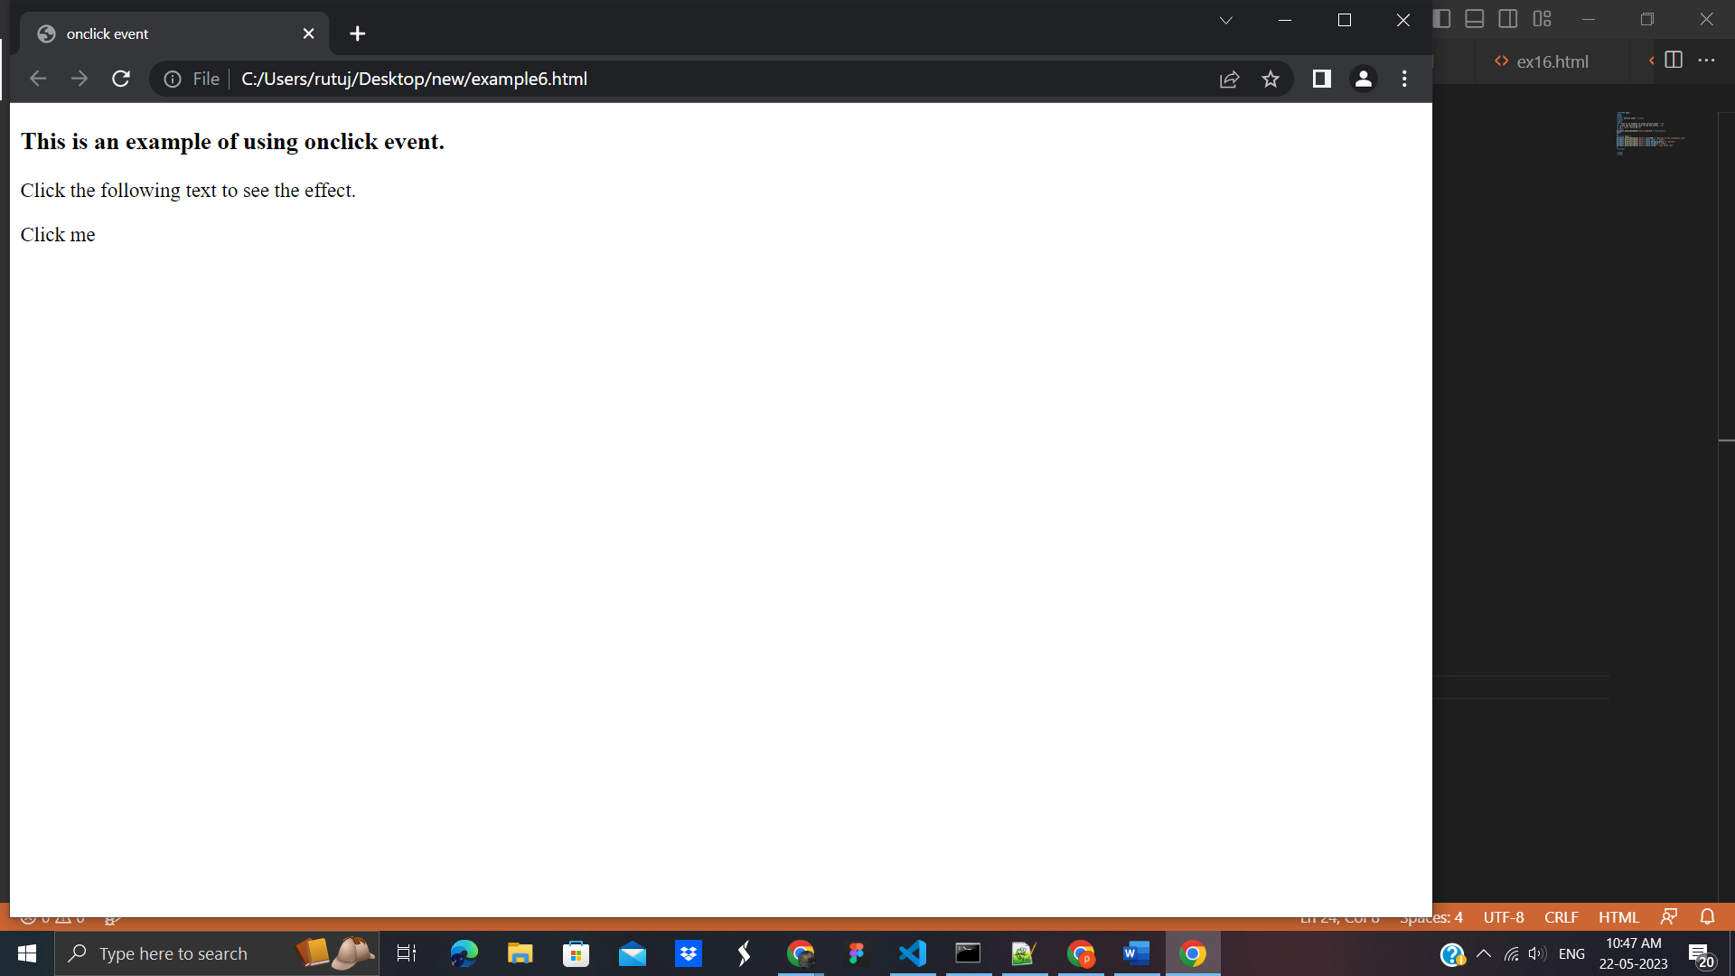

After clicking the text ***Click me,*** the output will be -

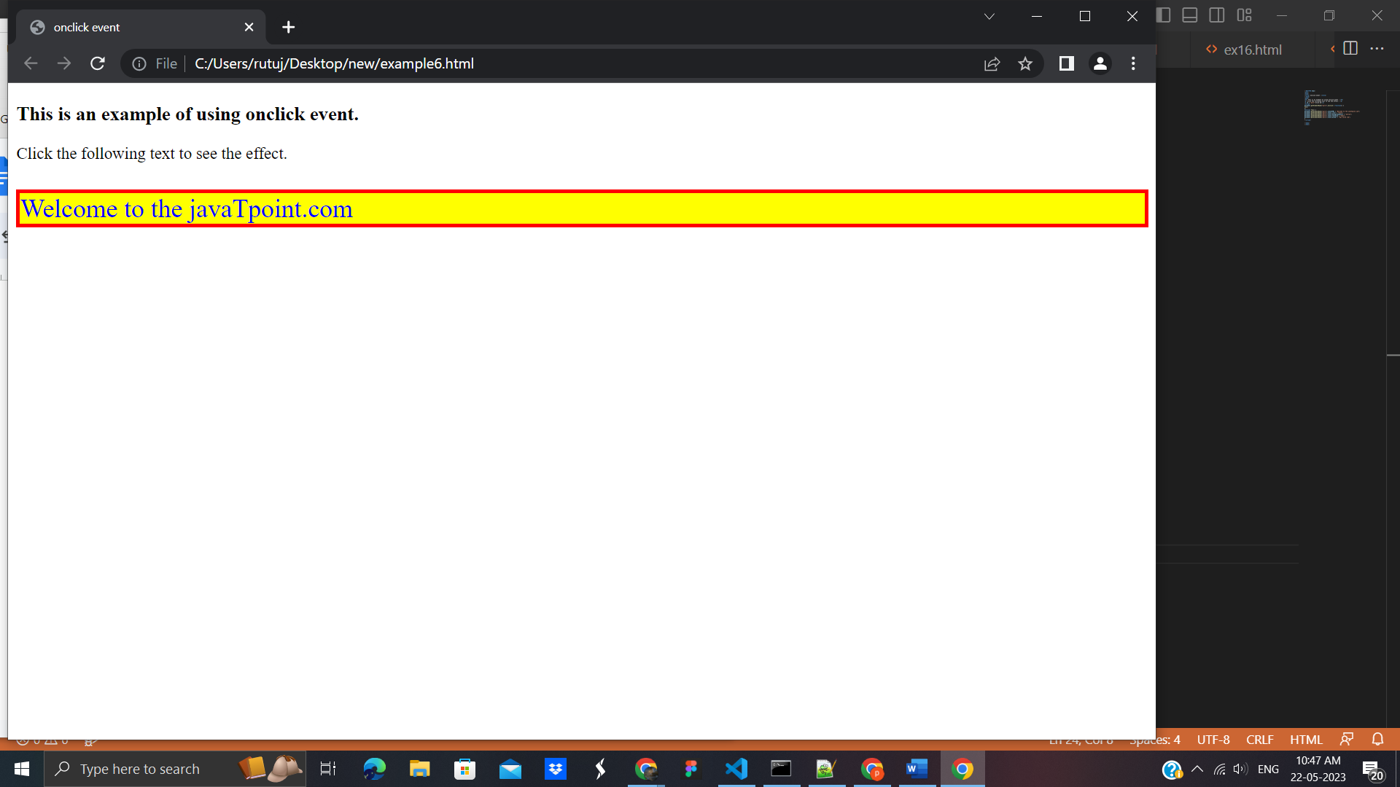

### Example3 - Using addEventListener() method

In this example, we are using JavaScript's **addEventListener()** method to attach a **click** event to the paragraph element. When the user clicks the paragraph element, the text of the paragraph gets changed.

On clicking the paragraph, the background color and font-size of elements will also change.

<!DOCTYPE html>

<html>

<head>

</head>

<body>

<h3> This is an example of using click event. </h3>

<p> Click the following text to see the effect. </p>

<p id = "para">Click me</p>

<script>

document.getElementById("para").onclick = function() {

fun()

};

function fun() {

document.getElementById("para").innerHTML = "Welcome to the javaTpoint.com";

document.getElementsByTagName("body")[0].style.color = "blue";

document.getElementsByTagName("body")[0].style.backgroundColor = "lightgreen";

document.getElementsByTagName("body")[0].style.fontSize = "25px";

document.getElementById("para").style.border = "4px solid red";

}

</script>

</body>

</html>

**Output**:

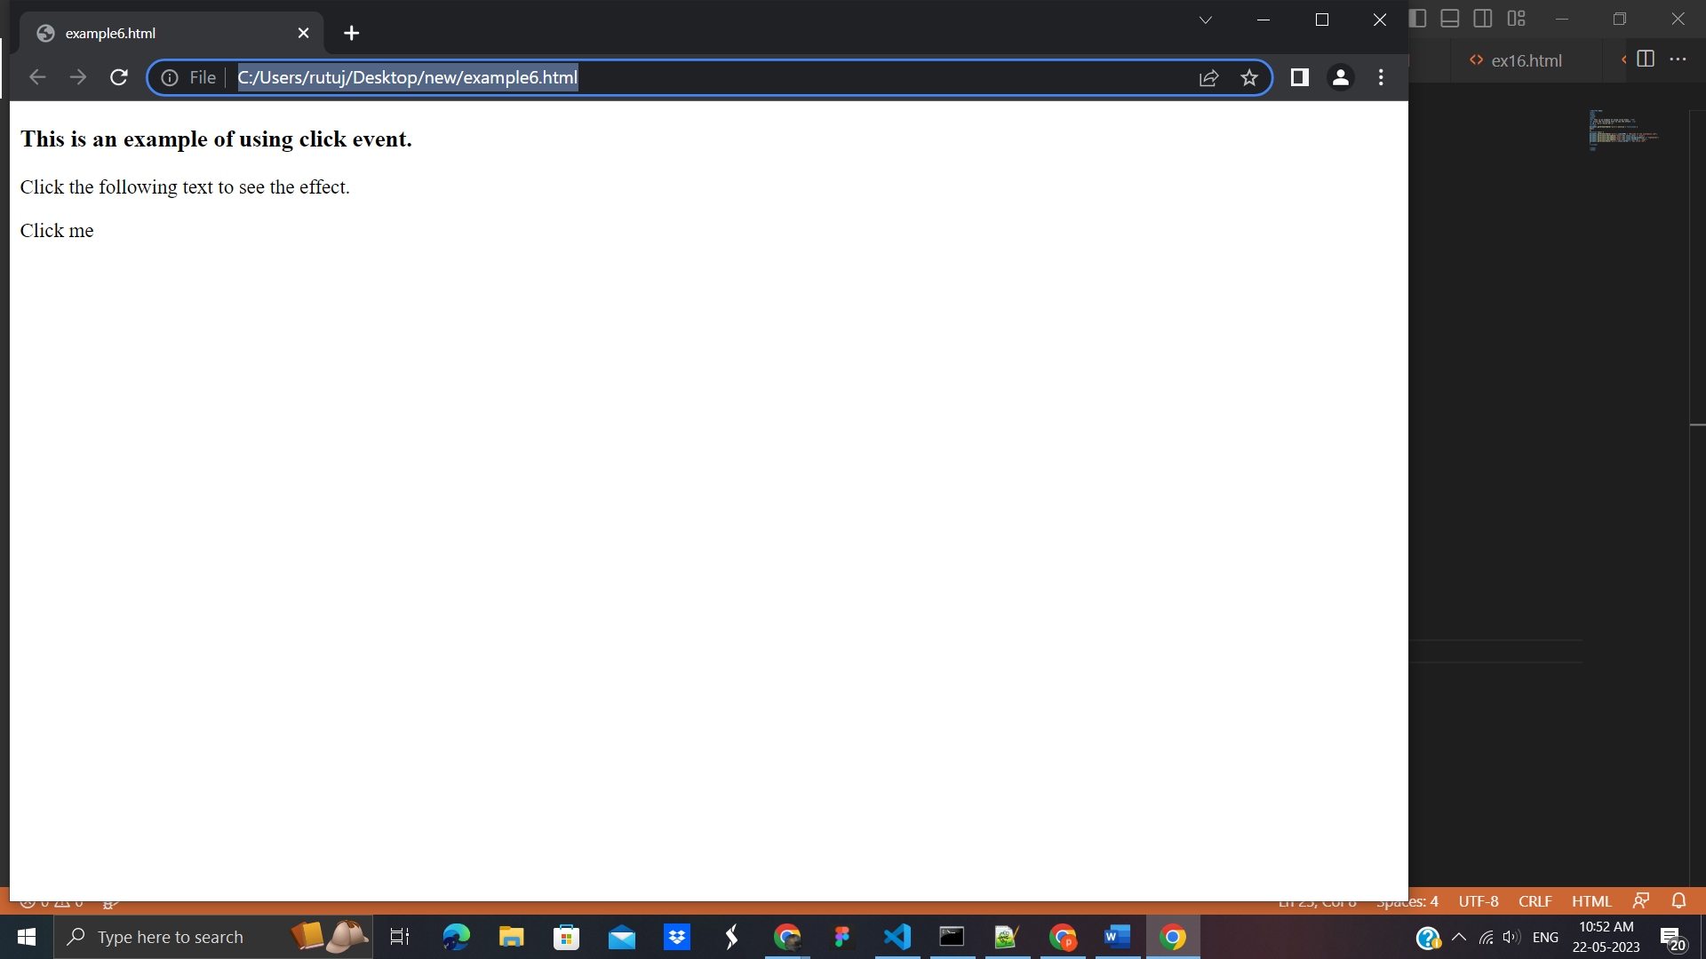

On clicking the text ***Click me***, the output will be -

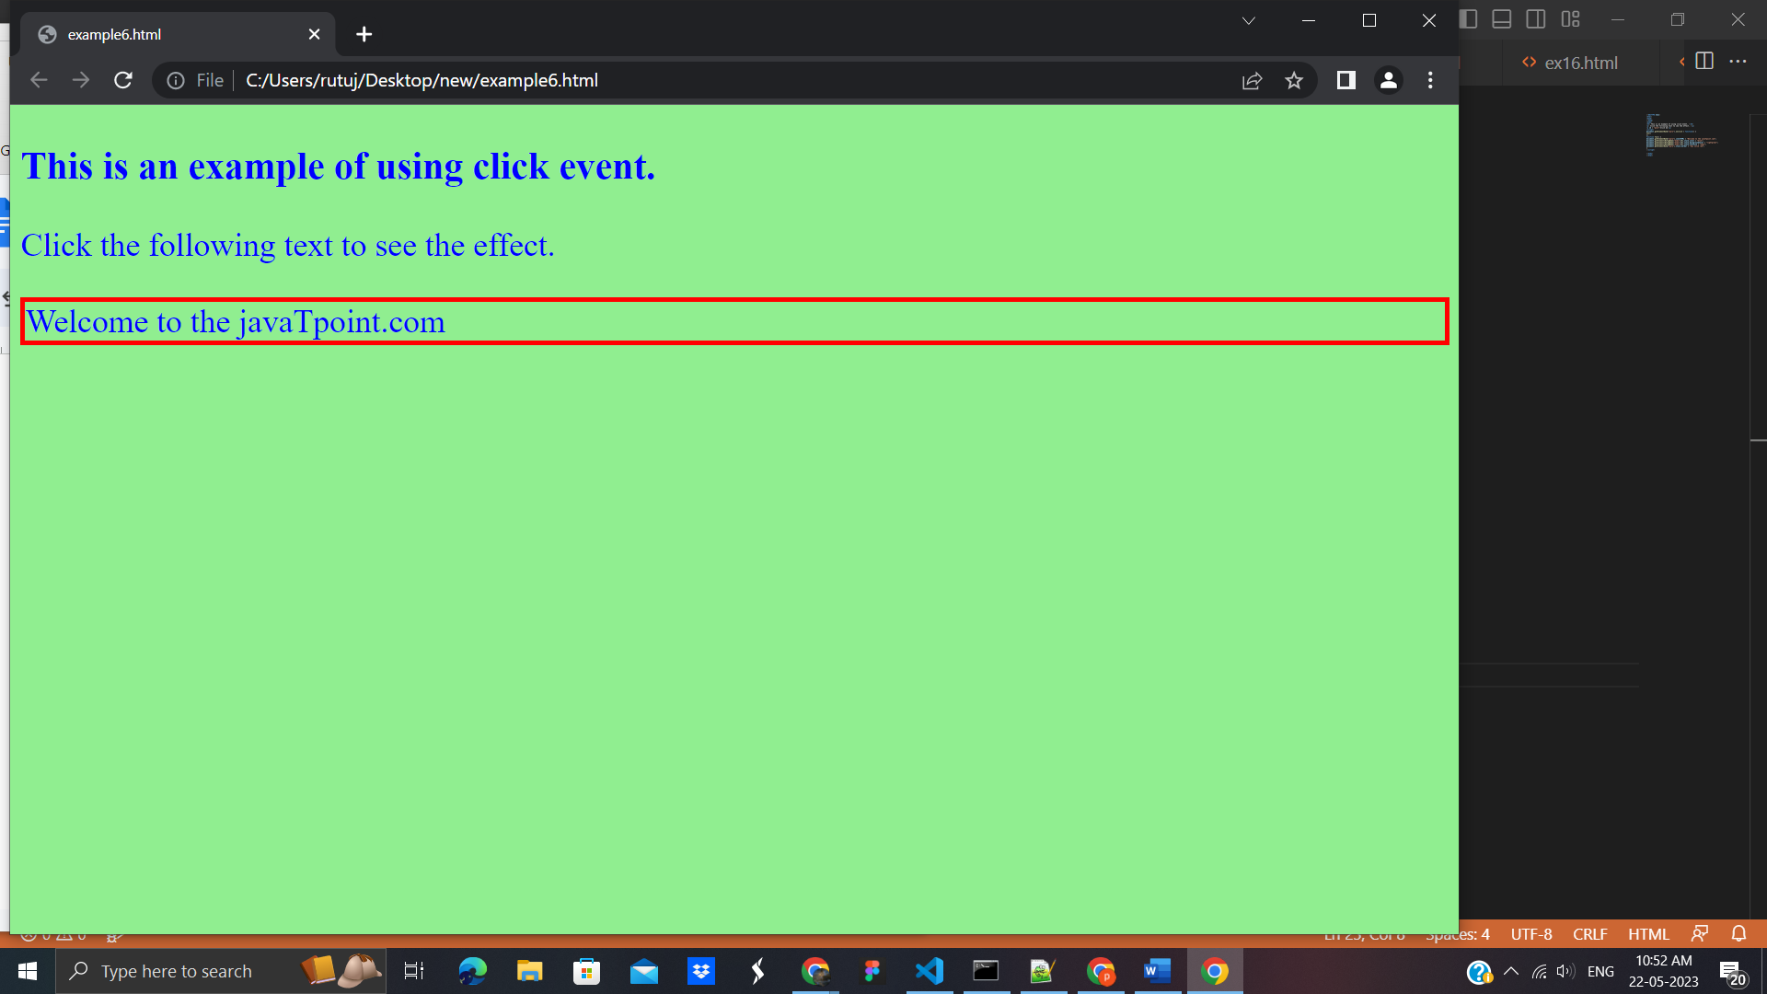

# **JavaScript dblclick event**

The **dblclick** event generates an event on double click the element. The event fires when an element is clicked twice in a very short span of time. We can also use the JavaScript's **addEventListener()** method to fire the double click event.

In [HTML](https://www.javatpoint.com/html-tutorial), we can use the **ondblclick** attribute to create a double click event.

<!DOCTYPE html>

<html>

<head>

</head>

<body>

<h1 id = "heading"> Hello world :):) </h1>

<h2> Double Click the text "Hello world" to see the effect. </h2>

<p> This is an example of creating the double click event using the <b> addEventListener() method </b>. </p>

<script>

document.getElementById("heading").addEventListener("dblclick", fun);

function fun() {

document.getElementById("heading").innerHTML = " Welcome to the javaTpoint.com ";

}

</script>

</body>

</html>

**Output:**

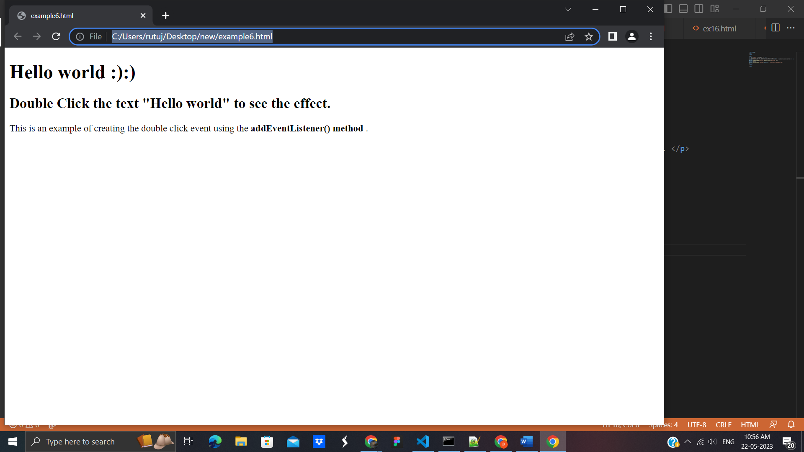

# **JavaScript onload Example**

# <!DOCTYPE html>

# <html>

# <head>

# <meta charset = " utf-8">

# <title> window.onload() </title>

# <style type = "text/css">

# #bg{

# width: 200px;

# height: 200px;

# border: 4px solid blue;

# }

# </style>

# <script type = "text/javascript">

# window.onload = function(){

# document.getElementById("bg").style.backgroundColor = "red";

# document.getElementById("bg").style.width = "300px";

# document.getElementById("bg").style.height = "300px";

# }

# </script>

# </head>

# <body>

# <h2> This is an example of window.onload() </h2>

# <div id = "bg"></div>

# </body>

# </html>

# **Output:**

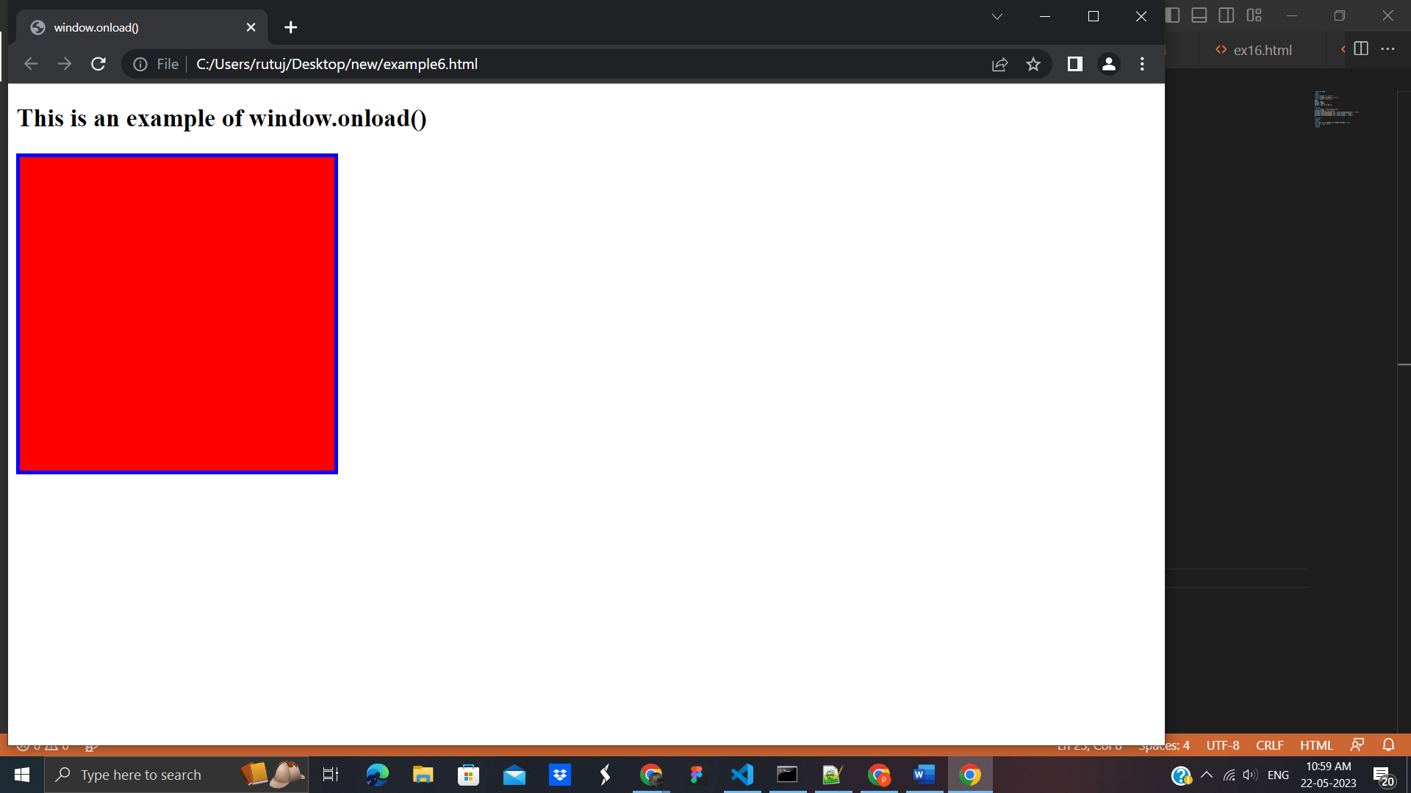

# JavaScript onresize event

The **onresize** event in JavaScript generally occurs when the window has been resized. To get the size of the window, we can use the JavaScript's ***window.outerWidth*** and ***window.outerHeight*** events. We can also use the JavaScript's properties such as ***innerWidth, innerHeight, clientWidth, ClientHeight, offsetWidth, offsetHeight*** to get the size of an element.

<!DOCTYPE html>

<html>

<head>

<script>

var i = 0;

function fun() {

var res = "Width = " + window.outerWidth + "<br>" + "Height = " + window.outerHeight;

document.getElementById("para").innerHTML = res;

var res1 = i += 1;

document.getElementById("s1").innerHTML = res1;

}

</script>

</head>

<body onresize = "fun()">

<h3> This is an example of using onresize attribute. </h3>

<p> Try to resize the browser's window to see the effect. </p>

<p id = "para"> </p>

<p> You have resized the window <span id = "s1"> 0 </span> times.</p>

</body>

</html>

**Output:**

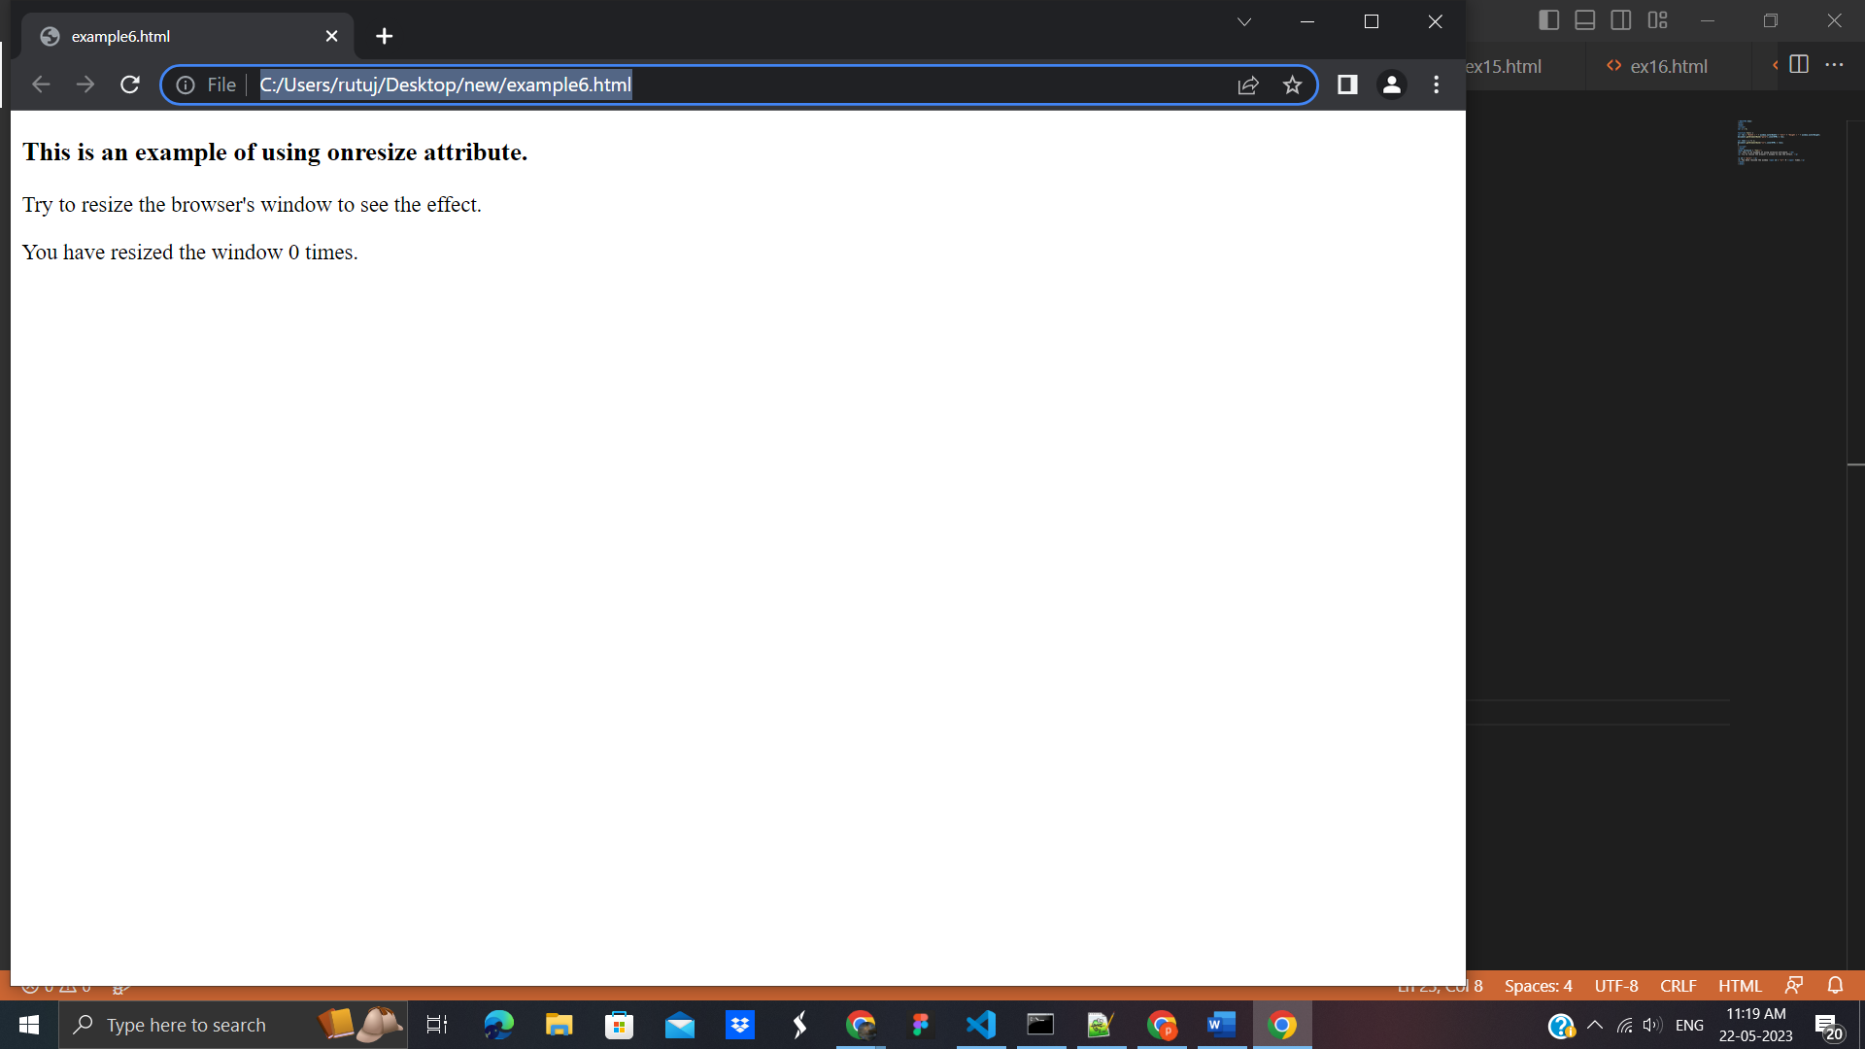

When we try to resize the window, the output will be -

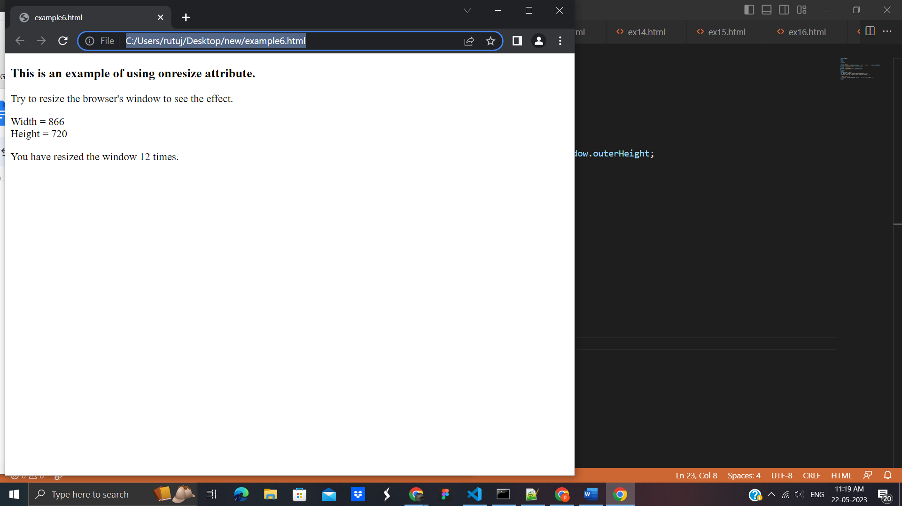

## **32. Exception Handling**

# Exception Handling in JavaScript

An exception signifies the presence of an abnormal condition which requires special operable techniques. In programming terms, an exception is the anomalous code that breaks the normal flow of the code. Such exceptions require specialized programming constructs for its execution.

An error is an action that is inaccurate or incorrect. There are three types of errors in programming which are discussed below:

Syntax error

Logical error

Runtime error

Syntax error: According to computer science, a syntax error is an error in the syntax of a sequence of characters or tokens that is intended to be written in a particular programming language or it is also the compile-time error if the syntax is not correct then it will give an error message.

Example:

<script type="text/javascript">

// An runtime error here

window.printme();

</script>

As the syntax is not correct of the JavaScript it will affect only the thread that is under this JavaScript and the rest of the code in other threads gets executed as nothing in them depends on the code containing the error.

Logical error: It is the most difficult error to be traced as it is the error on the logical part of the coding or logical error is a bug in a program that causes it to operate incorrectly and terminate abnormally (or crash).

Runtime Error: A runtime error is an error that occurs during the running of the program, also known as the exception. In the example that is given below the syntax is correct, but at runtime, it is trying to call a method that does not exist.

Example: javascript

// an runtime error here

window.printme();

As in runtime errors, there are exceptions and these exceptions can be handled with the help of the try and catch method

try-catch method

JavaScript uses the try catch and finally to handle the exception and it also uses the throw operator to handle the exception. try have the main code to run and in the catch block if any error is thrown by try block will be caught and the catch block will execute. Finally block will always occur even if an error is thrown

Syntax:

try {

// Here the main Code runs

[break;]

}

catch ( exception e ){

// The code will run when there is an exception

[break;]

}

**Example:**

<html>

<body>

<p id="gfg">

Click the GfG button to see the result:

</p>

<form>

<input type="button" value="Click GfG" onclick="First();" />

</form>

<script type="text/javascript">

function First() {

var a = 123

var b = 145

try {

document.getElementById('gfg').innerHTML +=

'<br> Division of ' + a + ' by ' + b + ' = ' + a / b

}

catch (e) {

alert(e.description)

}

}

</script>

</body>

</html>

**Output**:

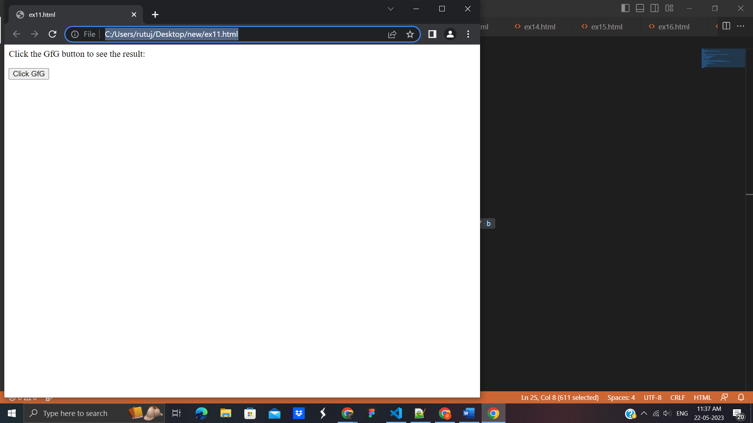

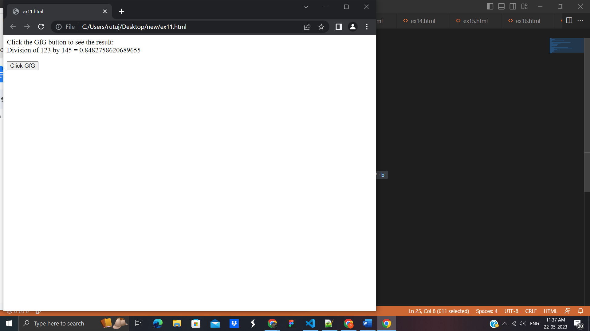

Example 2: In this example, use the finally method which will always execute unconditionally after the try/catch.

<script>

function First() {

var a = 123;

var b = 0;

try {

if(b==0){

throw "Do not divide by zero";

}

}

catch ( e ) {

document.getElementById('gfg').innerHTML += "<br>"+e+"<br>" ;

}

finally {

document.getElementById('gfg').innerHTML +=" Finally block will always execute!" ;

}

}

</script>

<p id="gfg">Click the GfG button to see the result:</p>

<form>

<input type="button" value="Click GfG" onclick="First()" />

</form>

**Output**:

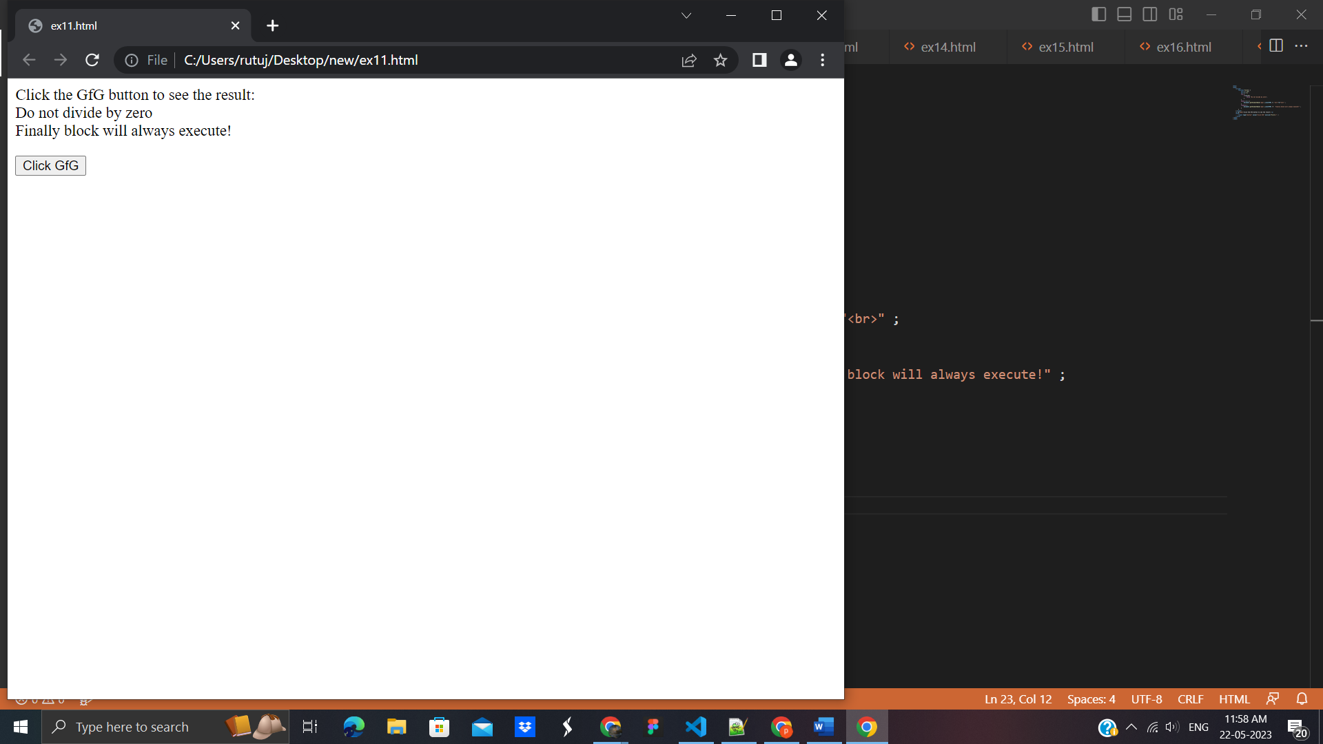

## **33. JavaScript Advance**

**TypedArray**

A TypedArray object describes an array-like view of an underlying binary data buffer. There is no global property named TypedArray, nor is there a directly visible TypedArray constructor. Instead, there are a number of different global properties, whose values are typed array constructors for specific element types, listed below. On the following pages you will find common properties and methods that can be used with any typed array containing elements of any type.

**Example:**

<html>

<body>

<script>

// Create a TypedArray with a size in bytes

const typedArray1 = new Int8Array(8);

typedArray1[0] = 32;

const typedArray2 = new Int8Array(typedArray1);

typedArray2[1] = 42;

console.log(typedArray1);

// Expected output: Int8Array [32, 0, 0, 0, 0, 0, 0, 0]

console.log(typedArray2);

// Expected output: Int8Array [32, 42, 0, 0, 0, 0, 0, 0]

</script>

</body>

</html>

**Output:**

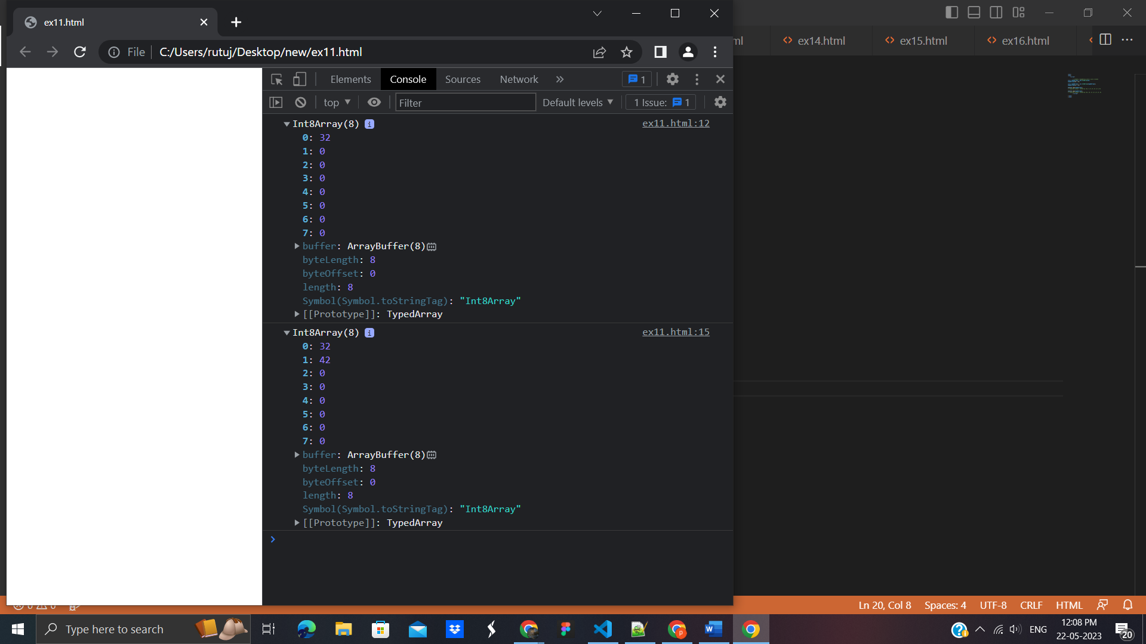

# JavaScript Set Object

Set objects are collections of values. A value in the set may only occur once; it is unique in the set's collection. You can iterate through the elements of a set in insertion order. The insertion order corresponds to the order in which each element was inserted into the set by the add() method successfully (that is, there wasn't an identical element already in the set when add() was called).

**Example:**

<html>

<body>

<script>

const mySet1 = new Set();

mySet1.add(1); // Set(1) { 1 }

mySet1.add(5); // Set(2) { 1, 5 }

mySet1.add(5); // Set(2) { 1, 5 }

mySet1.add("some text"); // Set(3) { 1, 5, 'some text' }

const o = { a: 1, b: 2 };

mySet1.add(o);

mySet1.add({ a: 1, b: 2 }); // o is referencing a different object, so this is okay

mySet1.has(1); // true

mySet1.has(3); // false, since 3 has not been added to the set

mySet1.has(5); // true

mySet1.has(Math.sqrt(25)); // true

mySet1.has("Some Text".toLowerCase()); // true

mySet1.has(o); // true

mySet1.size; // 5

mySet1.delete(5); // removes 5 from the set

mySet1.has(5); // false, 5 has been removed

mySet1.size; // 4, since we just removed one value

mySet1.add(5); // Set(5) { 1, 'some text', {...}, {...}, 5 } - a previously deleted item will be added as a new item, it will not retain its original position before deletion

console.log(mySet1); // Set(5) { 1, "some text", {…}, {…}, 5 }

</script>

</body>

</html>

**Output:**

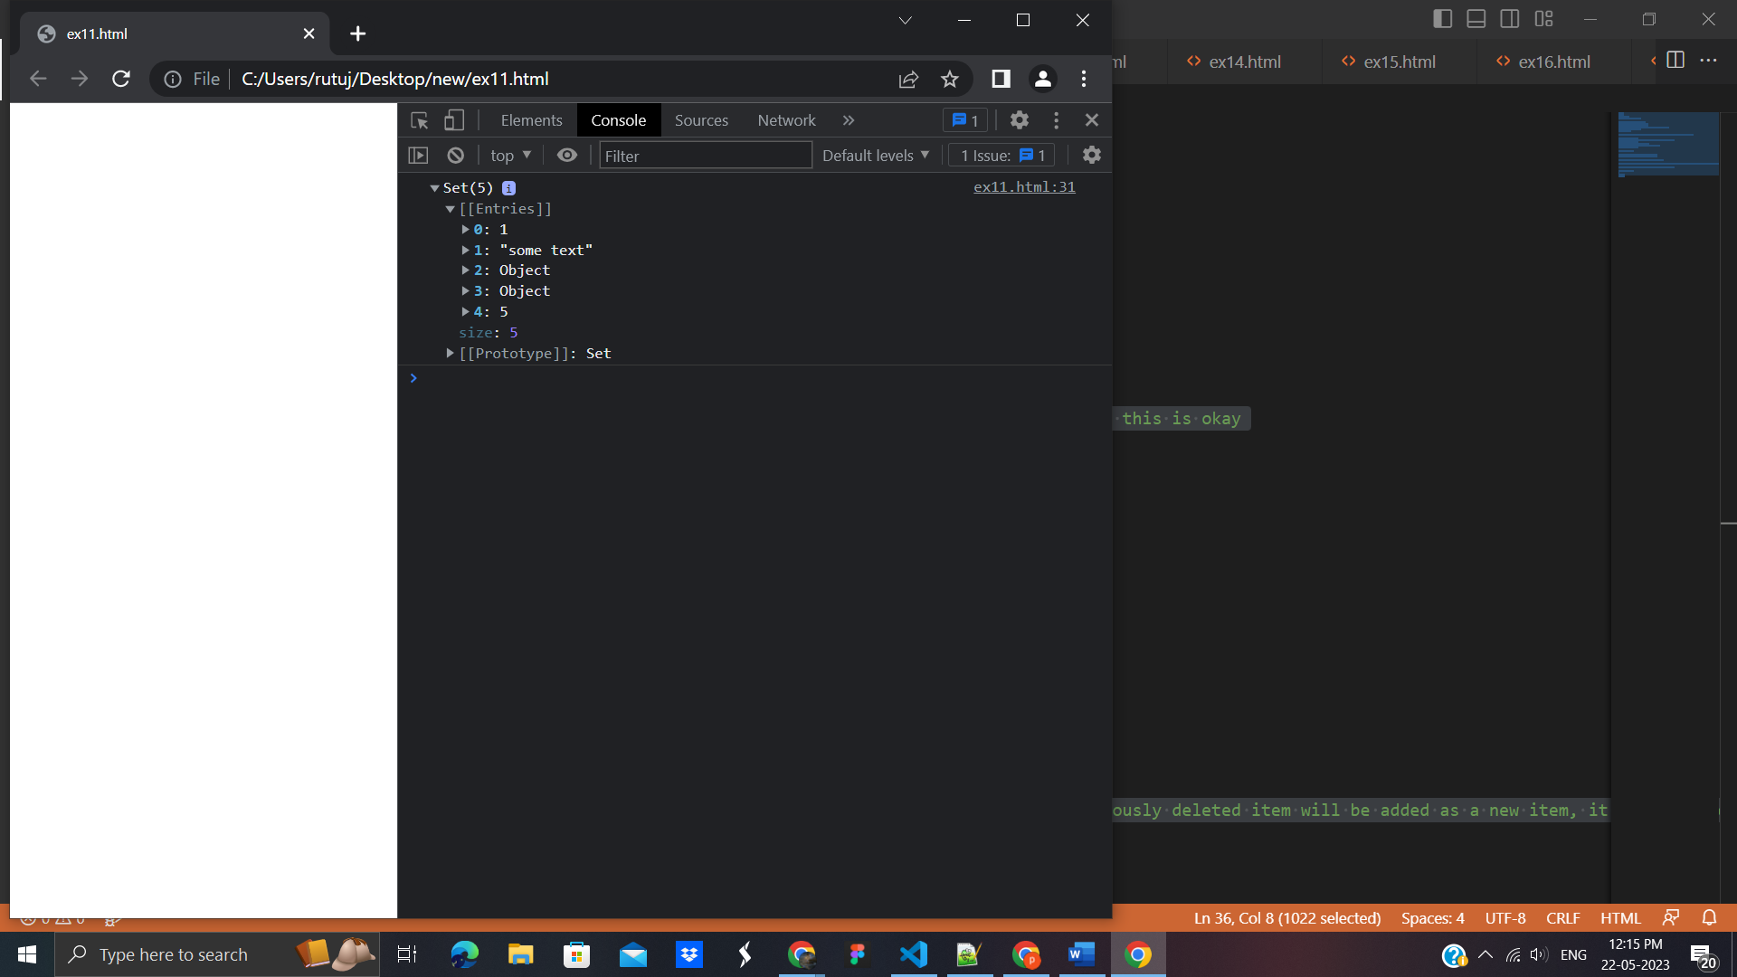

# **34.JavaScript Maps**

## How to Create a Map

**You can create a JavaScript Map by:**

* **Passing an Array to new Map()**
* **Create a Map and use Map.set()**

## **new Map()**

You can create a Map by passing an Array to the new Map() constructor:

<!DOCTYPE html>

<html>

<body>

<h2>JavaScript Map Objects</h2>

<p>Creating a Map from an Array:</p>

<p id="demo"></p>

<script>

// Create a Map

const fruits = new Map([

["apples", 500],

["bananas", 300],

["oranges", 200]

]);

document.getElementById("demo").innerHTML = fruits.get("apples");

</script>

</body>

</html>

**Output:**

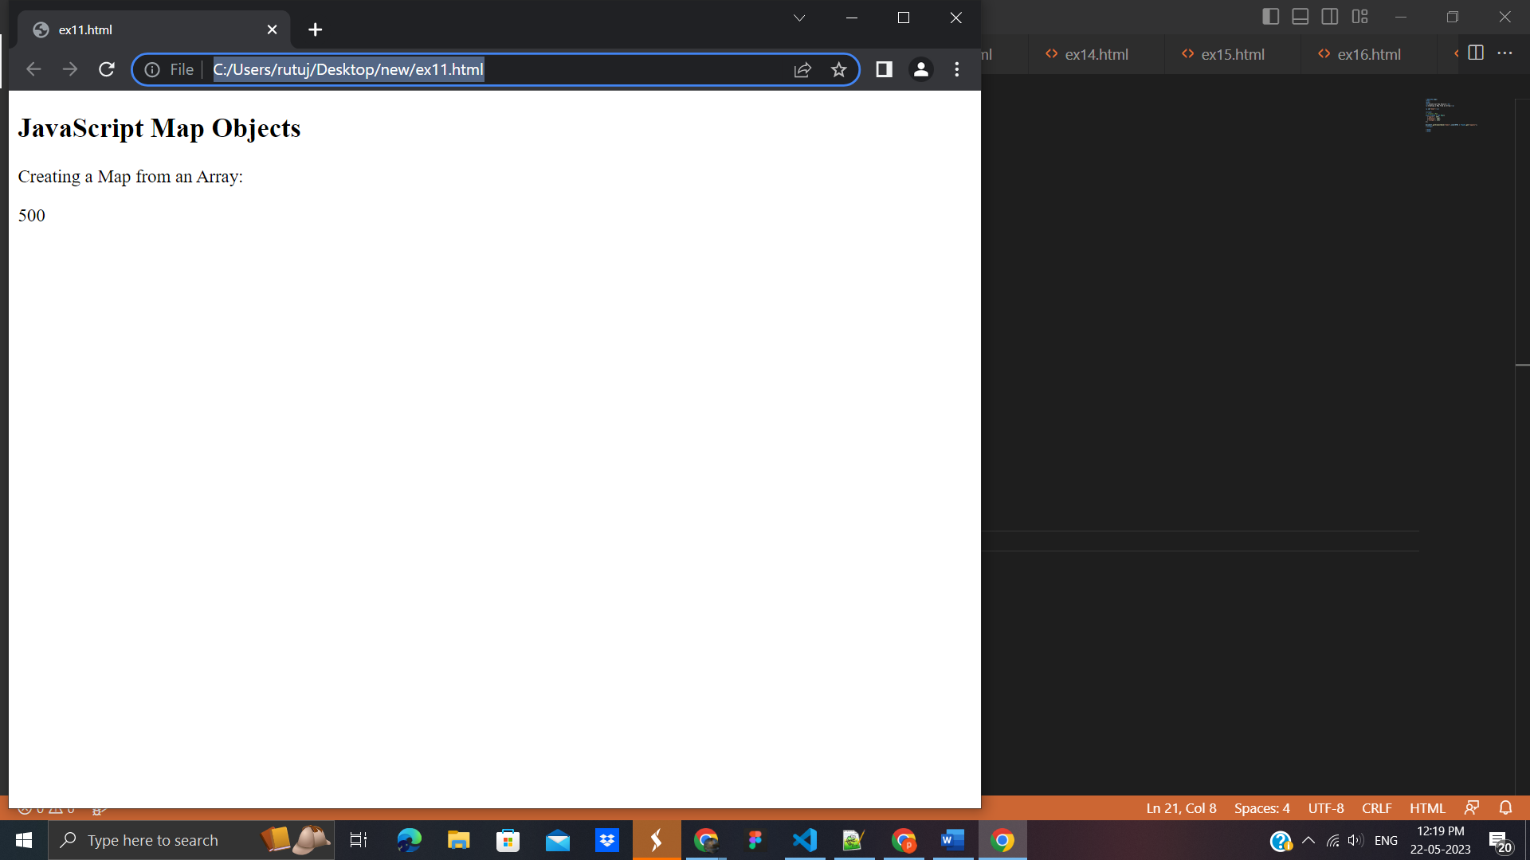

## **Map.set()**

You can add elements to a Map with the set() method:

<!DOCTYPE html>

<html>

<body>

<h2>JavaScript Map Objects</h2>

<p>Using Map.set():</p>

<p id="demo"></p>

<script>

// Create a Map

const fruits = new Map();

// Set Map Values

fruits.set("apples", 500);

fruits.set("bananas", 300);

fruits.set("oranges", 200);

document.getElementById("demo").innerHTML = fruits.get("apples");

</script>

</body>

</html>

**Output:**

